#1. (1 Point) Give a regular expression for an identifier composed of letters, digits, and underscores that begins with a Letter (denote it by L), ends with a letter (L) or digit (denote it by D), and contains no consecutive underscores (denoted by _ ). You may use ? for optional, * for 0 or more and + for 1 or more.

#2. (1 Point) Consider the following NFA
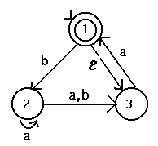
a) Why is it non-deterministic? (State all reasons you find)

b) Convert the NFA to a DFA.

c) Minimize your DFA.

d) What is L(M) for all three machines (it should be the same for all three!)

