Setting up Python 3.6.5, matplotlib, and numpy
on your own Windows PC or laptop
CS-1004, Introduction to Programming for Non-Majors, A-Term 2018

Hugh C. Lauer©
Teaching Professor
Worcester Polytechnic Institute
Programming assignments in CS-1004 will be carried out in the programming language Python — specifically, version 3.6.5 of Python. In addition, you will need several Python packages, including one called matplotlib, a Python version of the popular Matlab system, and one called numpy (meaning “Numerical Python”). This document provides instructions for installing Python 3.6.5 on Windows 7, Windows 8, and Windows 10 laptop and desktop computers. This document also includes instructions for installing Python packages such as matplotlib and numpy.
Public laboratory computers at WPI will have Python 3.6.5, matplotlib, and numpy installed on them for the academic year 2018-2019.
In general, it is expected that assignments will be compatible among Windows, Macintosh, and Linux systems, assuming they all use compatible versions of Python, matplotlib, and numpy.
Note: Two different, incompatible versions of Python are in general use around the world — Python 2.7 and variations of Python 3. Significant changes were made to the Python language between Python 2.x and Python 3. The Python 3 language is cleaner, more self-consistent, and more user-friendly. Programs written for versions of Python 2 will not necessarily run on Python 3 installations; if they do run, they may get different answers to the same problem.
Note that a lot of legacy Python 2 code is still in use, and new Python 2.7 code is still being written and distributed by organizations that have not yet upgraded to Python 3. Not all Python 2 packages have been ported to Python 3.
Note 2: There are many integrated environments for supporting Python programming, including PyCharm and Enthought. Most of these are more advanced that what is needed for this course. If you choose to use one of them, you are on your own for installation.

Installing Python 3.6.5 on Windows Systems,
Python 3.6.5 for Windows exists in two variations — a 32-bit version and a 64-bit version. Almost all Windows PCs sold over the past few years are 64-bit systems. Therefore, these instructions focus primarily on installing the 64-bit versions. If you have a 32-bit version of Windows, please seek assistance from the Professor, the TAs, or the Helpdesk.
To obtain the correct 64-bit version of Python, click on this link — python-3.6.5-amd64.exe — and download the resulting file to a convenient folder or directory. Alternatively, you may browse to
http://www.cs.wpi.edu/~cs1004/a18/Resources-A18
and download it from there.
Right-click on your downloaded copy of the file python-3.6.5-amd64.exe and select Run as Administrator to start the installation. You should be greeted by a dialog box resembling the following:–
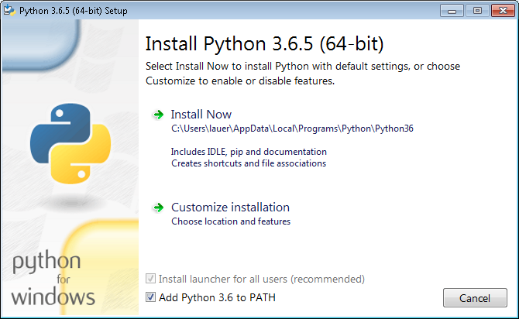
Figure 1
Be sure to check the box at the bottom labeled “Add Python 3.6 to PATH” (shown in a red circle).
Note1: The “Add Python 3.6 to PATH” checkbox may seem trivial but forgetting to check it has led to numerous problems for students in previous terms!
Note 2: It is essential that you run the installation as Administrator. If you forget to so, the installation will appear to proceed successfully, but you are likely to get weird errors at runtime and even in the installations of numpy and matplotlib.
If you forgot to select Run as Adminstrator, uninstall Python and start over.
If all goes well, you should see a window resembling the following:–
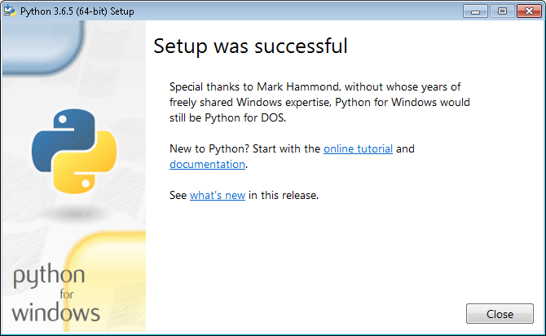
Figure 2
Three big “ifs”:–
- If an earlier version of Python 3.x is already installed on your computer, you may see a window resembling Figure 3 (below) instead of Figure 1. In this case, you may proceed with the installation of Python 3.6.5 by clicking Upgrade Now. If successful, you will see a window resembling Figure 2 above.
- If you have a 32-bit version of Windows (an unlike event nowadays), you should cancel this installation and download and install python-3.6.5.exe instead. You are strongly encouraged to seek help for 32-bit issues.
- If something else goes wrong, please contact the Professor, the TAs, and/or the Helpdesk to get a working version of Python 3.6.5 installed on your computer.
You should do this right away. There won’t be enough time in the days before the first assignment is due.
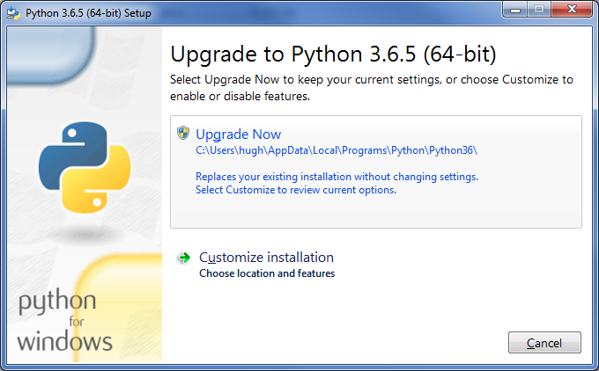
Figure 3

Customized installation
If you share a computer with someone else (unlikely) or have a non-standard installation of Windows, you may have to invoke the Customize Installation button in Figure 1 or Figure 3. This will bring up a dialog box similar to that of Figure 4. Be sure all the boxes are checked, and then click Next to bring up a dialog similar to Figure 5.

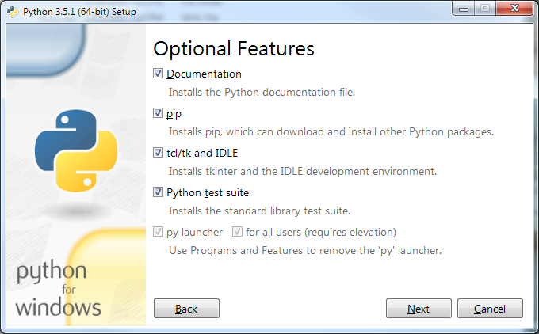
Figure 4

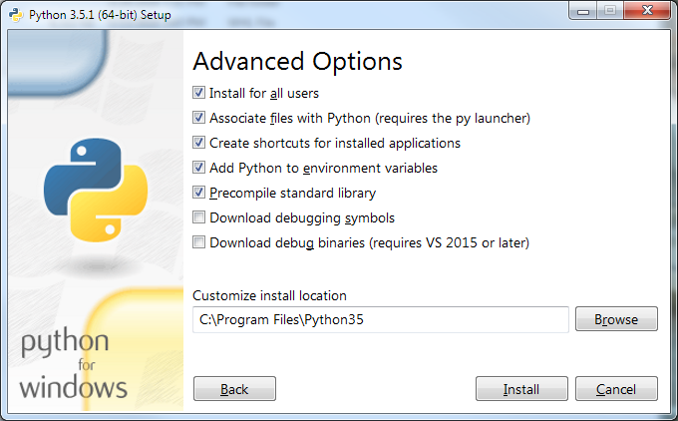
Figure 5
Click Install for all users to force the installer to choose a commonly accessible directory for all the users of this computer. Be sure that the check boxes in your installation match those in Figure 5.
Click Install to begin the installation. If the installer tells you the directory already exists and asks if you are sure that you want to overwrite existing files, click Yes. The progress of the installation will be shown in the dialog box.
The installation will take several minutes and will finish with the dialog box of Figure 3 on page 4 of this document. Click Close to complete the installation of Python 3.6.5.

Testing your installation
The following two sections pertain to testing on Windows 7 and Windows 10, the two most common Windows versions in common use. In the (unlikely) event that you have Windows 8, please refer to the appendix of this document for testing.

Testing on Windows 7
To confirm and test your installation, we will start IDLE, the Python Integrated Development Environment window. If you are running Windows 7, click the Start button to bring up the Windows Start menu. Select All Programs and scroll down to Python 3.6.5. This is a folder shown circled in the left side of Figure 6.
When you open this folder, you will see four options, shown in the right side of Figure 6. Select IDLE (Python 3.6 64-bit) to start the IDLE program shown in Figure 7.
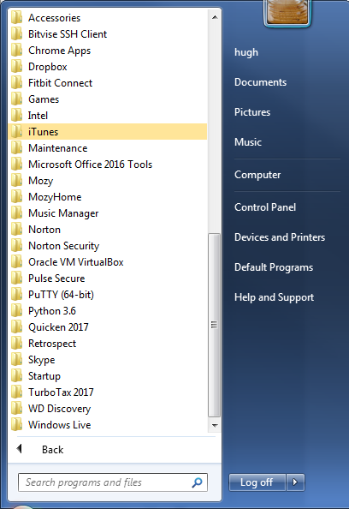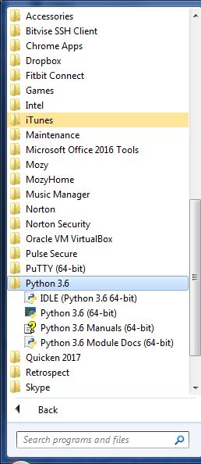
Figure 6
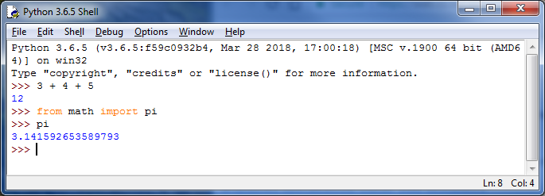
Figure 7
This is IDLE, the Python command prompt and graphical user interface. This is where we will start all programs and projects in this course. For now, simply type any Python statement or expression after the “>>>” prompt. For example, Figure 7 shows the expression
3 + 4 + 5
as typed, followed by Python’s response of the value 12.
After the next two “>>>” prompts, type the command
from math import pi
and the expression
pi
Python responds by printing the value of pi to 15 decimal places.
Continue testing by typing out the code on pages 10-11 of the textbook, just to make sure that your installation works as expected.
Note that if you mistype something, you will probably get some unexpected behavior. Simply try again. If you get really lost, type CTRL-C to get back to the IDLE prompt.

Testing under Windows 10
Windows 10 has something like the Start button, but it looks a little different — the symbol at the left end of the taskbar. Click on this to bring up a menu something like Figure 8 below:–
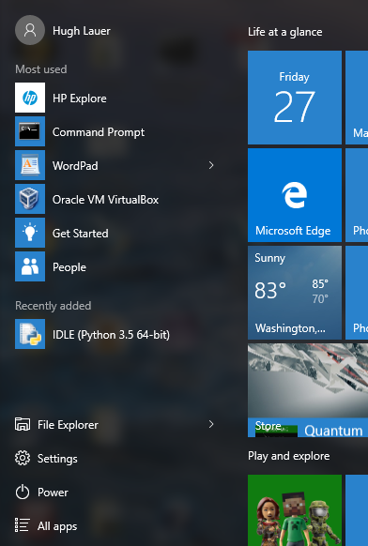
Figure 8
In most cases, IDLE (Python 3.6.5 64-bit) should be shown under “Recently added” (five lines up from the bottom of this Start Menu). If you don’t see it there, click on All apps, at the bottom of the Start Menu. This will provide an alphabetical list of all applications. Python 3.6.5 appears under “P” and shows the same four options as the right side of Figure 6. Since you will be using this a lot, it is suggested that you right click on IDLE (Python 3.6.5 64-bit) and select either Pin to Start or More > Pin to Taskbar.
To test your installation, double-click on this icon and carry out the same tests as shown above under Figure 7.
Congratulations! You now have a usable Python 3.6.5 running on your Windows computer or laptop.

Installing graphics.py
Graphics.py is a simple drawing package that we will use a lot in this course. It was written in Python 3 and created by the textbook author for making simple drawings. To install it, click on this link — graphics.py — and download the file to the folder where you keep your Python programs. Follow the instructions in sections 4.3-4.8 of the textbook (3rd edition).

Installing matplotlib, numpy, and other packages
These steps require you to have a working internet connection.
One of the many benefits of Python is the vast number of third-party packages that can be downloaded and used by your Python programs. Many of these are open-source and free. For this course, we will use at least the following:–
- matplotlib (a package for creating 2D plots and graphs similar to Matlab),
- numpy (meaning “Numerical Python,” a package for efficient handling of large arrays of numerical data, also needed by matplotlib), and
The installation of these packages has been simplified from that of previous years. There is no need to download these packages separately. Instead, you will use a Windows Command Prompt to run pip, the Python Installation Program.
A command prompt is a window into which you type “commands” to tell the computer and operating system what to do. An example command prompt window is shown in Figure 10.
In this window, the system prints a prompt starting with the “path” of the current folder and ending with a “>” character. After the prompt, you type a command, consisting of a command name followed by zero or more operands that control what the command does. When you terminate the command with the Enter key, the system performs the command.
A command may work silently and then print out its results in the same window, or it may engage in a textual conversation with you, requiring you to respond by typing, or it may open its own window with its own graphical user interface. When the command has completed, the system prints a new prompt for the next command. The command consisting solely of the word “exit” causes the system to close the command prompt window.
To install matplotlib, you must run the Command Prompt in Administrator mode.
- In Windows 7, click on the Start button, select All Programs, scroll to the Accessories folder and open it. This folder will show many useful accessories, such as shown in Figure 9.
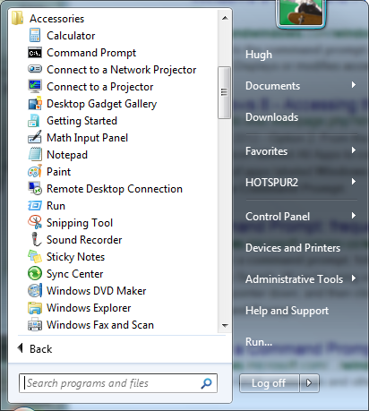
Figure 9
Right click on “Command Prompt” on the second line and select Run as Administrator. Windows will ask you if you really want to do this. Click yes. This will open a window into which you can type textual commands.
- In Windows 8, search for “Command Prompt” in the pallet of “charms,” the same way you searched in Figure 19. Drag an icon for the Command Prompt to your desktop, right-click on it, and select Run as Administrator.
- In Windows 10, click on the Windows icon at the left end of the taskbar, select All apps, and scroll down to Windows system (listed alphabetically). Open the Windows system item to expose a list of system applications, including Command Prompt. Right-click on Command Prompt and select More > Run as administrator.
If you are unable to find the Command Prompt or to run it as Administrator, seek help from the Professor, one of the TAs, or the Helpdesk. If you are successful, you should be presented with a window resembling Figure 10 below. The background is likely to be black or some other dark color. Note that the header of this window labels it as an Administrator Command Prompt.
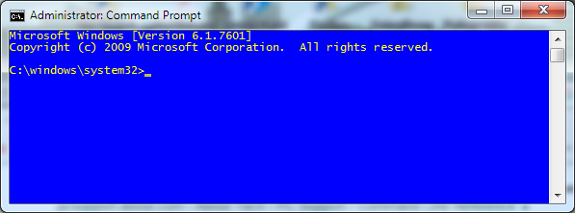
Figure 10
Next, in the Command Prompt window of Figure 10, type the following three commands, exactly as written here:–
python -mpip install -U pip
python -mpip install -U matplotlib
python -mpip install -U nose
In these commands, pip is the Python Installation Program. It knows how to find packages on the web and to keep versions consistent with each other. The matplotlib package is one that we will use extensively in this course. Installing it automatically causes the correct supporting version of numpy to be installed. Finally, nose is a comprehensive test package for the numpy package; we will use it to verify our installation.
Note: These commands will access the internet to retrieve files from an online Python distribution center.
Any of these commands may report errors, including that a package is already installed. To check what is installed, type the command
pip list
This will list the programs that pip knows about — shown, for example, Figure 11.
Figure 11
When this installation is complete, make a quick test numpy by opening an IDLE window, as in Figure 7. Type or paste the following commands into IDLE, one line at a time, exactly as written. Note that the word version is preceded by two underscore characters and followed by two more. Also note that the word arange is spelled with one “r”.
Note: Even if you had help installing Python and matplotlib, you should type out the test lines below yourself. This will help you get used to Python.
import numpy as np
np.__version__
a = np.arange(10)
a
b = np.arange(1, 9, 2)
b
c = np.eye(3)
c
d = np.diag(np.array([1, 2, 3, 4]))
d
The result should resemble Figure 12:–
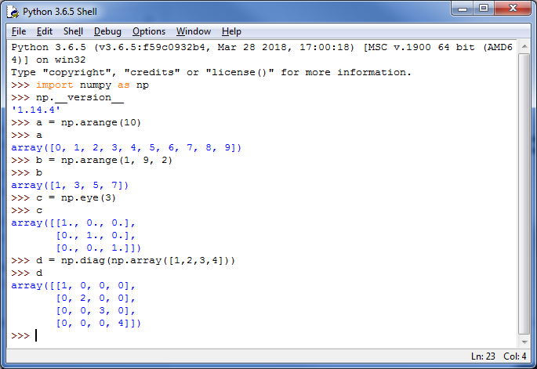
Figure 12
Finally, type the exit command to close the Administrator Command Prompt of Figure 10.

Testing Your Installation

Testing numpy
To carry out the comprehensive test of numpy, open a new IDLE window and type the following two commands:–
import numpy
numpy.test()
This uses nose to run the standard package of numpy tests for several minutes. It prints a bunch of stuff in the IDLE window. Although some of the output may look like error messages, these are known issues with the tests. The test should start with something resembling the following:–
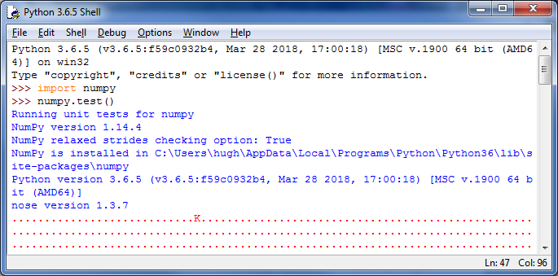
Figure 13
After a few minutes, the tests should end with something resembling the following:–
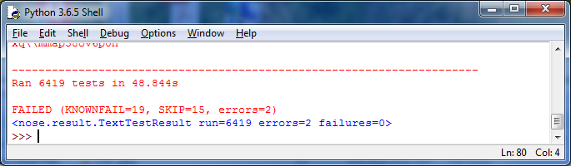
Figure 14
Congratulations! You have now installed a working versions numpy 1.14.4 and matplotlib 2.2.2.

Testing matplotlib
You can carry out a simple test of your matplotlib installation by typing or pasting the following commands into an IDLE window, one line at a time, exactly as written:–
from matplotlib import pyplot
pyplot.plot([1, 2, 3, 4], [1, 4, 9, 16])
pyplot.show()
The IDLE window should look something like the following:–
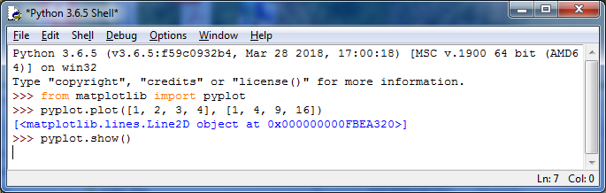
Figure 15
After you type the ENTER key following the last line, the following window should appear:–
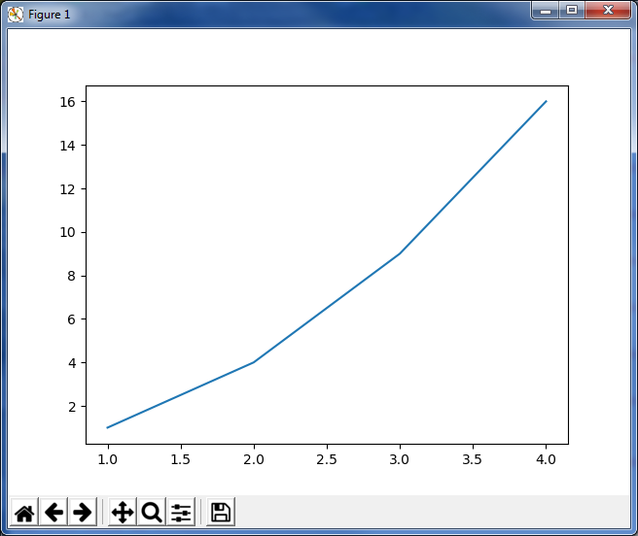
Figure 16
To close this window, click on the “close” button in the upper right.
For a more interesting test, download the file TestMatplotlib2.py, and then use the File menu in the IDLE window to open this file. The file should look like the following:–
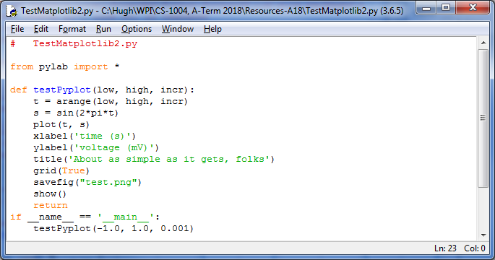
Figure 17
Click the Run > Run Module command in the menu at the top of the window to produce the following window:–
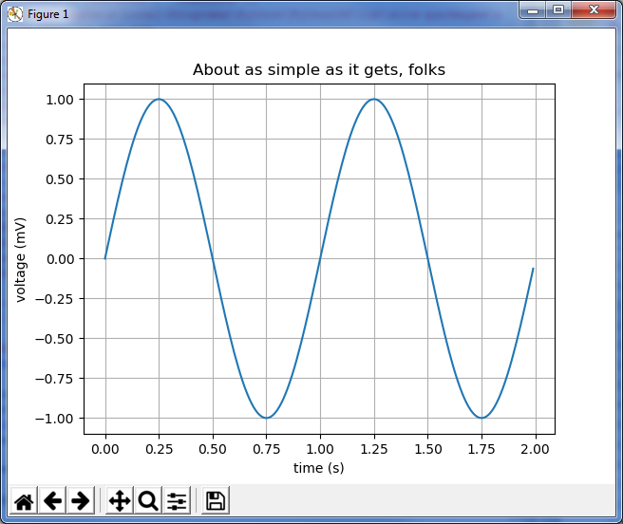
Figure 18
Congratulations! You now have a working version of matplotlib installed.

Appendix

Testing in Windows 8
Windows 8 does not have a Start button but rather a Start screen that is intended to make the user experience more like the smartphone experience. Unfortunately, when Python is installed as instructed above, its icon does not automatically appear on the Start screen. It also does not appear in the list of apps.
To find it, move the cursor to the upper-right or lower-right corner of the screen to expose the Windows 8 pallet of “charms”. Select the Search charm to bring up a Search box. Type the word “Python.” This will bring up a list of matching items, like that shown in Figure 19 below but referring to the 64-bit version of Python 3.6.5.
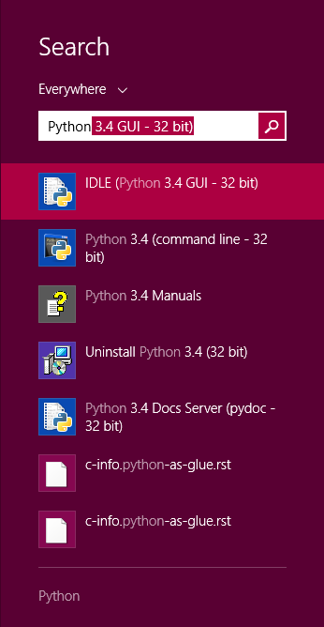
Figure 19
Note that this list is like the Python 3.6.5 folder in the Start Menu in Figure 6. Right-click on the item labeled IDLE (Python 3.6.5 GUI). From the resulting menu, select “Pin to Start” to cause an icon to be added to the Start screen. You may also want to pin the item to the Task bar (i.e., the bar of tiny icons at the bottom of the screen). You may also select “Open file location,” which will bring up the following window:–
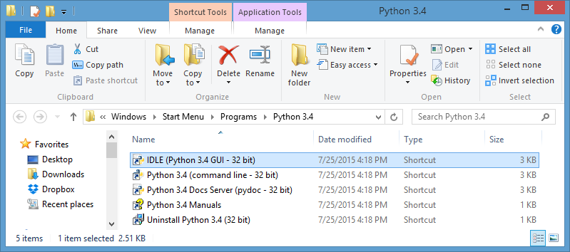
Figure 20
From this window, you can copy any or all the Python links to the desktop.
To test your installation, double-click on the IDLE (Python GUI) icon and carry out the same tests as shown above under Figure 7.

© Copyright 2018, Hugh C. Lauer. All rights reserved. Permission is given for use in courses at Worcester Polytechnic Institute, Worcester, Massachusetts.
If you have a Macintosh or Linux computer or laptop, please refer to these documents instead:– docx, pdf
It is useful to print out the relevant sections of this document. If you try read them on-screen, the dialog boxes of the installation tend to obscure the instructions, just when you need them the most!
These instructions have been tested on both Windows 7 and Windows 10. The professor no longer has access to an installation of Windows 8 for testing.
The processor designation “amd64” applies to microprocessors made by both Intel and AMD.
The “Customize install location” near the bottom of Figure 5 will refer to an appropriate folder for your computer.
Recent reports indicate that there are at least 45,000 different packages covering many fields of science, engineering, and mathematics.
This means that you have a lot of power to do good or evil to your computer!
This is a variation of the “range” function that we will learn about in the first week of class.
Note that Figure 19 and Figure 20 refer to an older version of Python because they were copied directly from an older version of this document. If you follow these instructions for Windows 8, you should see the current version of Python that you downloaded on page 2.

