Setting up Python 3.4, numpy, and matplotlib
on your Macintosh or Linux computer
CS-1004, Introduction to Programming for Non-Majors, A-Term 2015

Hugh C. Lauer0F©
Adjunct Professor
Worcester Polytechnic Institute
Programming assignments in CS-1004 will be carried out using the programming language Python — specifically, version 3.4 of Python. In addition, you will need several Python packages, including one called numpy (meaning “Numerical Python”) and one called matplotlib, a Python version of the popular Matlab system. The first part of this document provides instructions for installing Python 3.4 and packages such as numpy and matplotlib on Macintosh platforms. 1616 to skip forward to the Linux section of this document. 1F
In general, it is expected that assignments will be compatible among Windows, Macintosh, and Linux systems, provided that they all use compatible versions of Python and numpy.
Note: There are two different, incompatible versions of Python in general use around the world — Python 2.7 and Python 3.4. Significant changes to the Python language were made between Python 2.x and Python 3.y (for all values of x and y). The Python 3 language is cleaner, more self-consistent, and more user-friendly. Programs written for versions of Python 2 will not necessarily run on Python 3 installations; if they do run, they may get different answers to the same problem.
That being said, a lot of legacy Python 2 code is still in use, and new Python 2.7 code is still being written and distributed by organizations that have not yet upgraded to Python 3. Not all Python 2 packages have been ported to Python 3.
Note 2: Both Mac OS X and Linux come with Python 2.7 already installed for their own needs. That version of Python must not be deleted or disturbed when installing Python 3.4 and its packages.

Installing Python 3.4 on Macintosh2F, 3F
Installing Python 3.4 on Mac OS X presents two challenges:–
- Packages such as numpy 1.9.2 and matplotlib 1.4.3 are delivered in forms that require installation via commands in a Terminal window for installation.
- The IDLE tool of Python 3.4 has a dependency on Tcl/Tk, an open-source toolkit for building user interfaces. However, Python 3.4 requires a more recent version than is already installed on Mac OS X.
First, create a folder on your desktop — for example, Python-files — and download the following two installers to that by clicking on these links:– ActiveTcl 8.5.18.0, and python-3.4.3-macosx10.6. Alternatively, you may browse to
http://www.cs.wpi.edu/~cs1004/a15/Resources/
and download the files from there.

ActiveTcl 8.5.18.0
This step requires you to have an Administrative account and password for your Macintosh. Have that ready before you start.
Open the ActiveTcl 8.5.18.0 file that you just downloaded. You will be asked to confirm your action, and then it displays the following dialog box:–
Figure 1
Double-click on the icon that looks like a shipping carton. Under most circumstances, you will next be presented with the following dialog box of the Macintosh Gatekeeper:–
Figure 2
Click OK, and then open System Preferences under the Apple menu. In the System Preferences folder, open the Security and Privacy icon, shown circled in Figure 3, to bring up the Security & Privacy control panel of Figure 4.
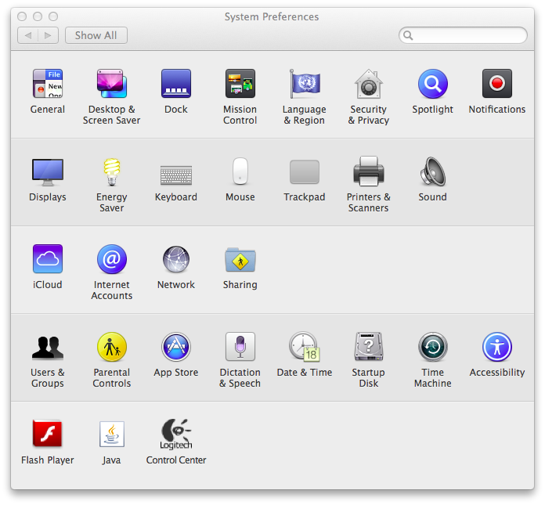

Figure 3
Figure 4
Notice near the bottom of this panel the message that “ActiveTcl-8.5.pkg” was block from opening because it is not from an identified developer. Click on Open Anyway to proceed with the installation. This will involve several more dialog boxes, including an agreement to the licensing terms. It will also require you to enter the user ID and password of the Administrator of your Macintosh.
The installation of ActiveTcl should now proceed to completion. It will finish with a window entitled ActiveTCL User Guide. For CS-1004, it is safe to ignore this user guide.

Installing Python 3.4
Next, you will install Python 3.4. Open the python-3.4.3-macosx10.6.pkg file that you downloaded on Page 2 above. This should bring up a dialog resembling Figure 5 below.
Figure 5
The message in the dialog box includes information about specific versions of Tcl/Tk. We have already addressed this issue with the installation of ActiveTcl 8.5.18.0.
If the installer complains that there is already a version of Python 3 installed on your computer, please seek help or contact the Professor. You must have Python 3.4.3 for this course. Earlier versions should be upgraded. Click Continue to bring up another dialog:–
Figure 6
This dialog box is scrollable and contains information about what is new in this release. It also has another reminder to update Tcl/Tk, which we just did in Figure 1 and Figure 4. Click Continue to bring up additional dialog boxes until the one in Figure 7 appears.
Figure 7
Click Agree to continue the installation. The installation itself will take several minutes and may show one or more dialog boxes. It will finish with a panel resembling Figure 8.
Figure 8
After it has completed, you should find a folder named Python 3.4 in your Applications folder, as shown circled in solid black below.
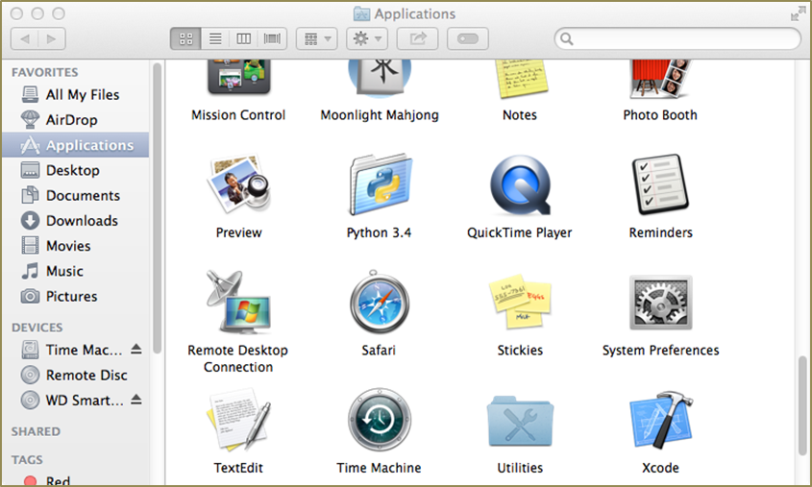

Figure 9
Open the Python 3.4 folder to show Figure 10 below.
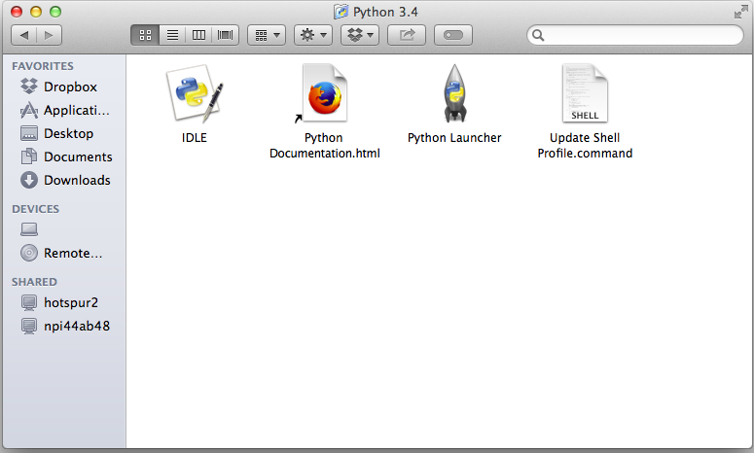
Figure 10
Create an Alias for IDLE and put it in a convenient place so that you can access it easily — for example, on your desktop. Double-click this alias to bring up the following window:–
Figure 11
This is IDLE, the Python command prompt and graphical user interface. This is where we will start all programs and projects in this course.
For now, simply type any Python statement or expression after the “>>>” prompt. For example, Figure 11 shows the expression 2 + 3 + 4 as typed, followed by Python’s response with the value 9. Continue testing by typing out the code on pages 10-11 of the textbook, just to make sure that your installation works as expected.
Note: IDLE is essentially the same across Windows, Macintosh, and Linux platforms. It is used the same way in all three.

Installing matplotlib, numpy, and other packages
One of the many benefits of Python is the vast number of third-party packages that can be downloaded and used by your Python programs. Many of these are open-source and free. For this course, we will use at least the following:–
- matplotlib (a package for creating 2D plots and graphs similar to Matlab),
- numpy (meaning “Numerical Python,” a package for efficient handling of large arrays of numerical data), and
- graphics.py, a simple tool written in Python 3 and created by the textbook author for making simple drawings.
Installing matplotlib, numpy, and other packages on a Macintosh requires you to type Linux-like commands in a Terminal window.
Open the Utilities folder, which is indicated by the dashed circle in Figure 9. This will bring up the window of Figure 12. Select Terminal (highlighted with a red circle) and open it.
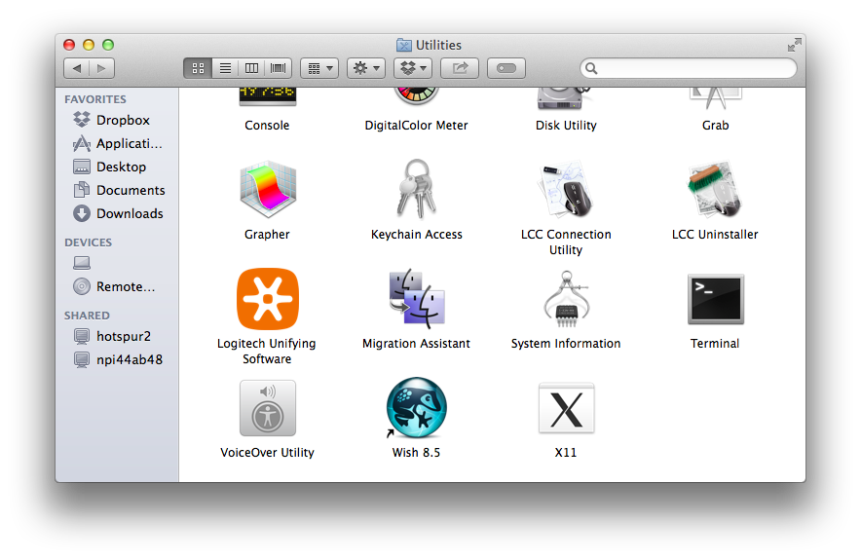

Figure 12
This will bring up a terminal window (also known as a command shell in Unix and Linux terminology). An example terminal window is shown in Figure 13. In this window, in this window, the system prints a prompt starting at the beginning of a line and ending in ‘$’. After the prompt, you type a command, consisting of a command name followed by zero or more operands, which control what the command does. When you terminate the command with the Enter key, the system performs the command.
A command may work silently and then type out its results in the same window, or it may engage in a textual conversation with you, requiring you to respond, or it may open its own window with its own graphical user interface. When the command has completed, the system prints a new prompt for the next command.

Installing numpy and matplotlib
This step requires you to have a working internet connection.
Click on the following links to download two files to the Python-files folder that you created on Page 2:–
- numpy-1.9.2-for-MacOS
- matplotlib-1.4.3-for-MacOS
Note that the actual names of these two files are really long — too long to remember or to type correctly. Instead, it is better to copy and paste them in the Terminal window.
First, type
cd Desktop/Python-files
(or whatever you called the folder to which you downloaded the two files). This is shown in the second line of Figure 13.
Figure 13
Next, type the command
ls
meaning “list directory.” Figure 13 shows, in the fourth and sixth lines the names of the two files, each of which overflows to the next line.

numpy
To install numpy, first select the entire name of the numpy installation file, right click, and select the copy command from the menu. The type the following line at the prompt, and paste what you copied in lieu of the placeholder
pip3 install <paste numpy file name here>
The entire command should be pasted onto one line, even though it will automatically wrap to the next line due to its length. This command will install numpy and all of its dependencies, as shown in Figure 14 below.
Figure 14
You can test your installation of numpy by opening an IDLE window, as in Figure 10. Type or paste the following commands into IDLE, one line at a time, exactly as written:–
import numpy as np
np.__version__ 6F
a = np.arange(10)
a
b = np.arange(1, 9, 2)
b
c = np.eye(3)
c
d = np.diag(np.array([1, 2, 3, 4]))
d
The result should resemble Figure 15 below:–
Figure 15
You have successfully installed numpy 1.9.2. However, we will run another test below.

matplotlib
Installation of matplotlib is done the same way. Copy the name of the matplotlib installation file into the following command into the Terminal window, all on one line:–
pip3 install <paste matplotlib file name here>
This is shown in Figure 16 below. Note that, matplotlib depends upon several other software packages; the .whl file instructs the pip3 install command to retrieve them from the Inernet and install them, also.
Figure 16
To test your matplotlib installation, type or paste the following commands into IDLE, one line at a time, exactly as written:–
from matplotlib import pyplot
pyplot.plot([1, 2, 3, 4], [1, 4, 9, 16])
pyplot.show()
The IDLE window should look something like the following:–
Figure 17
After you type the ENTER key following the last line, the following window should appear:–
Figure 18
To close this window, click on the “close” button in the upper left.
For a more interesting test, download the following file to a convenient folder and save it as a .py file:–
TestMatplotlib.py
Then, use the File menu in the IDLE window to open this file, which contains the following lines:–
from pylab import *
t = arange(0.0, 2.0, 0.01)
s = sin(2*pi*t)
plot(t, s)
xlabel('time (s)')
ylabel('voltage (mV)')
title('About as simple as it gets, folks')
grid(True)
savefig("test.png")
show()
Click the Run > Run Module command in the menu at the top of the IDLE file window. This will cause the Python program to run and to produce the window of Figure 19.
This tests not only matplotlib but also numpy (in the background). The result should be a window like this:–
Figure 19
Congratulations! You now have a working version of matplotlib installed.
For a final test, type the following into an IDLE window:–
import numpy as np
np.test()
This will run a complete set of tests of the numpy package for several minutes, producing a lot of output. The output of the test ends with the lines in Figure 20.
On some systems, it may ask to install or update gcc (the compiler for the C programming language). If it asks, say “no” or “later.”
Figure 20
The last line shows that 5198 tests were run with no errors or failures.
Congratulations! You now have both matplotlib 1.4.3 and numpy 1.9.2 working.

Cleaning up
Note that dmg files in Apple parlance are really virtual disk images. Opening the files to install ActiveTcl 8.5.18.0 leaves behind a disk icon on your desktop. You can remove these it right-clicking and selecting Eject.

Installing Graphics.py
To install graphics.py, click on this link — graphics.py — and download the file to the folder where you keep your Python programs. Follow the instructions on p.488 of the textbook.

Installing Python 3.4 on Linux
Linux comes in many flavors supported by different organizations with different approaches to software installation. The desktop/laptop versions of Linux typically package the most common applications — including Python — in their automated download and installation systems. The following describes the installation on Ubuntu 14.04, a popular Linux version in use on the WPI campus, also known by the code name Trusty Tahr.7F, 8F
To determine whether or not Python is installed in your Linux (for any version or distribution of Linux), open a Terminal Window (also called a Command Shell) and type the following two commands (on separate lines):–
which python
which python3
If either returns the name of an executable file, then execute it to start that version of Python. The version number should be the first thing that Python says, as illustrated in the following figure for python (line 5) and python3 (line 15):–
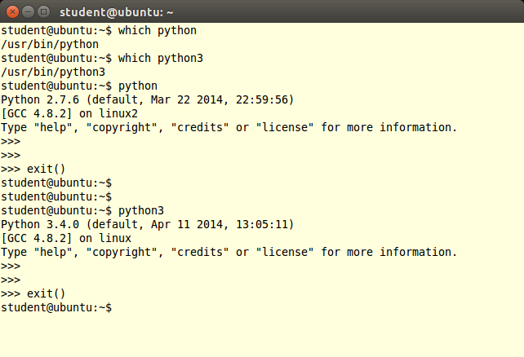
Figure 21
The first two commands (lines 1 and 3) ask which file contains the programs python and python3, respectively. In this case, both programs are present in the indicated files. If either had not been present, the command would have reported nothing.
In line 5, the python program is run. Its first action is to print a preamble announcing its version and other (possibly useful) information; in this case, it is Python 2.7.6. The exit() command following the traditional Python prompt of “>>>” merely tells Python 2.7.6 to finish what it is doing and to quit.
In line 14, the python3 program is run. You can see from its preamble that it is Python 3.4.0.9F
Note: Both Mac OS X and Linux come with Python 2.7 already installed for their own needs. That version of Python must not be deleted or disturbed when installing Python 3.4 and its packages.

Installing IDLE
Figure 21 applies to any version Linux from any distributor to determine whether or not Python is installed and, if so, what version it is.
The following is specific to Ubuntu Linux. Users of other Linux distributions should carry out similar actions on those distributions. Select and open the Ubuntu Software Center icon in the toolbar on the left of the Ubuntu desktop. In the upper right, enter the term “Python3” in the search box. A search should produce the results shown in the figure below.
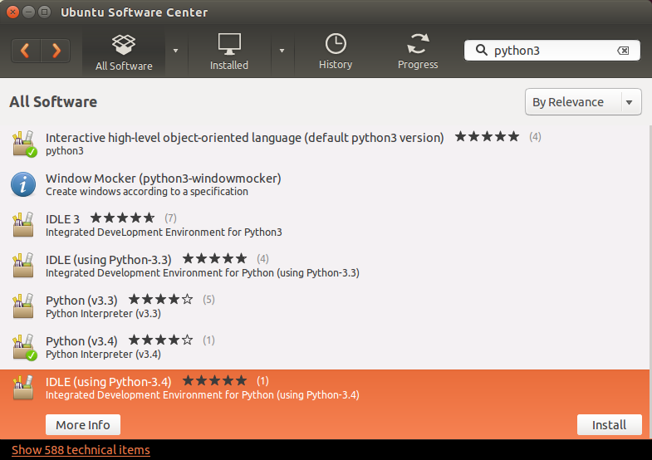
Figure 22
This shows that the Ubuntu Software Center knows about several versions of Python 3 and several versions of IDLE. The last line is highlighted and shows an Install button for “IDLE using Python 3.4). Click on this Install button to cause IDLE to be downloaded installed.
When the installation has completed, a new icon will have been added to the toolbar on the left, namely, the IDLE icon . IDLE has now been installed.

Testing your Linux installation of Python 3.4
Follow the same instructions as with Figure 11 in order to validate that you can run Python.

Installing numpy on Linux
In Ubuntu 14.04, open the Ubuntu Software Center again and search for the term “python3-numpy”. This will bring up one or more results, including the numpy package for Python 3.
Note: Be sure that you specified “python3” as part of the search term. Otherwise, the search will return information about numpy for Python 2.7.
Note2: If you use a different version of Linux, the search term in your software installation system should still be “python3-numpy.”
Select on the More Info button to bring up the following window:–
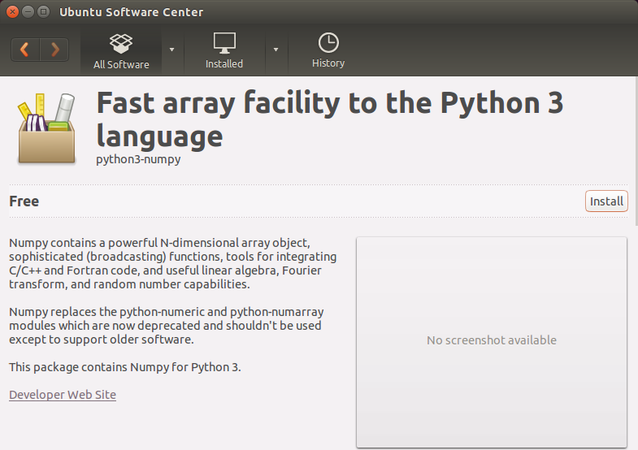
Figure 23
Although it does not specify which version of numpy is provided, click on the Install button to install it. It will automatically install any required dependencies. You do not need to select other options for this course.
Finally, open an IDLE window by clicking on the IDLE icon and carry out the tests of Figure 15. Results of these tests are shown in Figure 24 below. The version of numpy is 1.8.1, as indicated by line 5 of this window, but your version may be different
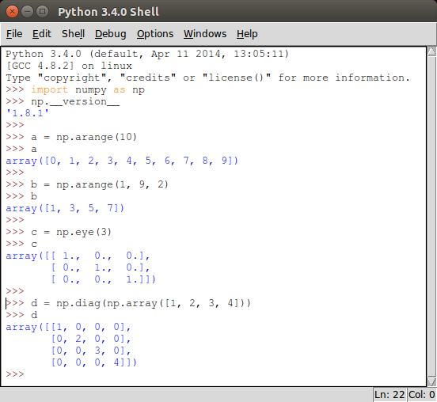
Figure 24

Installing matplotlib on Linux
To install matplotlib on your version of Linux, repeat the same steps as you used for numpy but search instead for “python3-matplotlib.” In Ubuntu , you would see the following:–
Figure 25
Install this, just as you installed numpy. To test your installation, carry out the tests of Figure 17 and of Figure 19. This should produce the IDLE window of Figure 26plots shown in those figures
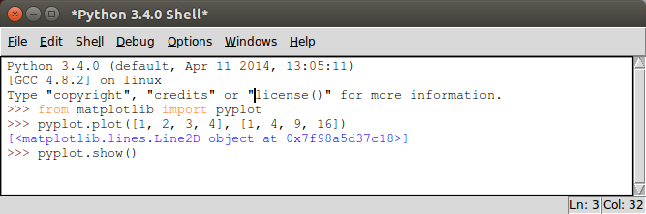
Figure 26

Conclusion
Congratuations! You have successfully used Python 3.4 as already installed and have added IDLE, numpy, and matplotlib.
If you are brave enough (and savvy enough) to use another distribution of Linux, good luck. The guidance here should help you get started. The official Python download page is at
https://www.python.org/download/
Source “tarballs” are available to compile for your own environment. Alternatively, a list of other Python distributors is also provided. Good luck!

© Copyright 2015, Hugh C. Lauer. All rights reserved. Permission is given for use in courses at Worcester Polytechnic Institute, Worcester, Massachusetts.
If you have a Windows computer or laptop, please refer to this documents instead:– docx, pdf
It is useful to print out the relevant section of this document. If you read it on-screen, the dialog boxes of the installation tend to obscure the instructions of the document, just when you need them the most!
These instructions have been tested on MacOS X 10.10.3 Yosemite. There may be slight differences with other versions of MacOS.
Note that the word “version” is preceded by two underscore characters and followed by two more underscore characters.
Note also that the word “arange” in several lines has only one ‘r’.
It is not clear whether up-to-date versions of Python are available for download on older releases of Ubuntu or other versions of Linux. If you have an older Linux and are not able to upgrade, please see the Professor or Teaching Assistants for advice.
The WPI Computer Science Department maintains a mirror distribution site for Ubuntu releases at http://ubuntu.cs.wpi.edu.
This is one minor release older than the versions that we have installed on Windows or the Macintosh. However, we will live with that difference for CS-1004.

