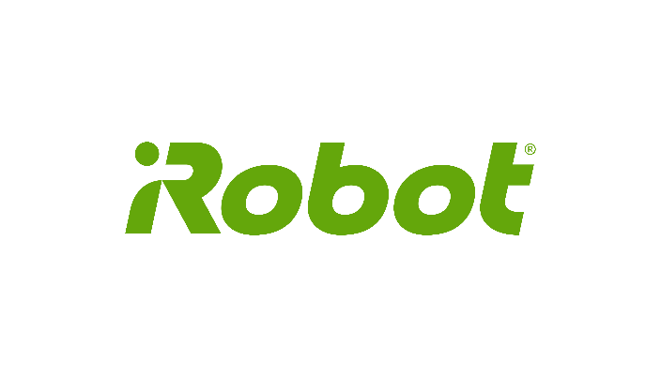

**iRobot Tech Talk/Info Session**

**November 10, 2017**

**WPI, Olin Hall, Room 107, 5:00- 6:30 p**

**Please join Jose Graziani, Consulting Engineer and   
Pat Higgins, Software Test Engineer**

**As they present an Information Session about**

**iRobot**

**and a Tech Talk on**

**The IoT and the Future of Home Robotics**

**With a Demo of the Roomba!!!**

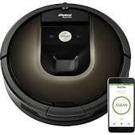

**Refreshments will be served**