Name_____________
CS5003
Homework #3

People talked to and URL’s consulted:

#1. a) Use the subset construction to convert the following NFA to a DFA. Show all work:

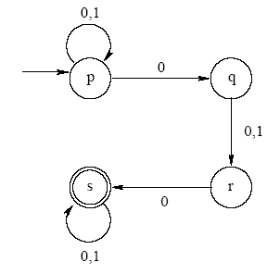

b) Use the subset construction to convert the following nfa to a dfa:

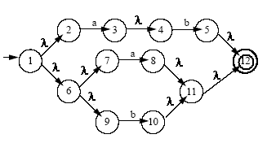

#2. Create the regular expression for the following automaton by eliminating states (show all steps!)

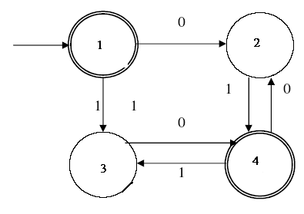

#3. a) Show that all finite languages are regular

b) Consider the operation g on three languages defined as:

g (L1,L2,L3) = L1 U L2 – (L3 ∩ ~L1)

Show that regular languages are closed under the g operation.

#4. Devise a method to show whether a regular language, L, is empty
Or not.

#5. Use the pumping lemma to show the following language is not regular:

{0^{n}1^{m} 0 ^{n+m} | n,m > 0}

