Homework #9

1. True or False

- Recursive languages are closed under complement TRUE FALSE
- Every language can be recognized by a Turing machine TRUE FALSE
- The membership question for recursive languages is decidable TRUE FALSE
- The membership question for context-free languages is decidable TRUE FALSE

#1 List 2 decidable problems about regular languages, 2 about context-free languages and 2 about recursive languages. Jot down how they might be decided.

#2. Prove that there is no algorithm that determines whether an arbitrary Turing machine halts when run with the input string 101.

Proof by contradiction
Assume such a Turing Machine does exist. Call it A:

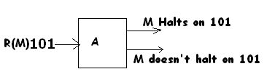

Create a Turing Machine N which produces the encoding of a Turing Machine M’.
M’ has all of M’s transitions, but some additional transitions to erase any input so that M’ runs M on an empty tape:

Note that M halts on a blank tape exactly when M’ halts on 101. This will decide the blank tape problem which is undecidable.

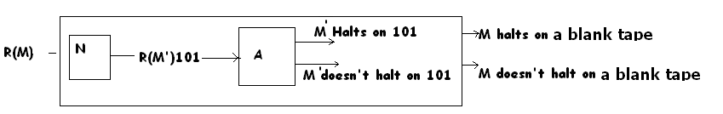

Can also reduce the Halting Problem:
Again assume, machine A exists:

To reduce HP to this, consider a TM N that converts R(M) w to R(M’)101 where M’ has all of M’s transitions except that there are extra transitions to replace 101 with w, return the tape head to the beginning and to the start state of M, (and then runs M)

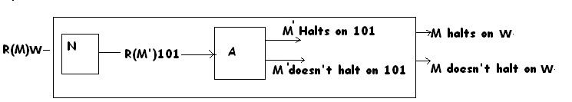

#3. List 2 undecidable problems about regular languages, 2 about context-free languages and 2 about r.e. languages. Provide a reference to the justification.
_
#4. Prove: L and L are recursively enumerable (re) if and only if L is recursive.
_
First: if L is recursive, L is recursive (just switch final and non-final states on L’s machine to get a machine for L. )
_
- If L is recursive, then L and L are re:
Proof
If L is recursive, ∃ a TM, M that accepts it, so L is re
By the above, if L is recursive, its complement is recursive and hence re
_
- If L and L are re, then their machines can be put together to form 1 machine
that both accepts and rejects. Thus L is recursive.

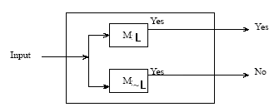

#5. Show that recursive languages are closed under union, intersection, complementation, concatenation, and *.

Can be shown by “putting together” Total TM’s:

Can be shown by “putting together” TM’s:

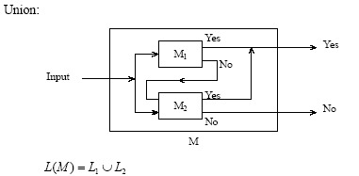

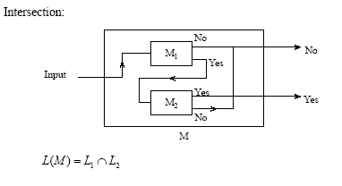
Complement:

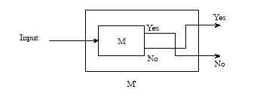
Rest are similar

#6. Show that re languages are closed under union, intersection, concatenation and *.

Similar to #5 except there are no “No” arrows.

#7. Show that re languages are not closed under complementation (hint: see #5)
_
If re languages were closed under complement, then both L and L would be re and hence recursive, making all re languages recursive which we know is not true.

