Name___________________

CS503 Homework #5

Worked with: _______________________

URL’s consulted: ______________________

#1. Show that the following languages are or are not context-free

- {w w^{R} w| w ε {a,b}* }

- {a^{i}b^{2i}c^{j} |i,j > 0}

- {a^{n}b^{n}a^{n} | n > 0}

- {x ε {0,1}*| #₀(x) = #₁(x)}

#2. For each of the following languages, show it is either a) regular, b) context-free, but not regular, c) not context-free

a) {a^{n}b^{m} | n = 2m}

b) {a^{n}b^{2m} | n, m > 0 }

c) {a^{n}b^{m} | n ≠ m}

#3. a) Use the subset construction to convert the following nfa to a dfa
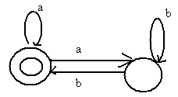

b) Give a regular expression for L(M)

#4. Prove: CFL’s are closed under union, concatenation and Kleene *

#5. Prove: CFL’s are not closed under intersection or complement

