Homework #5

1. (5 Points) True or False:
a) Regular Languages are always Context-Free Languages True False
b) Context Free Languages are always Regular Languages True False
c) The grammar S→ 0S |0S1S |ε is ambiguous True False
d) The language {a^{n}b^{n}c^{n}} is regular True False
e) The language {a^{n}b^{n}c^{n}} is context-free True False

2. (10 Points) Minimize the following dfa:

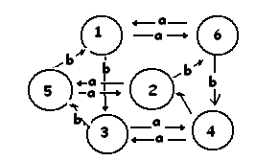

#3. (20 Points) a) Create a grammar that generates the set of all strings over {0,1} with an equal number of 0’s and 1’s Also b) construct a parse tree and c) leftmost
derivation of 0011. d) Is your grammar ambiguous? Why or why not?

#4. (5 Points) Find the Start symbol for the Java grammar shown at:
http://www.cse.psu.edu/~saraswat/cg428/lecture_notes/LJava2.html

#5. (10 Points) For the grammar G:
S → X Z Z X
X → x
X → ε
Z → z
Z → ε

What is L(G)?

#6. Post the CS applications of the following to the bb under Module 5:

- context-free grammars

(Don’t repeat anyone’s previous postings)

