Name_________________
CS503 Homework #3

People I talked to, urls I looked at:

#1. Consider the following nfa that will recognize both the keyword “if” and identifiers that consist of at least 1 letter:

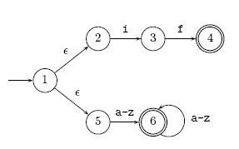

Use the subset construction to convert this nfa to a dfa:

Solution

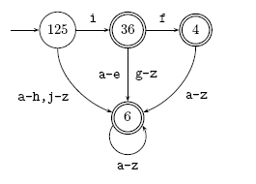
The problem here is that both f and i are in a-z so you need separate entries for
f, i, and {a-z} – {f,i} to get a deterministic machine.

#2. Create the regular expression for the following by eliminating states. Please eliminate r first, then s, then q:

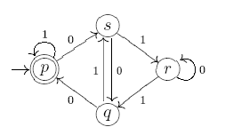

Solution

Eliminating r:

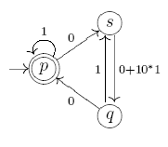

Eliminating s:

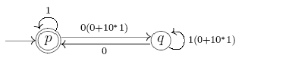

Eliminating q:

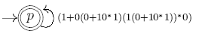

So L(M) = ( (1 + 0(0 + 10*1)(1(0 + 10*1))* 0 )*

#3. Consider the following operation -3 on regular languages L:

L⁻³ = {w | y w ε L and | y | =3}

Show regular languages are closed under the -3 operation.

Solution

A regular language L has a fa, M, such that L = l(M).

Add a new start state and λ-transitions to all states that are reachable by a path of length 3 from the original start state of M. This new nfa accepts L⁻³ .

#4. Show that it is decidable whether a regular language, L, contains 1000 strings or more.

If the dfa for L contains a cycle on a path from the initial to final state, then it accepts an infinite number of strings, so certainly accepts 1000 or more.

If there is no cycle from the initial to a final state, just count the number of paths from the initial to the various final states. If there are 1000 or more such paths, L contains 1000 strings or more. If there are fewer, then L does not accept 1000 strings or more.

#5 Use the pumping lemma to show
a) L = {w | w contains twice as many a’s as b’s} is not regular

Proof

Note that L ≠ { a^{2n}b^{n} | n > 0} !!!

If L were regular, then there is a dfa, M, with k states accepting L.

Pick z = a^{2k}b^{k}

Then, since z ε L and |z| > k, by the pumping lemma:

z = u v w with |u v| < k, length(v) >0 and uv^{i}w is also in L for all i > 0.

Because |u v| < k, u v is all a’s and since length(v) >0, v = a^{j} , some j.

When i = 2, we have the string: u v v w = a^{2k +j} b^{k}

which has more than twice as many a’s as b’s. Thus u v v w is not in L which is a contradiction.

Therefore the language is not regular.

b) L = {0^{n} | n is a power of 2}

Proof

If L were regular, then there is a dfa, M, with k states accepting L.
Pick z = 0^{m} where m = 2^{k}

Then, since |z| = 2^{k} > k, by the pumping lemma:

z = u v w with |u v| < k, length(v) >0 and uv^{i}w is also in L for all i > 0.

Since |u v| < k and length(v) >0, there are between 1 and k 0’s in v.

1 < |v| < k

So 2^{k} + 1 < |u v v w| < 2^{k} + k < 2^{k} + 2^{k} = 2^{k+1}

So u v v w has length between 2^{k} + 1 and 2^{k} + k.

So |uvvw| cannot be a power of 2 and thus uvvw is not in the language.
Therefore L is not regular.

