Name_________________
CS503 Homework #3

People I talked to, urls I looked at:

#1. Consider the following nfa that will recognize both the keyword “if” and identifiers that consist of at least 1 letter:

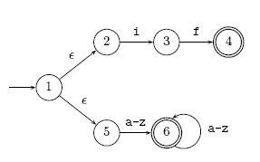

Use the subset construction to convert this nfa to a dfa:

#2. Create the regular expression for the following by eliminating states. Please eliminate r first, then s, then q:

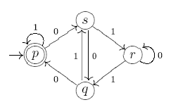

Eliminating s:

#3. Consider the following operation -3 on regular languages L:

L⁻³ = {w | y w ε L and | y | =3}

Show regular languages are closed under the -3 operation.

#4. Show that it is decidable whether a regular language, L, contains 1000 strings or more.

#5 Use the pumping lemma to show
a) L = {w | w contains twice as many a’s as b’s} is not regular

b) L = {0^{n} | n is a power of 2}

