Name________________________________

Homework #3
Solutions

#1. This is the NFA, M, from last Module’s homework

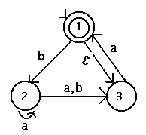
Show the regular expression for L(M) (You may work with this or the derived dfa – see Homework 2 solutions)

Eliminating State 2:
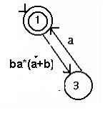
Eliminating State 3:

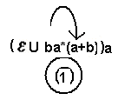

The regular expression from this is:

Regular expressions are not unique and if you did this a different way, you may have a different answer. There are techniques for simplifying regular expressions, but they are not worth the work involved!

#2.. Write a regular expression for strings composed of letters, digits, and underscores that begin with a Letter (denote it by L), end with a letter or digit (denote digit by D), and contain no consecutive underscores (denoted underscore by _ ).
One answer: L( _ (LUD) U (LUD) )*
#3. Create regular expressions for:
a) integers: 1 or more digits
digit digit*
b) decimals: they begin with 1 or more digits followed by a decimal point, “.” , followed by 0 or more digits
digit digit* . digit*
- reals: they consist of an integer or a decimal (see parts a and b) followed by an “E”, followed optionally by a “+” or “-“, followed by 0 or more digits

(digit digit* Udigit digit* . digit*) E (+ U – U ε) digit*

#4. Consider the following dfas:
M1:
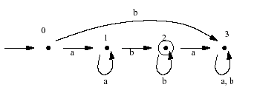
M2:
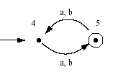

L(M1) = aa*bb*

L(M2) = (aUb) ((aUb) aUb))*

#5 Prove regular languages are closed under reversal (Hint: look at how closure was showed for complement)

Since we are given a regular language, there is a dfa that accepts it. Create 1 final state and an epsilon transition from all fnal states to this new single final state. Reverse the arrows to create an nfa. There is a path from ths start state of the orginla machine to its final state iff there is a path from the single final state to the (original start state in the reverse machine. This machine accepts L^{R}

