Name________________________________

Homework #3

#1. This is the NFA, M, from last Module’s homework

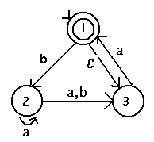
Show the regular expression for L(M) (You may work with this or the derived dfa – see Homework 2 solutions)

#2.. Write a regular expression for strings composed of letters, digits, and underscores that begin with a Letter (denote it by L), end with a letter or digit (denote digit by D), and contain no consecutive underscores (denoted underscore by _ ).
#3. Create regular expressions for:
a) integers: 1 or more digits

b) decimals: they begin with 1 or more digits followed by a decimal point, “.” , followed by 0 or more digits
- reals: they consist of an integer or a decimal (see parts a and b) followed by an “E”, followed optionally by a “+” or “-“, followed by 0 or more digits

#4. Consider the following dfas:
M1:
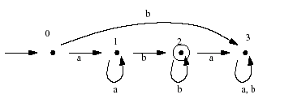
M2:
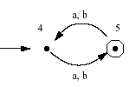

#5 Prove regular languages are closed under reversal (Hint: look at how closure was showed for complement)

