Name_______________________
Homework #2

People I worked with and URL’s of sites I visited:

#1. Convert to Chomsky Normal Form. Please follow the steps even if you can “see” the answer:

a) the expression grammar, G:
E → E + T | T
T → T * F |F
F → (E) |a

Recursive Start

E’ → E
E → E + T | T
T → T * F |F
F → (E) |a

No λ productions

Chain Rules

F → (E) | a ok
Change T → T * F |F to T → T * F | (E) | a
Change E → E + T | T to E → E + T | T * F | (E) | a
Change E’ → E to E’ → E + T | T * F | (E) | a

So have:
E’ → E + T | T * F | (E) | a
E → E + T | T * F | (E) | a
T → T * F | (E) | a
F → (E) | a

Useless

- All productions produce terminal strings
- All symbols reachable from S

Chomsky Normal Form

Introduce T_{a}, T₍, T₎, T₊, T*:

E’ → E T₊ T
E’ → T T* F
E’ → T₍E T₎
E’ → a
E → E T₊ T
E → T T* F
E → T₍E T₎
E → a
T → T T* F
T → T₍E T₎
T → a
F → T₍E T₎
F → a
T_{a} → a
T₍ → (
T₎→ )
T₊ → +
T*→ *

Introduce Intermediate variables: V_{1 ,}V_{2 ,}V_{3 ,}V_{4 ,}V_{5:}

E’ → T V₁
V₁ → E T₎
E’ → a
E → E V₂
V₂→ T₊ T
E → T V₃
V₃ → T* F
T → T₍V₄
E → a
V₄ → E T₎
T → a
F → T₍V₅
V₅ → E T₎
F → a
T_{a} → a
T₍ → (
T₎→ )
T₊ → +
T*→ *

b) S → A | A B a | A b A
A → A a | λ
B → B b | B C
C → C B | C A | b B

Recursive Start
none

Remove λ Productions

Null = {A, S}

C → C B | C A | b B
B → B b | B C
A → A a | a
S → A | A B a | A b A | B a | b A | A b | b | λ

or
S → A | A B a | A b A | B a | b A | A b | b | λ
A → A a | a
B → B b | B C
C → C B | C A | b B

Remove chain rules

S → A a | a | A B a | A b A | B a | b A | A b | b | λ
A → A a | a
B → B b | B C
C → C B | C A | b B

Remove useless

Term = {A, S}

so have:

S → A a | a | A b A | b A | A b | b | λ
A → A a | a

Reach = {S, A}
so above grammar is ok.

Chomsky Normal Form

Introduce new variables: T_{a}, T_{b}
S → A T_{a} | a | A T_{b} A | T_{b} A | A T_{b} | b | λ
A → A T_{a} | a
T_{a} → a
T_{b} → b

Introduce new variables: V₁
S → A T_{a} | a | A V₁ | T_{b} A | A T_{b} | b | λ
V₁ → T_{b} A
A → A T_{a} | a
T_{a} → a
T_{b} → b

#2. Show the following languages are regular by creating finite automata with L = L(M)

- Strings over {a,b} that contain 2 consecutive a’s

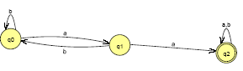

 | a | b
>q₀ | q₁ | q₀
q₁ | q₂ | q₀
*q₂ | q₂ | q₂

- Strings over {a,b} that do not contain 2 consecutive a’s

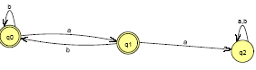
 | a | b
>*q₀ | q₁ | q₀
*q₁ | q₂ | q₀
q₂ | q₂ | q₂

- The set of strings over {0,1} which contain the substring 00 and the substring 11

Problem doesn’t say whether this must be a dfa and this is easier with an nfa:

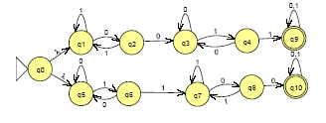

 | λ | 0 | 1
>q₀ | q₁ , q ₅
q₁ |  | q₂
q₂ |  | q₃ | q₁
q₃ |  | q₃ | q₄
q₄ |  | q₃ | q₉
q ₅ |  | q ₅ | q₆
q₆ |  | q ₅ | q₇
q₇ |  | q₈ | q₇
q₈ |  | q₁₀ | q₇
*q₉ |  | q₉ | q₉
*q₁₀ |  | q₁₀ | q₁₀

- The set of strings over {a,b} which do not contain the substring ab.

Similar to parts a and b, I will first create a fa that does accept a b and then I will reverse the final and the nonfinal states:

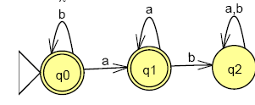

 | a | b
q₀ | q₁ | q₀
q₁ | q₁ | q₂
q₂ | q₂ | q₂

#3. Describe L(M) for the following nfa’s: a) in words and b) as a regular expression

a)

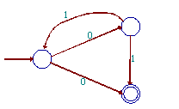
L(M) = Alternating 0’s and 1’s (including none) that begin with a 0
(01)* (01 U 0)

b)
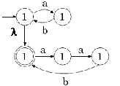

0 or more ab’s followed optionally by 0 or more aab’s
(ab)* (aab)*

#4. a) Create an NFA (with λ transitions) for all strings over {0, 1, 2} that are missing at least one symbol. For example, 00010, 1221,and 222 are all in L while 221012 is not in L.

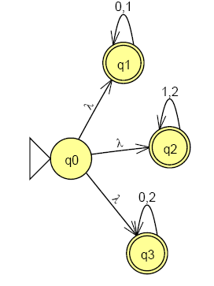

b) Given an NFA with several final states, show how to convert it into one with exactly one start state and exactly one final state.

Create a new initial state and a λ-transition from it to all the original start states
Create a new final state and a λ-transition from all the original final states (which mark to no longer be final) to this new final state

c) Suppose an NFA with k states accepts at least one string. Show that it accepts a string of length k-1 or less.

Look at a fa with 3 states:
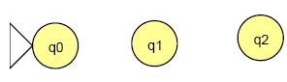
No matter how you draw the transitions or which states are final states, to process a string of length k means you visited a state twice. For example:

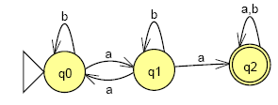

accepts the string of length 3: aba

But just by not visiting the revisited state (q₁), this will accept a a (of length 2)

In general, if a string of length k is accepted by a fa with k states, it visits (at least) 1 state twice. By not visiting this state the 2nd time (e.g., don’t take the loop), we can accept a string with 1 fewer symbol, i.e, of length k – 1.

d) Let L be a regular language. Show that the language consisting of all strings not in L is also regular.
If L is regular, there is a dfa, M, such that L = L(M), that is, M accepts L. If we create a new finite automaton, M’, by reversing final and non-final states, we will accept what M didn’t and reject what M accepted; that is, C(L) = L(M’)

#5. a) Consider the extended transition function, δ*, defined by:

δ *(q,λ) = q
δ * (q,wa) = δ (δ *(q,w),a)

- Show that δ*(q,a) = δ(q,a) (follows from the definition)

δ * (q,a) = δ (δ *(q,λ),a) = δ (q,a)

- Show that δ*(q, uv) = δ* (δ*(q,u),v) (use induction)

Proof by induction on |v|

Basis When |v| = 0, v = λ, and
left-hand-side: δ*(q, uλ) = δ*(q, u) (Property of λ)
right-hand-side: δ* ( δ*(q,u), λ) = δ*(q, u) (Definition of δ*)

Induction Hypothesis

δ*(q, uv) = δ* ( δ*(q,u),v) for 0 < |v| < n

Induction Step: To show δ*(q, uv) = δ* ( δ*(q,u),v) for |v| = n + 1:

Since |v|= n + 1, and n > 0, v an be written wa where |w|= n and a ε Σ *

left-hand-side: δ*(q, uv) = δ*(q, u (wa)) substituting wa for v
= δ*(q, (uw) a ) associativity of concatenation
= δ (δ*(q, uw), a) definition of δ*
= δ (δ*(δ*(q,u),w),a) IH
= δ*(δ*(q,u),wa) definition of δ*
= δ*(δ*(q,u) v) v = wa
= right-hand-side

- Show that δ*(q,aw) = δ*( δ(q,a),w) (follows from above)

Considering symbol “a” as a string:

δ*(q, aw) = δ* ( δ*(q,a),w) by part b
= δ* ( δ(q,a),w) by part a

