Homework #2

#1. Convert the following NFA to a DFA and informally describe the language it accepts.

 | 0 | 1
→p | {p,q} | {p}
q | {r,s} | {t}
r | {p,r} | {t}
*s | ∅ | ∅
*t | ∅ | ∅

DFA | 0 | 1
→{p} | {p,q} | {p}
{p,q} | {p,q,r,s} | {p,t}
{p,q,r,s} | {p,q,r,s} | {p,t}
*{p,t} | {p,q} | {p}

What is L(M)? Not easy to see. It looks like final states can only be reached with strings ending in “00” or “01”. Hard to see if there are restrictions on the front of the strings. So it looks like L(M) = (0 U 1)* (00 U 01) (Best to draw graph)
#2. Give an NFA over {0,1} that accepts the set of strings that contain an even number of substrings 01.
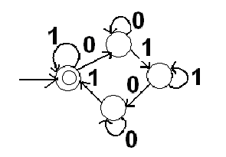

#3. Create nfa to:
- accept strings beginning with a letter (use l for letter) followed by any number
of letters or digits (use d for digit)
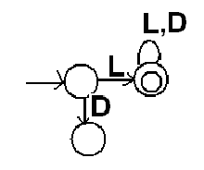
- accept strings of 1 or more digits (use d for digit).
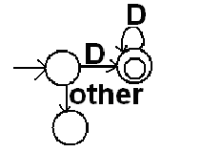
- accept either of the languages from part a and part b (use ε-transitions)

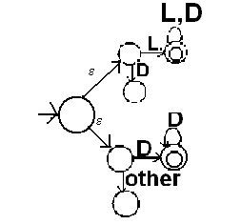
#4. Add states to accept the keyword “while” to the nfa in 3c.
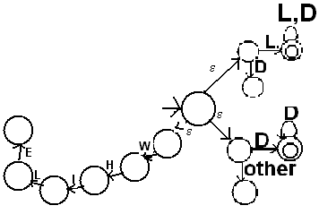

#5. Consider the following dfa’s over {a,b}. The start state of M1
is 1 and the start state of M2 is 1_ .
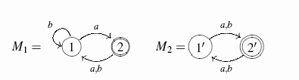
Use the product construction to produce dfa’s accepting a) the intersection and b) the union of the sets accepted by these automata.

- Intersection:
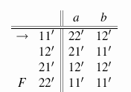

- Union: change the set of accepting states to be {12’, 21’, 22’}

