Homework #2

#1. (10 Points) Convert the following NFA to a DFA and informally describe the language it accepts.

 | 0 | 1
→p | {p,q} | {p}
q | {r,s} | {t}
r | {p,r} | {t}
*s | ∅ | ∅
*t | ∅ | ∅

#2. (10 Points) Show an NFA over {0,1} that accepts the set of strings that contain an even number of substrings 01.
#3. (9 Points) Create nfa to:
- accept strings beginning with a letter (use l for letter) followed by any number
of letters or digits (use d for digit)

- accept strings of 1 or more digits (use d for digit).

- accept either of the languages from part a and part b (use ε-transitions)

#4. (11 Points) Add states to accept the keyword “while” to the nfa in 3c.

#5. (10 Points) Consider the following dfa’s over {a,b}. The start state of M1
is 1 and the start state of M2 is 1_ .
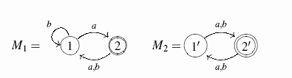
Use the product construction to produce dfa’s accepting a) the intersection and b) the union of the sets accepted by these automata.

#6. (Best ones will be posted to the bb) Name some applications in Computer Science or the world of:

- Regular Sets
- Non-deterministic Finite Automata

