Homework #1 Solutions

True or False:

a) Given a language (set of strings) L, the question: “Is string w ε L” is a decision problem: T F
b) Φ = {ε} T F
c) For sets A and C. ~ (A U C) = ~ A U ~ C T F
d) There is only 1 dfa that accepts a* T F
e) Given an alphabet Σ and a regular language L ⊆ Σ*, the strings in L’ = Σ* - L form a regular language T F

Proofs:

#2. Given that an integer n is even if there is an integer i such that n = 2 * i and an integer n is odd if there is an integer i such that n = 2 * i + 1, prove that for every integer n>0, n is either even or odd, but not both.

Solution

There are actually 2 things to prove: 1) an integer must be one of {even,odd} and
2) a number cannot be both even and odd.

- All numbers n can be written as n = 2q + r for 0 ≤ r ≤ 2
So r must be 0 or 1.
If r is 0 then n = 2q (i.e., n is even).
If r is 1, then n = 2 q + 1 (i.e., n is odd)

- If n is both even and odd, then
n = 2i
and n = 2j + 1

Then we have 2i = 2 j + 1
Case 1) i =j : then 0 = 1 (impossiblej
Case 2) i ≠ j: then (dividing by 2) i = j + ½ (impossible)

Therefore, an integer n must be even or odd, but not both

#3. Given an alphabet Σ, and a string x in Σ *, define the reversal of x, denoted x^{R} as:

- If length(x) = 0, then x = ε and ε^{R} = ε
- If length(x) = n>0, then x = wa for some string w with length n – 1 and some a in Σ, and x^{R} = aw^{R}.

Using this definition, the definition of concatenation and associativity, prove by induction that: (xy) ^{R} = y^{R}x^{R}.

Proof by induction on |y|

Basis:
Left:
if |y| = 0, then (xy) ^{R} = (xε) ^{R} = x ^{R}

Right:
if |y| = 0, then y ^{R} x ^{R} = ε ^{R} x ^{R} = εx ^{R} = x ^{R}

Induction Hypothesis: (xy)^{R} =, when 0 <|y| < n, n > 0
Induction Step:

If |y| = n + 1, then y = wa, where a ε Σ and |w| = n

(xy) ^{R} = (x (wa)) ^{R} where y = wa, |w| = n,
= ((xw) a) ^{R} associativity
= a(xw)^{R} def’n of reversal
= a(w ^{R}x ^{R}) induction hypothesis
= (aw ^{R})x ^{R} associativity
= (wa) ^{R} x ^{R} definition of reversal
= y ^{R} x ^{R} substitution of y for wa

#4. Disprove: All WPI computer science professors are men.

Proof by counterexample (me)

DFA’s

#5. What set of strings does the following automaton accept?

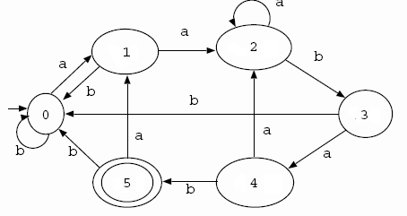

Strings of a’s and b’s that end in a a b a b:
(a + b)* a a b a b

#6. Create a DFA that accepts an odd number of a’s

