Homework #1

#1 (10 Points) True or False:

a) Given a language (set of strings) L, the question: “Is string w ε L” is a decision problem: T F
b) Φ = {ε} T F
c) For sets A and C. ~ (A U C) = ~ A U ~ C T F
d) There is only 1 dfa that accepts a* T F
e) Given an alphabet Σ and a regular language L ⊆ Σ*, the strings in L’ = Σ* - L form a regular language T F

Proofs:

#2. (10 Points) Given that an integer n is even if there is an integer i such that n = 2 * i and an integer n is odd if there is an integer i such that n = 2 * i + 1, prove that for every integer n>0, n is either even or odd, but not both.

#3. (10 points) Given an alphabet Σ, and a string x in Σ *, define the reversal of x, denoted x^{R} as:

- If length(x) = 0, then x = ε and ε^{R} = ε
- If length(x) = n>0, then x = wa for some string w with length n – 1 and some a in Σ, and x^{R} = aw^{R}.

Using this definition, the definition of concatenation and associativity, prove by induction that: (xy) ^{R} = y^{R}x^{R}.

#4. (5 Points) Disprove: All WPI computer science professors are men.

DFA’s

#5. (5 Points) What set of strings does the following automaton accept?

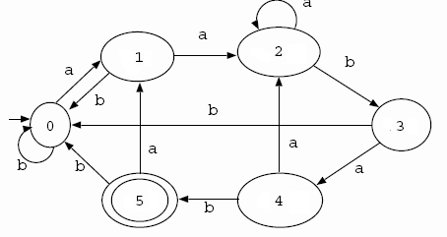

#6. (10 Points) Create a DFA that accepts an odd number of a’s

#7. (Best ones will be posted to the bb) Give applications in Computer Science or in the world that use

- strings
- languages
- regular sets
- finite automata
- proofs

