Comp 409
Test #1

Thursday, September 25, 2002

#1. Scanning is (Choose one)

- Tractable
- Intractable
- NP-Complete

a is the correct answer. Scanning is linear in the size of the input file.

#2. Show a regular expression for strings of a’s followed by b’s followed by c’s. It is possible there are no a’s, b’s, or c’s.

Answer:
a*b*c*

#3. Show a lex file which will generate a scanner to find identifiers composed of letters, digits, and underscores that begins with a letter , ends with a letter or digit, and contains no consecutive underscores

One possible Solution:

%{ #include <stdio.h>

%}

DIGIT [0-9]
LETTER [a-zA-Z]
UNDERSCORE "_"

%%
{LETTER}({LETTER}|{DIGIT})*({UNDERSCORE}({LETTER}|{DIGIT})+)*
printf("identifier\n");
. printf("other\n");
%%

#4. Convert the following nfa to a dfa. Redraw the graph when you are done.

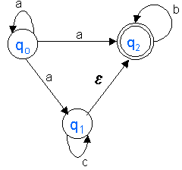

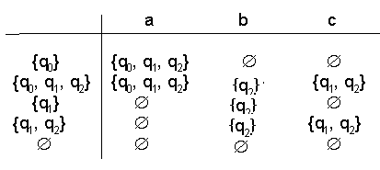
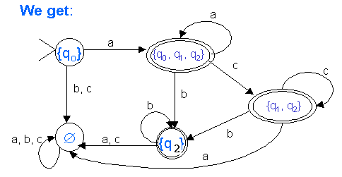

#5. Convert the following dfa to a minimal dfa. Redraw the graph when you are done.

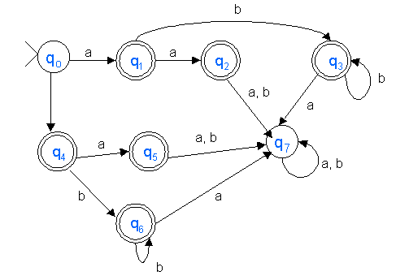
Separating final from nonfinal states and noticing that q₀ and q₇ go to different partitions (2 steps here)

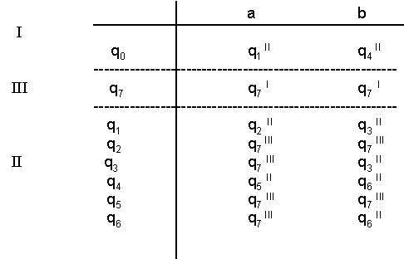
Looking at partition II, we see that states q₁ and q₅ are the same
(look at the partition they go to on each input). Similarly, q₂ and
q₄ are the same, and q₃ and q₆ are the same.

So we have:



