MAZETOOL 2.0: A simple game for analysis
Access the game at this URL (Chrome or Firefox urgently recommended):
http://users.wpi.edu/~bmoriarty/imgd2905/mazetool/cover.html
Mazetool is a simple maze run played on randomly generated perfect mazes.
A perfect maze has no loops and no inaccessible locations. Any two locations are connected by a single path.
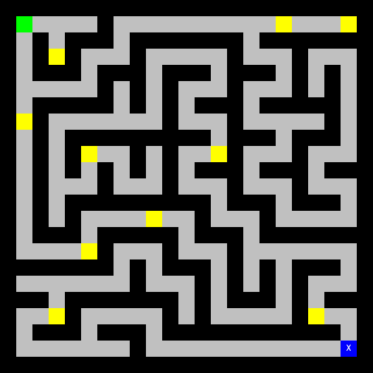
Each maze contains an actor in the top left corner (the green box), an exit in the bottom right corner (the blue box marked with an X), and ten gold pieces which are randomly distributed.
When you click on the cover page to open the game, an input box at the top of the screen prompts you to input your WPI username (no @wpi.edu suffix required). NOTE: Only students/instructors participating in IMGD-2905 can use this app.
If you have previously saved a maze, it is automatically reloaded at startup.
The game begins in edit mode. If you click on the actor, the exit or a gold piece, that object is “picked up” and sticks to your cursor. You can then move it by clicking on any unoccupied floor space. NOTE: None of the control buttons can be pressed while you’re “holding” a map object.
While in Edit mode, you can save your maze design by pressing the Save button. Once a game has been saved, the Load button can be pressed anytime to reload that maze and return to Edit mode. (Sorry, only one save slot is supported in this version.)
When you’re satisfied with your maze design, press the Play button to play.
Uh oh! The exit disappeared. You must collect all ten gold pieces to reveal it again. Then click on the exit to escape with your loot.
When you reach the exit, an Excel spreadsheet is automatically emailed to your WPI email address. This spreadsheet contains a complete record of every event that happened during gameplay. See below for details.
Press the Reset button at any time to reset the current maze to its initial state, and return to Edit mode.
Press the Random button at any time to generate a new random maze, and return to Edit mode.

time | click | gold | exit
00:03.0 | 0
00:13.6 |  | 1
00:14.0 | 106
00:21.3 |  | 2
00:21.6 | 180
00:23.4 |  | 3
00:23.7 | 198
00:25.7 |  | 4
00:26.0 | 218
00:27.0 |  | 5
00:28.4 | 228
00:30.8 |  | 6
00:31.1 | 252
00:35.3 |  | 7
00:35.6 | 294
00:36.4 |  | 8
00:37.7 | 302
00:55.5 |  | 9
00:55.9 | 480
01:00.7 |  | 10
01:01.9 | 528
01:08.1 |  |  | 590

Looking at the data
Your gameplay data should appear in neatly formatted rows and columns. Three types of game events are recorded: Mouse clicks, gold grabs, and reaching the exit.
The time column indicates the time of each game event (in minutes, seconds and milliseconds), beginning with the first mouse click.
The click column shows the moment of each mouse click. The value indicates the total number of path spaces traversed by the player up to that moment.
The gold column shows the moment each piece of gold was grabbed, numbered in sequence.
The exit column shows the moment the exit was reached. The value indicates the total number of path spaces traversed over the course of the game.

