Tuesday April 1st: Group Meetings in Class
Your first task is G.Analysis (which is due Tuesday April 8th). You should immediately begin to develop a set of use cases to describe how your component is involved in the larger task.

In today’s class, there should be pairs of groups. Specifically:

<UserManager, UserManagerGUI> 2 pairs
<TableManager, TableManagerGUI> 2 pairs
<GameManager, GameManagerGUI> 2 pairs
<DatabaseManager, DatabaseManager> 1 pair
<PluginManager, PluginManager> 1 pair
<AdminGUI> on your own
<CAPTCHA> 1 pair

While there are different types of components, in general there are some common tasks that will form the basis for G.Analysis. First, you are to determine the classes that you will need for your component, and divide them into:

- Entity – The essential classes to store information needed by your component
- Boundary – Typically the Component itself is the boundary with the rest of the system, in that commands and requests are the means of communication. Note that GUI components have other boundary classes that are graphical in nature. Also, Database component will have its own interface to deal with persistent storage. Finally, CAPTCHA is more-or-less fully encapsulated functionality, so some boundaries will be with the user.
- Controller – How your individual components react to commands and requests. Indeed, you should be able to “slice” your components into individual parts that directly correlate to the way in which it will either process a command (for server components) or requests (for client components).

Server Components: UserManager, TableManager, PluginManager, GameManager

Your task is to begin to determine the commands for which you are responsible. Note that you will need to coordinate these commands with the respective GUI group which will be sending the command to you. Then you need to consider the Entity classes you will need to store the proper information. Note that you will write “controllers” to process the commands and in response generate requests to be sent back to the originating client as well as other clients who may be logged in. The biggest challenge you have is to decide the PROTOCOL that will happen when a command is received. You should begin to think about that.

Note in the RAD I had only sketched out your interaction with the database component. The ideas I present here may seem to contradict some of the material in the RAD, so pay attention!

For components that require persistent storage (UM, TM, GM) you will need to work out the separation between your classes and the interfaces by which you communicate to the database. As an example, the UserManager would likely need to deal with password change requests. A database-centric version would force the Database to be involved in all such decisions and essentially take over much of the core classes that would be found in the individual components. This would overly complicate the databasemanager group. Instead, I am aiming for a component-centric version. Thus, for this example, the UserManager component would have a User class that would implement an interface IUser (to be agreed upon by both User Manager groups and the professor). Now, the database manager would offer the following method in its IUM_DB interface:
void updateUser (IUser user) throws Exception;
and it is the responsibility of the DatabaseManager to persistently store the information as contained in the User Manager’s user object when viewed solely through the lens of IUser.

To continue this logic, IUM_DB will presumably have a method:

IUser getUser (String name) throws Exception;
Now the object which DatabaseManager returns is going to be from a class that it has chosen to implement the IUser interface. From the User Manager’s point of view, this object is read only, and likely you will have to some work to construct an object of your own choice which you can mutate at will. I am intrigued to see what you will do.

Client Components: UserManagerGUI, TableManagerGUI, PluginManagerGUI, GameManagerGUI, AdminGUI

Your task is to begin to sketch out your GUI interface. In your final Analysis document, I don’t want to see full information regarding each and every GUI element (i.e., Labels, buttons, scrollbars). Rather, you should focus on the following two tasks:

- What commands are to be generated by your component and how are you going to get the necessary information from the user to do this?
- What requests are you expecting to receive from the server in response to these commands. Note that you will need to communicate these needs to the server groups

There will need to be a clear protocol defined between the paired groups of [C] and [S] components. That is, UserManagerGUI must know the requests that are going to be generated by UserManager in response to a command, and UserManager must know the set of requests that it is going to generate in response to a command from the UserManagerGUI. How is this to be worked out? Well, the teams are going to have to agree upon interfaces (April-8th) and this includes the protocol. We will have sufficient class time to be able to work these out.

Database Manager Components:

Your task is to begin to think about the way that you will need to store information for the different components. Try to develop some schemas. Perhaps start with the user manager since that is written up in the RAD. You will be responsible for storing information for UserManager, PluginManager, and GameManager.

You will need to open up a communication dialog with these groups to ensure that all of their specific information is to be stored in the database.

Note that there are still TWO groups, so each group will have its own database and its own code to properly manage that database. The only thing that is intentionally to be in common between the two groups is the set of interfaces that are to be provided (in particular, IUM_DB, IPM_DB, IGM_DB).

Note that your component is totally unaware of the command and request infrastructure that other groups are using to communicate from client to server. Review the details above regarding the interaction example between UserManager and the DatabaseManager

Plugin Manager Components:

Your task is to identify what persistent information you will expect to store on disk and in what format the solitaire variations are to be stored. For now, consider that a solitaire variation is going to be packaged as a JAR file. You will need to work with AdminGUI to determine what commands you need to deal with regarding installing and uninstalling solitaire variations.

CAPTCHA:

You’re different. Your CAPTCHA! You have both server-side responsibilities as well as client-side responsibilities. Make sure that you understand the commands and requests that only you are going to be paying attention to, since your communication channel will be entirely separate from the rest of the other server-side components.

Nonetheless, there will need to be some communication between you and the DatabaseManager group because only you are capable (from your server-side component) of creating a user account. I note that this communication path is not part of the RAD document and that will need to be addressed later.

I also want to have “moving CAPTCHAs”. That is, instead of just having a GIF file that has warped text in some way, I’d like you to try to envision an image that is sent (in some piecemeal fashion) to the client and then reassembled dynamically so the user can at times see that there is a word or image or picture or something there. And then the user is going to have to type in some CAPTCHA phrase to match the picture image.
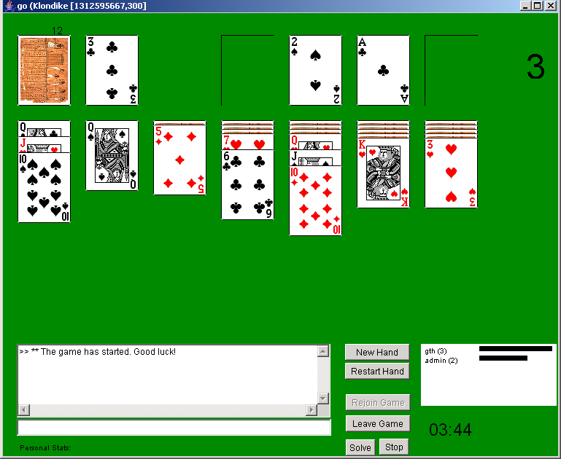
Client IPC
Message Bus
TableMgr
GUI
UserMgr
GUI
Room
GUI
GameMgr
GUI
GameWindow
Be creative!

Server IPC
Message Bus
Table Mgr
User Mgr
Plugin Mgr
DB
Game Mgr
DB Mgr
CAPTCHA
Phrases
CAPTCHA
Images
Server IPC
Client IPC
CAPTCHA
GUI
CAPTCHA
Server
Admin IPC
Plugin
Repository
Message Bus
User Mgr
Plugin Mgr
Admin
GUI
Client IPC

