CS2102 B2005 Exam #3 NAME _______________

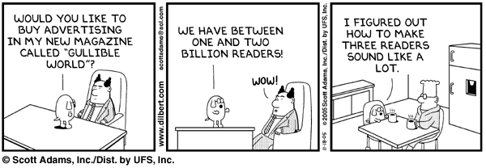
Q1. [16 points] There are at least four logical errors in the following code. Circle them and provide a brief explanation of why they are errors. The code is supposed to output the string "4S equals 8S is false" but instead, it outputs "Card@45a877 equals Card@1372a1a is false".
public class Card {
static int rank; // in the range 1..13
static int suit; // Club=1, Diamond=2, Heart=3, Spade=4

public Card(int r, int s) {
rank = r;
suit = s;
}

public String tostring() {
String suits = "CDHS";
return "" + rank + suits.charAt(suit);
}

public boolean equals (Object o) {
if (o == null) return false;
if (o.getClass() == getClass()) return false;

Card c = (Card) o;
return (rank == c.rank) && (suit == c.suit);
}
}

public class MC {
public static void main (String[] args) {
Card c = new Card (4, 4); // 4 of Spades
Card c2 = new Card (4, 8); // 8 of Spades

System.out.println (c + " equals " + c2 + " is " + c.equals(c2));
}
}

Q2. [2 points] Fill in this Dilbert cartoon. Extra points if I fall out of my chair laughing.
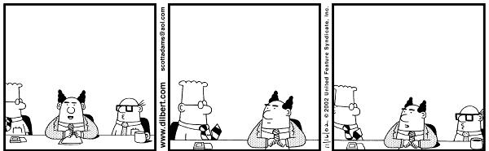
Q3. [10 points] You are given the following proposal. Explain whether you support this proposal and give your reasons.
Change the class java.lang.Object so that it implements the java.lang.Comparable interface. By doing so, java.lang.Object will provide an int compareTo(Object o) method for all classes.
Recall that the java.lang.Comparable interface is defined as follows:
public interface java.lang.Comparable {
// @return a negative integer, zero, or a positive integer if this
// object is <, =, or > than the specified object.
// @throws ClassCastException if the specified object's type
// prevents it from being compared to this Object.
public int compareTo (Object o);
}
I do not support this proposal
If java.lang.Object implemented this interface, then it would have to provide some default implementation (otherwise it would then have to be an abstract class). But there is no means for a “generic” object to be compared (numerically) with another “generic” object.
Yet, assume you still persisted, then java.lang.Object would be fully abstract and then each Java class (regardless of its functionality) would have to provide an implementation of compareTo, since java class derives from java.lang.Object. How would this method be implemented, for example, for Table or StringIterator? In short, there are classes from which objects can be instantiated but cannot be easily compared with each other.
In addition, having such a method by default would open the door to strange invocations by programmers to compare, say, a String with a Table.
Q3. [25 points] Design a class that maintains information about a Table. Each Table has a maximum size that declares how many people can sit at that Table. A Table stores the names of the people sitting at the Table.
Your Table class must define the following public methods and throw an Exception when appropriate.
- Table (int size) – constructor
- void add (String person) – add a person by name
- int count() – return # of people at the table
- boolean isFull() – return whether table is full
- String toString() – return String containing names of
people at the table, separated by spaces
public class Table {
// people & total
String []people;
int total;
public Table (int size) throws Exception {
if (sz < 1) throw new Exception (“size < 1”);
people = new String[size];
total = 0;
}
public void add (String name) throws Exception {
if (isFull()) throw new Exception (“Table is full.”);
people[total++] = name;
}
public int count () {
return total;
}
public String toString () {
String ret = "";
for (String s : people) {
if (s != null) {
ret += s + " ";
}
}
return ret;
}
public boolean isFull() {
return total >= people.length;
}
}

Q4. [25 points] Define a class StringIterator that conforms to the java.util.Iterator interface and enables you to iterate over each character in a given String object, exactly once, from left to right. As a reminder, the class type java.lang.Character corresponds to the primitive type char.
package exam3;
import java.util.Iterator;
import java.util.NoSuchElementException;
public class StringIterator implements Iterator<Character> {
// String and pos.
int pos = 0;
String string;
public StringIterator (String s) {
this.string = s;
}
public boolean hasNext() {
return (string != null) && (pos < string.length());
}
public Character next() {
if (hasNext()) {
return string.charAt(pos++);
}
throw new NoSuchElementException ("StringIterator invalid next.");
}
public void remove() {
throw new UnsupportedOperationException("remove invalid.");
}
}
Q5. [24 points] This question tests your knowledge of Generics and some advanced Java syntax topics. There are four independent parts:
- [6 pts] Write the Java statement(s) that (1) define a variable x to reference an ArrayList of String objects; and (2) instantiates an empty ArrayList of String objects that x will reference.
ArrayList<String> x = new ArrayList<String>();
- [6 pts] Write a method called convert that takes an ArrayList of Point objects p and returns an ArrayList of String objects where the i^{th} String object is the result of calling toString() on the i^{th} Point object stored by p.
public ArrayList<String> convert(ArrayList<Point> p) {
ArrayList<String> al = new ArrayList<String>();
for (Point pt : p) {
al.add(p.toString());
}
return al;
}
- [6 pts] Describe the purpose of the java.lang.Iterable interface:
public interface Iterable<T> {
public Iterator<T> iterator();
}
The Iterable interface defines functionality that enables a class to tell the world that it is capable of generating an Iterator using the standard ‘iterator()’ method. This feature is used by the enhanced-for loop since the syntax “for (Type t : x)” is only valid if x is an Array or implements Iterable
- [6 pts] Assuming variable ar references an array of int values, write an enhanced-for loop that is equivalent to the following code:
int ct = 0;
for (int i = 0; i < ar.length; i++) {
ct += ar[i]*ar[i];
}
int ct = 0
for (int x : ar) {
ct += x * x;
}

