CS2102 B2005 Exam #1 NAME _______________


Q1. [16 points] This question tests your basic knowledge of the Java for statement. Convert the following sequence of statements into a for statement where the invocation of System.out.println only appears once.
System.out.println (64);
System.out.println (36);
System.out.println (16);
System.out.println (4);
System.out.println (0);
Q2. [20 points] Please circle either TRUE or FALSE for each statement.
(a) [TRUE / FALSE] | To instantiate an array of 8 boolean values use the Java statement:  boolean [] ba = new boolean(8);
(b) [TRUE / FALSE] | To overload a method, a programmer simply declares that a method can throw an Exception
(c) [TRUE / FALSE] | Assuming that d is a variable of type double, while i is a variable of type int, the following statement is valid:  i = d;
(d) [TRUE / FALSE]
  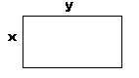 | Given a rectangle with int sides x and y as shown, the perimeter is calculated by the Java statement:  int p = 2*x+y;
Q3. [20 points] There are at least five logical errors in the following code that compiles successfully. The code is supposed to read in two numbers and then print them out in increasing order. Instead, after following the instructions given by the prompt, the program throws an Exception and terminates with no output. Circle where the error(s) occur in the code.
import java.util.Scanner;
public class Test {
static int []list;
static int tmp;
static void order (int a, int b) {
if (list[a] > list[b])
tmp = list[a];
list[a] = list[b];
list[b] = tmp;
}
public static void main (String []args) {
Scanner sc = new Scanner (System.in);
System.out.println ("Enter two numbers separated by commas");
int []list = new int [2];
int low = 1;
int high = 2;
list[low] = sc.nextInt();
list[high] = sc.nextInt();
order (low, high);
System.out.println (list[0] + list[1] + " are increasing.");
}
}

Q4. [20 points] Given the following code, fill in the diagram with appropriate references. Show all objects, variables (static, instance, and local) and parameters including values or references as appropriate. Note that the program is stopped at the comment.

public class Value {
public int x;
Value next;
public Value (int x) {
this.x = x;
next = null;
}
}
public class Sample {
static Value inspect (Value p) {
if (p.x < 5) {
return p;
}
return null;
}

static void update (Value x, Value y) {
x.next = inspect(y);

// STOP AND DRAW HERE.
}

public static void main (String args[]) {
Value p = new Value (5);
Value q = new Value (3);

update (p, q);
}
}

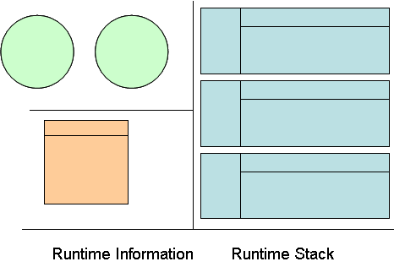

Q5. [2 points] Fill in this Dilbert cartoon. Extra points if I fall out of my chair laughing.

public class List {
Node head;
public List () {
head = null;
}
}

public class Node {
int x;
Node next;
public Node (int x) {
this.x = x;
next = null;
}
}

Q6. Design an append method for the List class that maintains an ordered list of int values (always appending to the end) but ensures that an Exception is thrown if one tries to append an int already in the list.
(a) [6 points] Write the declaration for append.
(b) [8 points] Write the method implementation for append.
(c) [8 points] Describe in English the test cases for append.

