CS585: Big Data Management
(MongoDB Project 2)
(Done in teams)

Total Points: 100 (10 each question)
Release Date: 04/14/2017
Due Date: 04/29/2017 (midnight 11:59pm )

References: Lecture notes & MongoDB Manual

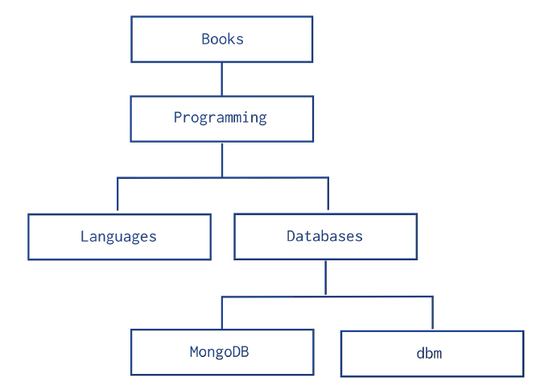
Figure 1: Tree Structure Relationships

Question 1

1) Assume we model the records and relationships in Figure 1 using the Parent-Referencing model (Slide 49 in MongoDB-2). Write a query to report the ancestors of “MongoDB”. The output should be an array containing values [{Name: “Databases”, Level: 1},
{Name: “Programming”, Level: 2},
{Name: “Books”, Level: 3}]

* Note: “Level” is the distance from “MongoDB” node to the other node. It should be computed in your code

2) Assume we model the records and relationships in Figure 1 using the Parent-Referencing model (Slide 49 in MongoDB-2). You are given only the root node, i.e., _id = “Books”, write a query that reports the height of the tree. (It should be 4 in our case).

3) Assume we model the records and relationships in Figure 1 using the Child-Referencing model (Slide 54 in MongoDB-2). Write a query to report the parent of “dbm”.

4) Assume we model the records and relationships in Figure 1 using the Child-Referencing model (Slide 54 in MongoDB-2). Write a query to report the descendants of “Books”. The output should be an array containing values [“Programming”, “Languages”, “Databases”, “MongoDB”, “dbm”]

5) Assume we model the records and relationships in Figure 1 using the Child-Referencing model (Slide 54 in MongoDB-2). Write a query to report the siblings “Databases”.

Question 2

As you did in MongoDB Project 1, Create a collection named “test”, and insert into this collection the documents found in this link (10 documents): http://docs.mongodb.org/manual/reference/bios-example-collection/

1) Write an aggregation query that groups by the award name, i.e., the “award” field inside the “awards” array, and reports the count of each award. (Use Map-Reduce mechanism)

2) Write an aggregation query that groups by the birth year, i.e., the year within the “birth” field, are report an array of _ids for each birth year. (Use Aggregate mechanism)

3) Report the document with the smallest and largest _ids. You first need to find the values of the smallest and largest, and then report their documents.

4) Use the $text operator to search for and report all documents containing “Turing Award” as one sentence (not separate keywords).

5) Use the $text operator to search for and report all documents containing either “Turing” or “National Medal”.

Submission Mechanism
Submit all your statements in a single text file electronically using blackboard system.

