CS585: Big Data Management

Project 3

Total Points: 100

Release Date: 03/06/2017

Due Date: 03/21/2017 (11:59PM)

Teams: Project to be done in teams of two.

Short Description
In this project, you will write Scala/SparkSQL code for executing jobs over Spark infrastructure.

You can either work on a Cluster Mode (where files are read/written over HDFS), or Local Mode (where files are read/written over local file system). This should not affect your code design, i.e., in either cases your code should be designed with the highest degree of parallelization possible.

Spark Virtual Machine
You can either build your own VM or work with the one provided to you (See below).

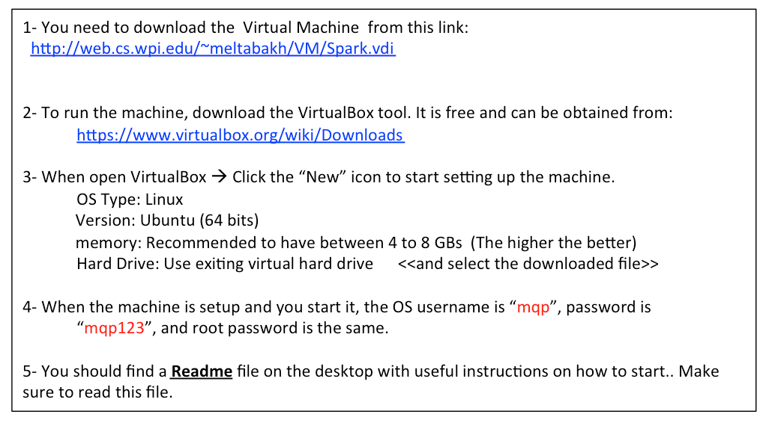

Problem 1 SparkSQL (Transaction Data Processing) [30 points]

Use the Transaction dataset T that you created in Project 1 and create a Spark workflow to do the following. [Use SparkSQL to write this workflow.]

- T1: Filter out (drop) the transactions from T whose total amount is less than $200
- T2: Over T1, group the transactions by the Number of Items it has, and for each group calculate the sum of total amounts, the average of total amounts, the min and the max of the total amounts.
- Report back T2 to the client side
- T3: Over T1, group the transactions by customer ID, and for each group report the customer ID, and the transactions’ count.
- T4: Filter out (drop) the transactions from T whose total amount is less than $600
- T5: Over T4, group the transactions by customer ID, and for each group report the customer ID, and the transactions’ count.
- T6: Select the customer IDs whose T5.count * 3 < T3.count
- Report back T6 to the client side

Problem 2 Spark-RDDs (Grid Cells of High Relative-Density Index) [70 points]

Overview:
Assume a two-dimensional space that extends from 1…10,000 in each dimension as shown in Figure 1. There are points scattered all around the space. The space is divided into pre-defined grid-cells, each of size 20x20. That is, there is 500,000 grid cell in the space. Each cell has a unique ID as indicated in the Figure. Given an ID of a grid cell, you can calculate the row and the column it belongs to using a simple mathematical equation.

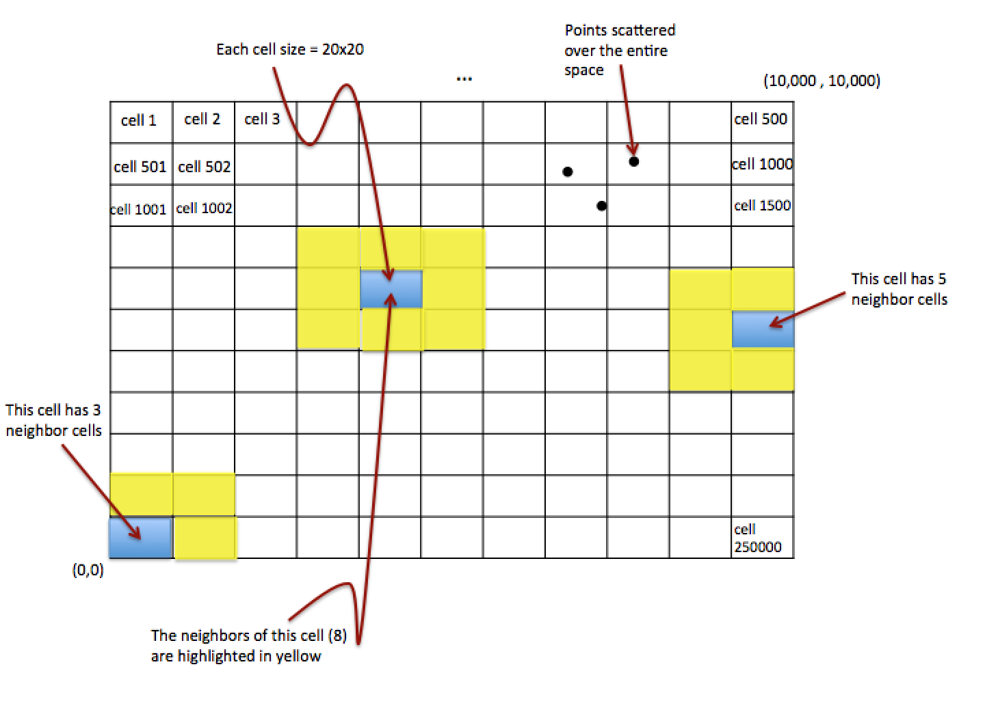
Neighbor Definition: For a given grid cell X, N(X) is the set of all neighbor cells of X, which are the cells with which X has a common edge or corner. The Figure illustrates different examples of neighbors. Each non-boundary grid cell has 8 neighbors. However, boundary cells will have less number of neighbors (See the figure). Since the grid cell size is fixed, the IDs of the neighbor cells of a given cell can be computed using a formula (mathematical equations) in a short procedure.
Example: N(Cell 1) = {Cell 2, Cell 501, Cell 502}
N(Cell 1002) = {Cell 501, Cell 502, Cell 503, Cell 1001, Cell 1003, Cell 1501, Cell 1502, Cell 1503}

Relative-Density Index: For a given grid cell X, I(X) is a decimal number that indicates the relative density of cell X compared to its neighbors. It is calculated as follows.

I(X) = X.count / Average (Y₁.count, Y₂.count, …Y_{n}.count)
Where “X.count” means the count of points inside grid cell X, and {Y₁, Y₂, …, Y_{n}} are the neighbors of X. That is N(X) = {Y₁, Y₂, …, Y_{n}}

Step 1 (Create the Datasets)[10 Points] //You can re-use your code from Project 2
- Your task in this step is to create one dataset P (set of 2D points). Assume the space extends from 1…10,000 in the both the X and Y axis. Each line in the file should contain one point in the format (a, b), where a is the value in the X axis, and b is the value in the Y axis.
- Scale the dataset to be at least 100MB.
- Choose the appropriate random function (of your choice) to create the points.
- Upload and store the file into HDFS

Step 2 (Report the TOP 50 grid cells w.r.t Relative-Density Index)[40 Points]
In this step, you will write Scala or Java code (it is your choice) to manipulate the file and report the top 50 grid cells (the grid cell IDs not the points inside) that have the highest I index. Write the workflow that reports the cell IDs along with their relative-density index.

Your code should be fully parallelizable (distributed) and scalable.

Step 3 (Report the TOP 50 grid cells w.r.t Relative-Density Index)[20 Points]
Continue over the results from Step 2, and for each of the reported top 50 grid cells, report the IDs and the relative-density indexes of its neighbor cells.

What to Submit
You will submit a single zip file containing the code needed to answer the problems above. Also include a .doc or .pdf report file containing any required documentation.

How to Submit
Use blackboard system to submit your files.

