CS3431
B-Term, 2013
Homework 2: Relational Model & Algebra

Post Date: Nov. 11, 2013.
Due Date: Nov. 18, 2013 (3:00 PM).

General Instructions
- The homework is to be done individually.
- Any assumptions you make, which are not stated in the problem definition, need to written explicitly. The assumptions you add must be “in addition” to the specified requirements in the problem definition without deleting any of the given requirements.

Problem 1 (Map ERD to Relational Model) [30 Points]
Map the ERD given in Figure 1 (Page 3), to the corresponding relational model. The ERD is a representation of a book database that captures the relationships between “books”, “publishers”, and “authors”. This ER diagram meets the requirements given in Problem 1, Homework 1.
You should follow the refinement rules given in the class while generating the relational model. In the relational model, you should provide:
- For a given relation (say R) with attributes A1, A2, …An, represent R as follows:
  - R(A1, A2, …, An) and underline the primary key attribute(s)
- State the foreign key relationships. If R.A1 references the primary key S.B1, then represent that as follows:
  - Foreign key: R.A1 references S.B1
- In this homework, you are not asked to write Create Table statements nor to define data types.

Problem 2 (Relational Algebra) [30 Points (5 Points each query)]
Given the relational model that you will build in Problem 1, provide the algebraic expression corresponding the following queries:

Q1: Report the author name who has a phone number “1-555-444-7777”.

Q2: Report the book information for the book with ISBN = 1112223333444.

Q3: Report the names and addresses of the authors and publishers who have contracts between “Jan-01-2007” and “Dec-31-2008” with total payment above $100,000. Also report the contract date.

Q4: Report the publisher name that have published more than 10 books.

Q5: Report the number of pages of textbook “The Country” edition 3.

Q6: Report the contract IDs that have the sum of “partial payments” of the contact lines does not match the “total payment” defined in the contract.

Problem 3 (Relational Algebra) [25 Points (5 Points each)]

Assume we have the two relations R and S as shown above. Answer the following questions:

1. What is the Arity and Cardinality of both R and S

2. Write the output relation from the following expression (if the relation is empty, then state so):
σ_{X = 3} (R ⋈ S)

3. Write the output relation from the following expression (if the relation is empty, then state so):
σ_{A >1} (Π_{A X+B, C} R) ⋈ Π_{c} (S),

4. Write the output relation from the following expression (if the relation is empty, then state so):
R – S

5. Write the output relation from the following expression (if the relation is empty, then state so):
R º⋈_{(X=Z or C=Z)} γ_{B, sum(C) As W , min(D) As Z} (S)

**Note: In the output relations that you will write, the column names should be included.
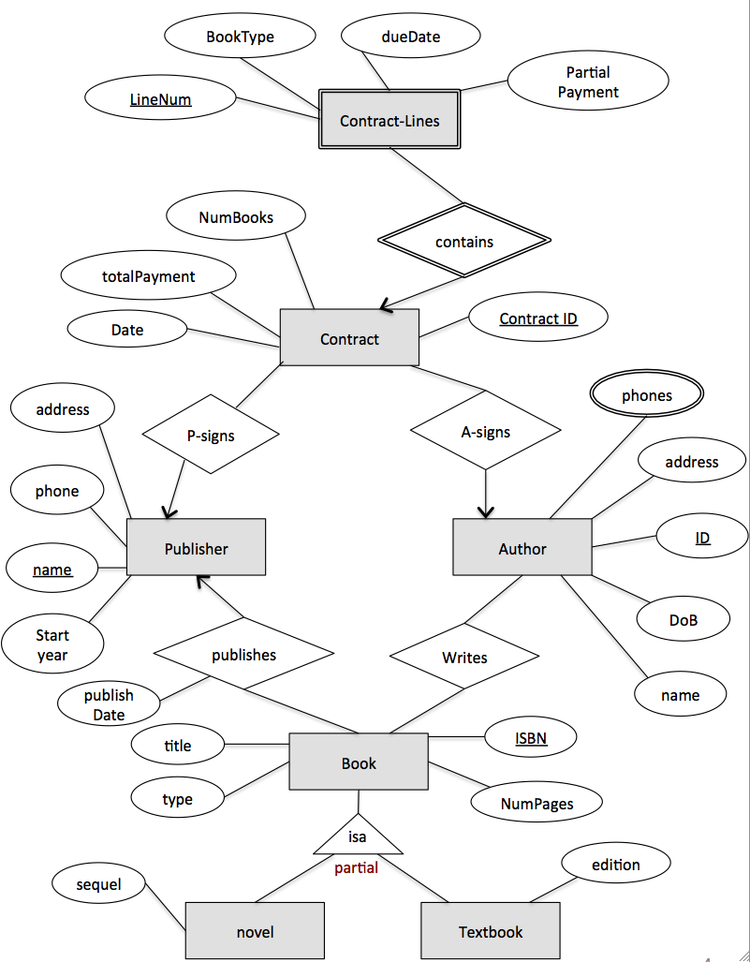
Figure 1

Grading:
The maximum grade is 85 Points. Late submissions follow the rules stated on the website.

Deliverables:
Each student should deliver a report containing the required solution.

Submission:
Submit a hardcopy in the beginning of the class (3:00 PM), or submit electronically via blackboard.wpi.edu website (Electronic submission is recommended).

