CS-3013 (Operating Systems)
A-term 2008

Setting up your Virtual Machine

Hugh C. Lauer©
Adjunct Professor
Worcester Polytechnic Institute
For this course, each student (or team) will need a virtual machine on which to build, modify, and test Linux kernels. We will be using OpenSUSE Linux version 10.3, a widely available version of Linux that is freely distributable with source code.
Project assignments will require you to learn how to build a new version of a kernel, to add new service calls to the kernel, and to create a message system to transmit messages among Linux processes using the facilities of the kernel.
This document describes how to set up your virtual machine on a Fossil Lab workstation. Alternatively, you may set it up on your own personal computer, which should have two processors, at least 10 gigabytes of free disk space, and two gigabytes of RAM.

Virtual Machines
A virtual machine is an application program capable of simulating a computer with enough fidelity and performance to mimic an actual hardware system. It simulates the microprocessors, memory, disks, network connections, CD drives, and other devices. The virtual machine concept originated in the 1960s, and it has now matured to the point that virtual machines are used in a wide variety of commercial and operational settings.
Two terms are used in virtual machine technology:–
- The host system is the hardware and operating system on which the virtual machine application runs — e.g., your PC running Windows or a server running Linux.
- The guest system is the simulated machine, which runs a different operating system and set of applications — e.g., Linux running on VMware on your Windows PC.
The virtual machine application uses the host processors to simulate the guest processors, and it uses files on the host system to simulate disks on the guest system. It also simulates other hardware in the guest system, sometimes by using host hardware directly. For example, the virtual machines distributed for this course allow you to access the CD or DVD drive and your USB Flash drive of your host PC directly from your guest operating system. Using the “ bridged” network option, VMware connects the virtual machine directly to the Ethernet, making it indistinguishable from a real hardware system on the network.
A goal of this Operating System course is to provide experience in working directly with the inner layers of a real operating system of the kind used by many people for their daily work, including the WPI community. You will be exposed both to the breadth and depth of such an operating system and also to many of its gory details. In order to do this, a safe place must be provided for you to work — a place where you can make mistakes, crash your operating system, corrupt disks and data structures, etc., without harming anyone else and even without harming your own, working PC.
The virtual machine provides this kind of environment. For this course, we are providing a dual processor virtual machine with OpenSUSE Linux version 10.3 already installed. The reason for two processors is to expose you to the issues of concurrent execution at the kernel level of the operating system.

VMware Workstation
VMware is a company that makes and sells virtualization systems for commercial and scientific applications. VMware Workstation is a virtualization application designed for Windows and Linux personal computers. It can be used to create new virtual machines and to run existing virtual machines. It supports dual processors, multiple disks, network connections, and a variety of peripheral devices common to modern PCs. It includes the ability to take snapshots of a virtual machine and to role the state of that machine back to the snapshot. It also includes the ability to clone a virtual machine – i.e., to make an exact copy of it. VMware Workstation is installed on all of the PCs of the Fossil Lab.
(VMware Player is a freeware subset of VMware Workstation that is designed to run virtual machines that were created under some other VMware system. It does not have all of the capabilities of Vmware Workstation — particularly the ability to take snapshots and roll back to them. However, it is free, and it is adequate for the purposes of this course.)

Installing your virtual machine
The host operating system on the Fossil Lab PCs is Windows XP. As a member of the class, you will have a login ID for the Fossil Lab that is the same as your login ID on the CCC computers, but with a special password. This login is valid for all Fossil Lab PCs as well as the Fossil server (a Linux server). When you login in for the first time, you should change your password to something you can remember. Changing your password on one Fossil PC automatically changes it for all Fossil PCs and also for the server.
When you log in, you will find on your desktop two remotely mounted disks. The H drive is your home directory on the Fossil server. It follows you to whichever Fossil PC you log into. The P drive is the public directory on the Fossil server, a read-only directory.
To install your virtual machine, open the following folder:–
P:\CS-3013\A-term 2008\Clonable SUSE Linux 10.3 (32-bit)\
Within this folder, is a file named Clonable SUSE Linux 10.3 (32-bit).vmx. This is a file of type VMware Configuration. Double click on this file to open it and start VMware Workstation. Alternatively, you may start the VMware Workstation application, invoke the File > Open menu command, navigate to this same file, and click Okay.
Either action should open the VMware Workstation main window, which resembles the following:–
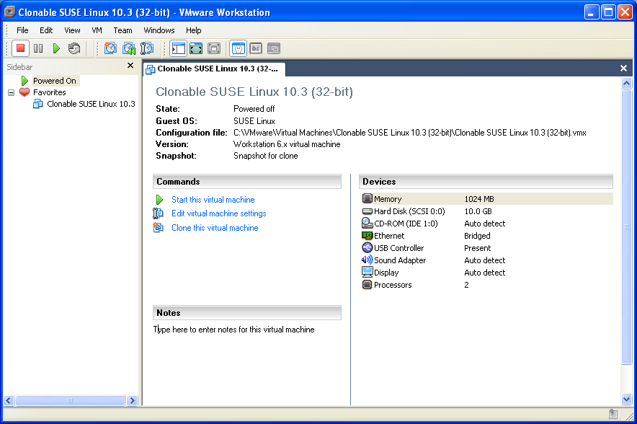
This shows the master virtual machine for this course. It is write-protected, so you cannot use it directly. Instead, you must make a clone for your own use and store it in your own directory. From this window, you can see that this virtual machine has 1024 megabytes of RAM memory, a 10 gigabyte hard disk, a CD-ROM drive, an Ethernet interface, a USB drive, and two processors. The entire virtual machine is described in the VMware Configuration file that you just opened, and its devices are implemented by the files in this directory.
The VMware Configuration File named Clonable SUSE Linux 10.3 (32-bit).vmx is a text file describing your virtual machine. You may peruse it if you wish, but there is no need to edit it. To start a virtual machine, browse to (or double click on) the VMware Configuration File. The rest of the files are for implementing the virtual machine itself.
To create your own clone, click on “Clone this virtual machine” in the Commands panel. This will bring up the Clone Virtual Machine Wizard. Click Next in the Wizard window and also in the Clone Source window that follows. Eventually, you will see the Clone Type window, shown below.
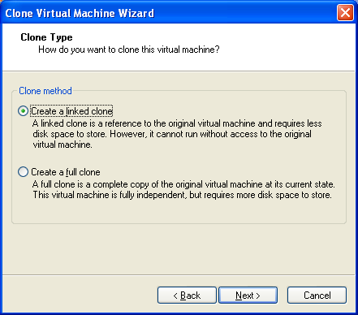
Select the first option — i.e., Create a linked clone — and click Next. A linked clone is one that stores only those disk blocks of the cloned virtual machine that are different from the same blocks of the master. The rest of the disk blocks of the clone are linked back to the master in order to save space. Since you will be working in the Fossil Lab, you will always have access to the master, and therefore it is worthwhile saving the space.
In the next window, you will name your virtual machine and assign a file location to store it. In this course, it suggested that you store your virtual machine in a folder on your desktop, so that it is accessible no matter which Fossil workstation you use. This has the performance advantage that the files of the virtual machine are cached on the local hard drive of the Fossil PC, while at the same time they are restored to the server for backup and possible use at other Fossil PCs.
After you click Next, VMware will create a linked copy of the virtual machine in the directory or folder that you specified, and then it will return you to the VMware Workstation main window as shown above. You will notice that a new tab representing the cloned machine has been added to that window.
If you were to list the directory where you stored your virtual machine, you would find something resembling the following:–
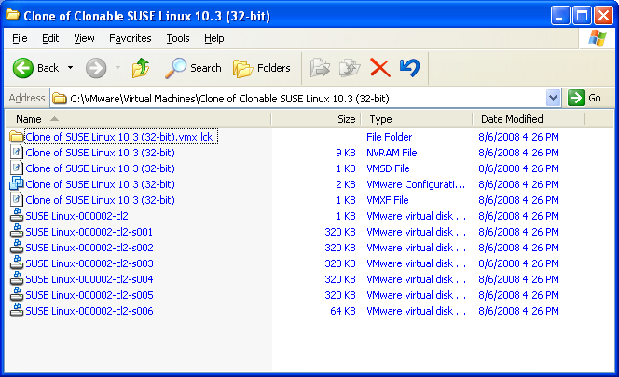
The files with names starting with SUSE Linux-000002 are clones of the files with the same names in the master virtual machine. These implement the disks of your virtual machine. You will notice that they are quite small right now, even though the combined storage of the master virtual machine is about six gigabytes. These files will grow as you modify disk files in your virtual machine, thereby necessitating separate storage from the master.

Starting your Virtual Machine for the first time
In the main VMware Workstation window, under the tab for your cloned virtual machine, click Start this virtual machine. This will cause the virtual machine to boot up and eventually to display the following boot screen.
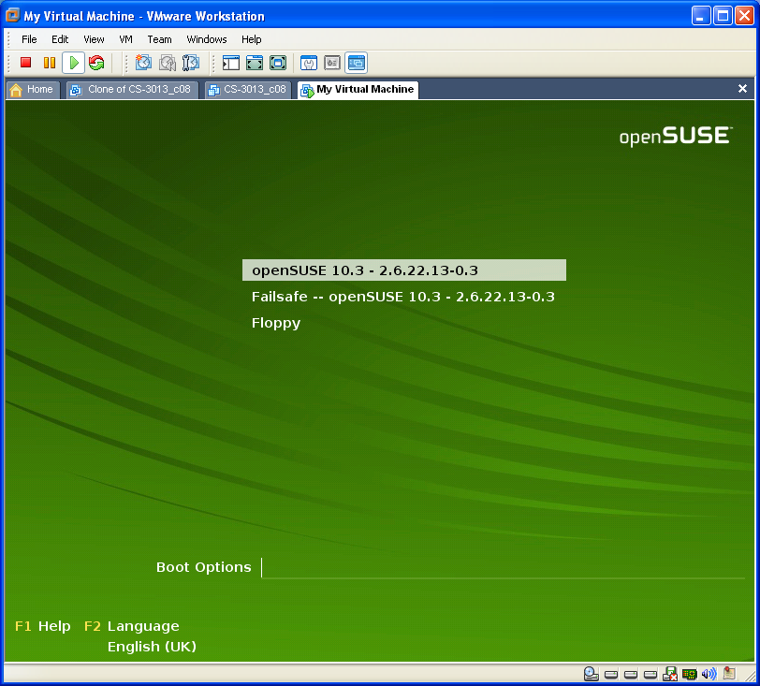
If you do nothing at this point, the virtual machine will boot the default option (openSUSE 10.3). The numbers after the operating system identification are the version of the kernel. In the future, you will need to control the boot options; do this by clicking in boot screen, then using the arrow keys to select the desired option, and finally pressing Enter.
Note: You transfer the input focus of the mouse and keyboard to the virtual machine by clicking in its window. You can return the input focus to the desktop by typing CTRL-ALT. If the input focus is in the wrong place, the virtual machine won’t hear you type or move the mouse.
Once the focus is in the virtual machine, you may use the up and down arrows to select the booting option and Enter to invoke that booting option. There is a settable boot timer that controls how long SUSE Linux waits before booting the default option.
During booting, the screen will briefly change to a text console, and then it will eventually change to a graphical login interface resembling the one below. If you want to watch the Linux boot messages, type ESC when the focus is in the virtual machine.
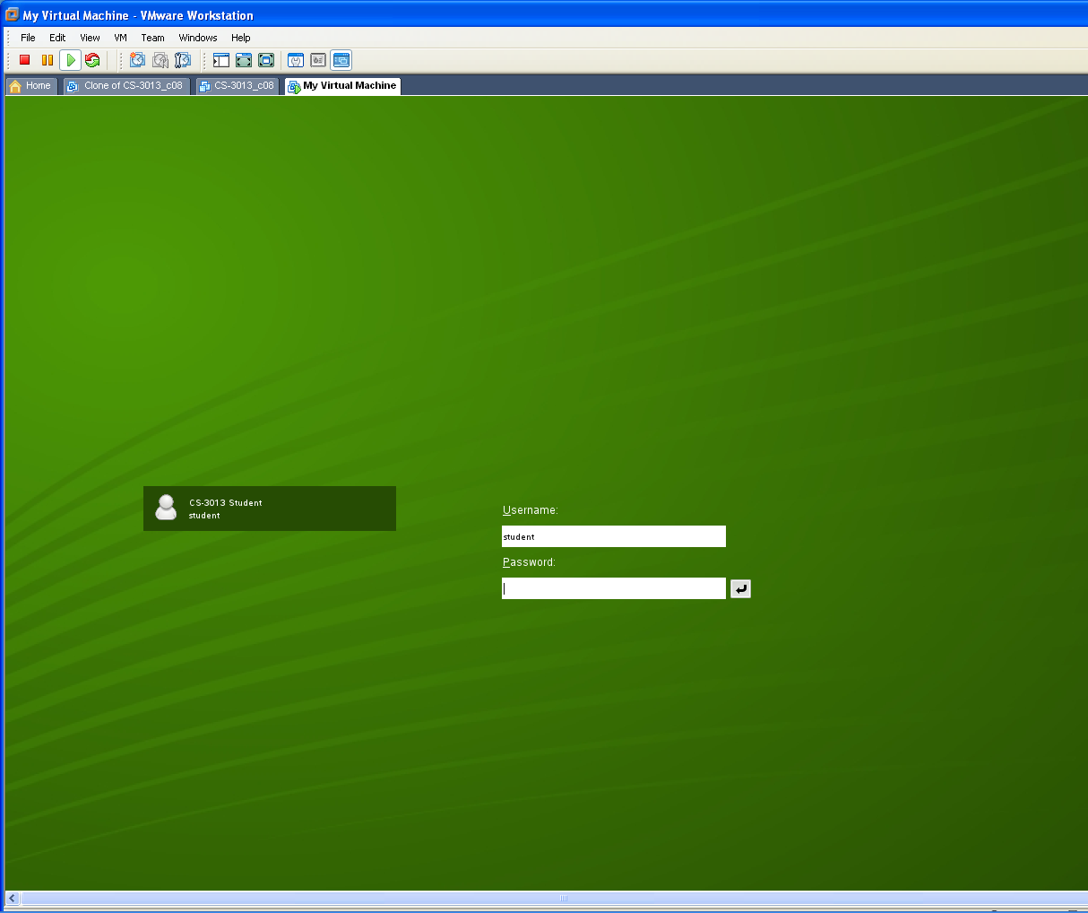
This screen is configured to be 1280-by-1024 pixels in size. If you wish it to take over the entire display, press CTL-ALT-Enter. Later, if you wish to return it to a Windows display, press CTL-ALT-Enter again.
Note: When you are running your virtual machine in full-screen mode, a fragment of a Windows menu bar appears at the top of the screen. This lets you access useful VMware commands, including the VM menu of the VMware Workstation application.

Logging in
Your login ID is student, and your password is CS-3013. You will be presented with a graphic desktop called KDE, the Linux Desktop Environment, shown below. This is the SUSE Linux equivalent of the Windows desktop, and it is used much the same way. In particular, note the little green “Gecko” icon in the lower left corner. This is functionally equivalent to the Start button in Windows. Click it to get a two-dimensional menu of program items and other commands.
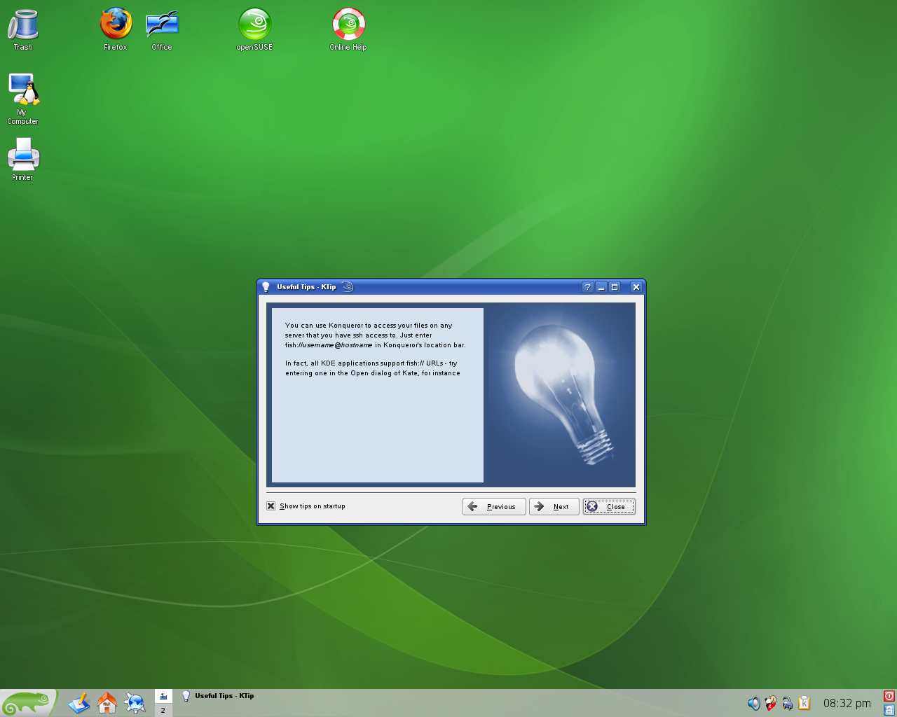
Note: In modern versions of Linux, you rarely have to log in as root. Most of the time, you should log in as a non-privileged user and use the sudo command to invoke root privileges where needed. This avoids accidents that are typical in most system development environments. As a helpful reminder, KDE configures the user root with a red desktop background that contains warning signs and images of bombs.

Creating a user identity for yourself
It is helpful to create a user identity for yourself and to get rid of the student identity built into these virtual machines. If you are part of a team, create an identity for each team member. To create an user identity, click the “Gecko” icon and select the third tab of this menu, labeled Computer. When the tab opens, you will see at the top an item entitled Administrator Settings and in smaller print below it YaST. Click this item to start the YaST program, SUSE Linux’s general purpose administrative setting tool. You will use YaST a lot; it is much easier than learning and remembering a book full of arcane shell commands and scripts.
When you start YaST, it asks you to enter the root password. This is CS-3013, the same as the password for the user student. You should next see the YaST main window, which resembles the following:–
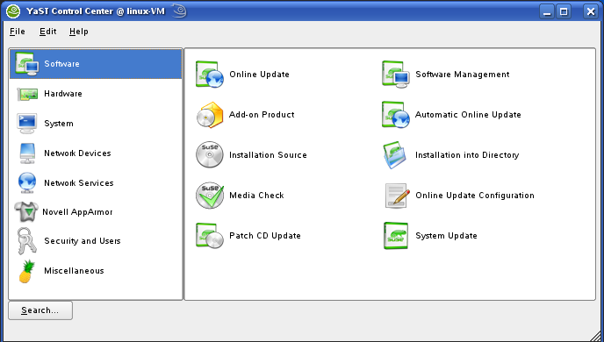
Select Security and Users in the left panel, and click on User Management in the right window that appears. At this point, you can follow your instincts to add your own identity as a user. (We suggest that you use your WPI e-mail identity.) Log out, and then log in with this new identity, and finally use YaST again to delete the student identity.

Fixing your network connection
An unfortunate consequence of cloning a SUSE Linux guest system is that its Ethernet network connection stops working. This is because VMware changes the MAC addresses of any Ethernet cards in the cloned guest system to avoid conflict with the MAC addresses of those same Ethernet cards in the original system. This is important because having two computers with the same MAC address on the same network would be a calamitous situation.
SUSE Linux records the MAC address in some internal configuration file, so when it boots the clone, it finds a virtual Ethernet card with a different MAC address from the MAC address it had recorded internally. Therefore, to be safe, it does not connect to the network until you take some action.
To remedy this situation, invoke YaST as above, select Network Devices in the left panel and select Network Card in the right panel. This brings up a window resembling the following:–
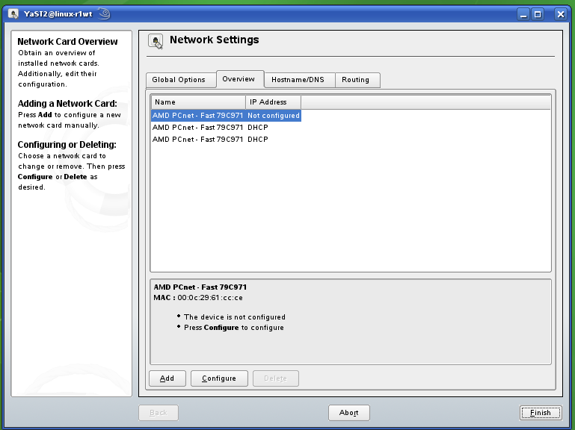
Select the card that is not configured and click the Configure button at the bottom. This brings up another window entitled Network Card Setup. Accept the default options as proposed, specifically that the network card has a dynamically assigned IP address via DHCP. Click Next to return to the Network Settings window, which now shows that the network card has been configured. Finally, click Finish, allow YaST to go through its network reconfiguration steps, exit YaST, and finally restart your guest operating system by invoking the Leave > Restart System command in the Gecko menu.
After rebooting, you can open a command window in the Gecko menu and type the command
sudo /sbin/ip address
It will ask you for the root password, and then it will display the IP address of the Ethernet connection.

Useful Features

Snapshots
A highly useful feature of VMware Workstation is the ability to take snapshots. This is accessed from the VM menu of the Workstation application (and also the menu bar at the top of the full-screen mode display). When you take a snapshot, VMware records the state of your virtual machine for future use. Later, after you have crashed or corrupted your disk beyond belief, you can restore it to a previous state by invoking the Snapshot command in the VM menu.
To make a snapshot, VMware uses the same mechanism that it uses to make clones. That is, a record of all of the disk blocks is made, and any subsequent changes to any disk blocks are made to new copies. Later, to revert to a snapshot, the new copies of blocks are discarded and the original blocks are restored. Conversely, if a snapshot is deleted, the copied blocks and original blocks are merged so that the appropriate state is preserved. VMware does this automatically for you, so you don’t have to keep track of it yourself.
It is possible to have snapshots of snapshots, recursively, but it is not advisable because performance can suffer.

Suspending, Restarting, and Moving your Virtual Machine
Another highly useful feature of VMware is that you can suspend a virtual machine and resume it later. Simply use the Suspend sub-command of the Power command of the VM menu. Moreover, you can log out, leave the Fossil Lab, return later, log into a different Fossil workstation, and resume your suspended virtual machine.
When you do resume it, you may get a dialog box saying that it noticed that your machine is in a different place than before and asking if you copied or moved it. Respond to this dialog saying that you moved it.
The reason for this dialog is a precaution on the part of VMware:– It doesn’t know whether or not you copied your virtual machine, thereby creating a new one so that a new MAC address is required (as above, when you made the clone). If you say you moved it, VMware keeps the same MAC address for its virtual Ethernet card, and SUSE Linux continues as if nothing had happened (except for the passage of time).

Shared Folders
Installed in your guest operating system are the VMware Tools. This is a set of drivers that improve the performance and operation of the guest operating system in the virtual environment by setting up some private channels between the host and the guest systems. The most useful feature is the shared folder between the host and the guest operating system. This is a folder that lives in both the host and the guest operating system. You can move files into it from one system and take them out from the other.
On the guest side, the shared folder is mounted in the directory /mnt/hgfs. On the host side, it must be enabled and configured in VMware Workstation. The configuration dialog is accessed from the VMware Workstation window by editing the virtual machine settings. Select the Options tab and the Shared Folders item under that tab. You will need to “enable” sharing and specify which host folder you want to share.

VMware Tools
The VMware tools installed in your guest operating system have a tendency to disable themselves when you modify the kernel, even when you reboot back with the original kernel. Among other things, this causes the shared folder facility to stop working. It has occasionally been known to cause the network card to stop working, so you would have to go through the process of configuring it again.
There are two ways to re-establish the VMware Tools:–
- Execute the shell command
sudo /usr/bin/vmware-tools-config.pl
This uninstalls and then reinstalls the VMware Tools. As part of the installation step, it recompiles the VMware Tools with the header files of the current operating system kernel. If it cannot find these header files, it will ask you for a pathname. Rebuilding VMware Tools takes only a few minutes.
Note: You can also use this command to resize the display of your virtual machine.
- Reboot with the last known kernel for which VMware Tools worked. Execute the following two shell commands:–
sudo rm /etc/vmware-tools/not_configured
sudo /etc/init.d/vmware-tools start
The first command removes the file /etc/vmware-tools/not_configured, which was put there by VMware Tools when it tried to start up with a kernel that did not match the one it was compiled with. Once this file is in place, VMware Tools will not even attempt to start up.
The second command restarts VMware Tools. Presumably, if the kernel is right, it will start operating again. In particular, the shared folder will become accessible.

Disaster Prevention
During the first several terms when we taught Operating Systems courses using VMware virtual machines, students stumbled on a number of idiosyncrasies that rendered their virtual machines totally inoperable, trapping all of their work inside. As we have refined this course, this kind of disaster occurs less and less frequently.
Nevertheless, it is always a good idea to back up your own work. The best way to do this is to copy the relevant files onto a USB flash drive or memory stick or to send them to a server directory via FTP or other transport mechanism. From time to time, we have tried other methods of protecting students from lost work — particularly, configuring virtual machines with separate drives for the /home directory — but none of them has proven very practical.

Other Notes
If you want to run your virtual machine on your own PC, you must make a Full clone on a Fossil Lab machine and then copy it to your PC. Once it is one your PC, you can run it using the freeware VMware Player, which can be downloaded from the VMware web site.
Neither the professor not the TAs are able to provide support this term for running on your own PC, but if you are skilled enough (and brave enough) to try it, please consult the web pages of CS-502, the graduate operating course at the following URL:–
http://web.cs.wpi.edu/~cs502/f07/#_Virtual_Machines
Note that when VMware asks, you will have to say that you copied the virtual machine, so that it assigns a unique MAC address.

Conclusion
That’s it. Enjoy your virtual machine. You are now ready for your first kernel project. When you are ready to take a break, you may power off your virtual machine by invoking the “leave” tab from the Gecko menu and selecting the appropriate option. You may also “Suspend” the virtual machine by simply exiting VMware Workstation.

Documentation
Documentation for VMware Workstation can be found here:–
http://www.vmware.com/support/pubs/
Documentation about OpenSUSE Linux can also be found on-line at
http://www.novell.com/documentation/opensuse103/
This includes a getting started guide, a user’s manual, and administrator’s manual, and other information. Do not try to print these. Together, they are over 1000 pages.

 Copyright 2008, Hugh C. Lauer. All rights reserved. Permission is given for use in courses at Worcester Polytechnic Institute, Worcester, Massachusetts.
There is also a folder entitled Clonable SUSE Linux 10.3 (64-bit). This represents a virtual machine for a 64-bit processor. Unfortunately, the Fossil Lab PCs do not support 64-bit operation.
By constrast, a full clone is a complete copy of the virtual machine than can be taken elsewhere and run on VMware Workstation, VMware Player, or some other VMware applications.
MAC addresses are the hardware addresses that Ethernet devices use to communicate with each other. MAC stands for “Media Access Code”.
The two other network cards in the Network Settings window were from previous clones of the virtual machine that were made in order to create this one. It is okay to delete them, but it is harmless to leave them in place.

