Lab 5 — Using Microsoft Visual Studio
CS-2301, System Programming for Non-majors, B-term 2011

Objective
- To learn to use an Integrated Development Environment (IDE), specifically Microsoft Visual Studio.

Introduction
This week, you will learn how to create a Solution in Visual Studio from an existing application, and then how to build it and debug it.

Getting Started
- Create a Windows folder to hold the files for Lab 5. Using your browser, download and unzip the same files we used for Lab 4 to your new folder. These files can be found at:–
http://web.cs.wpi.edu/~cs2301/common/Lab4Files.zip
Your folder should now contain the files intarray.c, intarray.h, sinewave.c, and makefile. Ignore the makefile! (We won’t be using it.) Visual Studio will create something else instead.
- Open Microsoft Visual Studio 2010. In the File menu, select New…, and in the submenu, select Create New Project from existing code. You should see a dialog box like the following:–
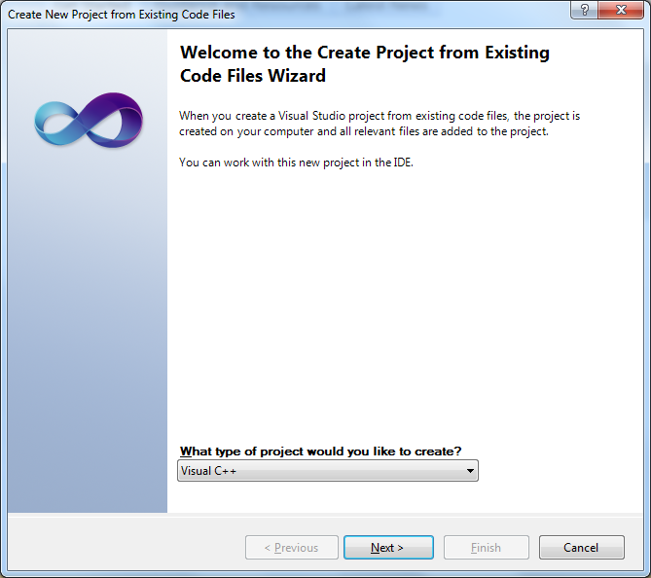
Select Visual C++ from the pull-down menu asking what type of project to create, and then click Next. (In Visual Studio, the C language is a subset of C++).
- You will now see a dialog box like the one below. In this dialog, enter or browse to the folder where you copied the files in step 2. Also, give the project a name, such as Lab5.
The folder containing your code files should automatically be added to the Folders list. If it’s not, click Add… to add it. Click Next. (Note:– don’t click Finish at this time. There is one more step!)
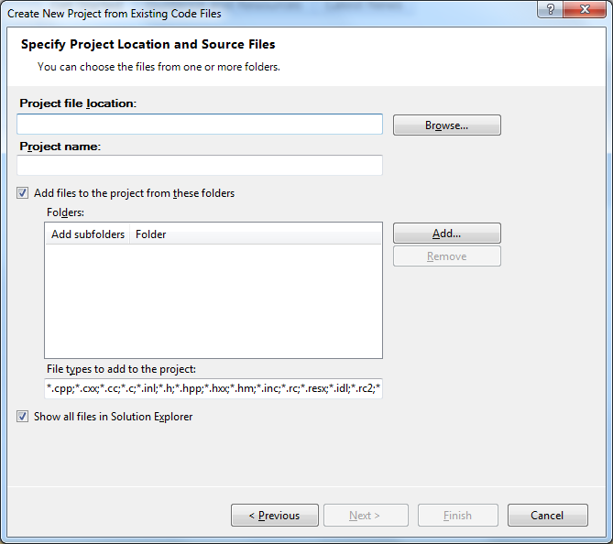
- You should now be presented with another dialog box resembling the following:–
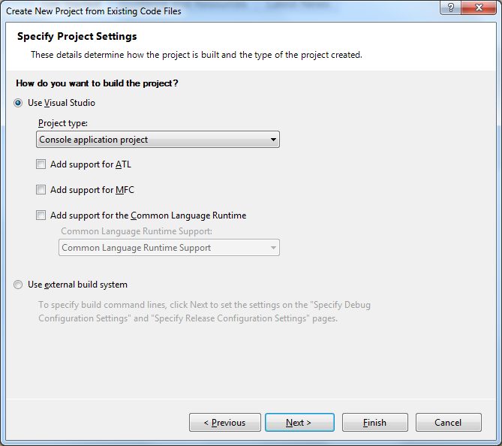
In this dialog box, select Console application project from the pull-down menu under Project Type. Also, be sure that the Use Visual Studio button is selected. Now you should click Finish.
(Note:– If your Windows folder is hosted on a network, you may get some complaints from Visual Studio about the dangers of opening files from the network. You can ignore those complaints and tell it to go ahead and use that folder or directory.)
- Finally, you should be in the main Visual Studio window. There should be a tall, narrow panel on the left side, the first two lines of which look like the first two lines of the following:–
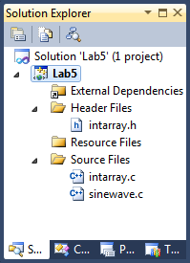
This is the Solution Explorer. It can accommodate multiple projects, but you will have only one in this exercise, namely Lab5. Click on the arrow to the left of Lab5 to open your project. Similarly, click on the arrow to the left of Header Files to see your header file, and click on the arrow to the left of Source Files to see the two source files of this project.
Eventually, Visual Studio will populate the External Dependencies folder in the Solution Explorer. When it does, you can see a list of all of the files that your program includes, either directly or as a result of some other include file.
Initially, the Solution Explorer panel is “docked” on the left side of the Visual Studio window, but you can undock it and allow it to be moved to any part of your desktop. To do so, pull down the tiny arrow in the top bar of this panel to reveal these options.
- If you look at your original Windows folder, you will see that Visual Studio has added some files, most notably Lab5.sln (or whatever you named this project). This file describes the Solution — i.e., Visual Studio’s way of packaging up one or more projects into an integrated whole. (One of the other files is Visual Studio’s equivalent of a Linux makefile.) If you exit Visual Studio, you can later return to where you were working by simply double-clicking or opening Lab5.sln. Do this now. I.e., exit Visual Studio and then re-open it to where you left off.
- Right click on the name of your project in the Solution Explorere and select Properties. In the next dialog box, select Configuration Properties > Linker > System. You should see a dialog like the following:–
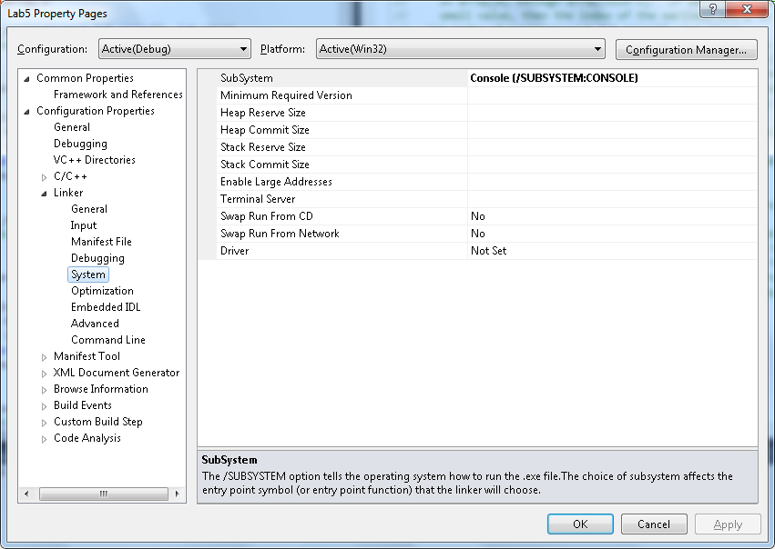
Make sure that the first line on the right panel (i.e., Subsystem) says Console. If not, click on it to reveal a pull-down menu and select Console. This creates a typical command-line application that takes the normal command line arguments (argc and argv[]). Click okay.
- Try to build the code by pressing the F7 button or clicking Build Solution from the Build menu. You should see the results of the build in the Output window at the bottom of the Visual Studio screen.
- To run your program, press the green button next to Debug or click F5. Your program should run without any errors. But did you notice that all it does is flash a console window for an instant before it quits?
To see what the output looks like, add a function call getchar(); to the main() function in sinewave.c, right before return statement. Now your program will execute and wait for a character input before quitting. You should see something like the following in the console window:–
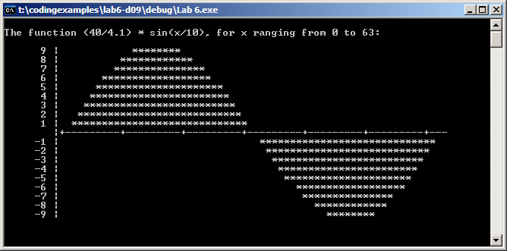
To finish execution, type any character in this window and hit the enter key. The window will disappear, and the Output panel at the bottom will show the results of execution.

Debugging
- To set a breakpoint on any line, open an edit window on the code file (by double clicking on that file in the Solution Explorer window of step 5. Right click on the line where you want to insert the breakpoint, and select Breakpoint > Insert breakpoint.
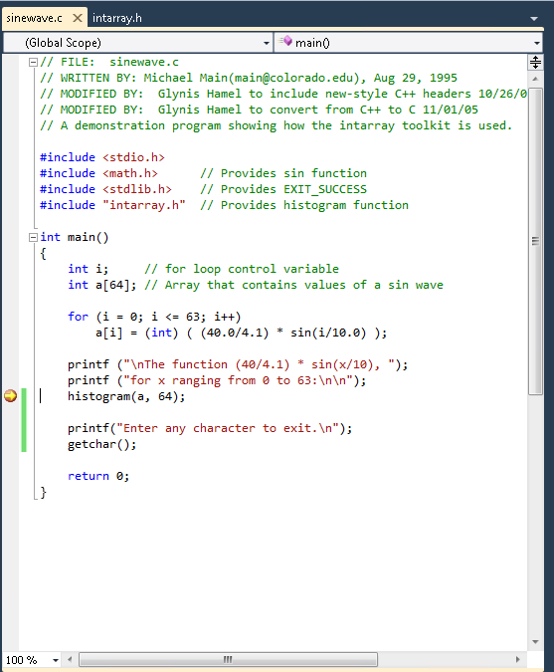
Now again press F5 or the green button at the top to run your code. It should break at the breakpoint you just inserted. After it does, hover your cursor over a variable name to see what’s in that variable at that point during execution. For example, the following screenshot shows the value of the argument a in the call to the histogram function at the line of the breakpoint
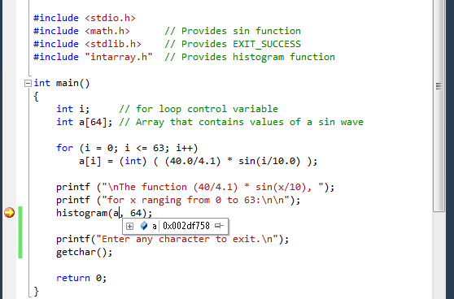
This illustrates the tremendous power and time-saving capabilities of an Integrated Development Environment. You can simply point and/or click on variables while stopped at breakpoints to see what they are. If you right-click on any identifier, you will bring up a menu of options allowing you to go to its declaration or definition, open the header file, find all references to it, etc. You can also single-step through your code by click Step into or Step over in the Debug menu, and you can ask the debugger to watch a variable so that it will break when the variable reaches a certain value.
At the bottom of the Visual Studio window, you should see a panel labeled Autos, like this:–
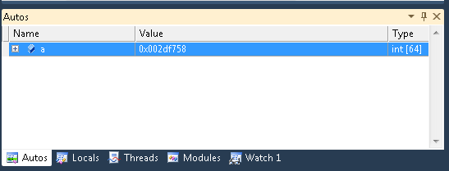
This shows the automatic variables of the current function. In this case, the array a. If you expand the + symbol to the left of the variable name, you will see the values of the individual elements of a. Likewise, you will find other panels that show the call stack, the breakpoints, the values of watched variables, etc.
Experiment with these, and see whether your program is doing what you think it should.

Building in release mode
- So far you were building your project in Debug mode, which is the normal default. When you’re done with debugging and are about to deploy your application, normally you would want to build it on Release mode.
Debug and Release are different configurations for building your project. As the name implies, you generally use the Debug mode for debugging your project (equivalent to the –g switch in gcc), and the Release mode for the final build for end users. The Debug mode does not optimize the binary it produces (as optimizations can greatly complicate debugging), and it generates additional data to aid the debugger. The Release mode enables optimizations and generates less (or no) extra debug data.
- To build your project in Release mode, use this dropdown menu and select Release. You should be all set.
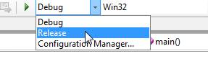
- You can also clean your project by selecting one of the Clean commands from the Build menu. Do this now and exit Visual Studio.
- Open a window on to your Lab 5 folder. Notice that there are a bunch of new files and folders in addition to the three you originally copied. These new files were created by Visual Studio; they describe your project and how to build it. Select all of the files and folders, right click and select Send to > Compressed (zipped) folder. This zips all files together into a single one.
- Turn in your .zip file to the Linux turnin program using the following command:
/cs/bin/turnin submit cs2301 LAB5 Lab5.zip

(where Lab5.zip is the name of your .zip file)
This lab assignment is due at 5 PM on Thursday, December 1.
See you next week!

You may get an error that the file Lab5.exe is not executable. This is a consequence of using a Windows folder that is hosted on a Linux system — for example, on filer.wpi.edu.. To fix this problem, log into the Linux system, navigate to your Lab5 folder, and then open the Debug folder within it. Locate the file Lab5.exe (or whatever you named your project), and make it executable. In Linux, the command to make a file executable is chmod 755 Lab5.exe.

