Setting up Python 3.6.5, matplotlib, and numpy
on your Macintosh computer
CS-1004, Introduction to Programming for Non-Majors, A-Term 2018

Hugh C. Lauer0F©
Teaching Professor
Worcester Polytechnic Institute
Programming assignments in CS-1004 will be carried out using the programming language Python — specifically, version 3.5 of Python. In addition, you will need several Python packages, including one called numpy (meaning “Numerical Python”) and one called matplotlib, a Python version of the popular Matlab system. This document provides instructions for installing Python 3.5 and packages such as numpy and matplotlib on Macintosh platforms.1F
In general, it is expected that assignments will be compatible among Windows and Macintosh, provided that they all use compatible versions of Python and numpy. Unlike previous years, we have no prepackaged Linux installation of Python 3.6.5 this year.
Note: There are two different, incompatible sets of versions of Python in general use around the world — Python 2.7 and Python 3.5. Significant changes to the Python language were made between Python 2.x and Python 3.y (for all values of x and y). The Python 3 language is cleaner, more self-consistent, and more user-friendly. Programs written for versions of Python 2 will not necessarily run on Python 3 installations; if they do run, they may get different answers to the same problems.
That being said, a lot of legacy Python 2 code is still in use, and new Python 2.7 code is still being written and distributed by organizations that have not yet upgraded to Python 3. Not all Python 2 packages have been ported to Python 3.
Note 2: All versions of Mac OS X come with Python 2.7 already installed for their own needs. That version of Python must not be deleted or disturbed when installing Python 3.6.5 and its packages. Please follow these instructions exactly to avoid corrupting Python 2.7.

Installing Python 3.6.5 on Macintosh2F, 3F
Installing Python 3.6.5 on Mac OS X is somewhat simpler than in previous years. However, packages such as numpy and matplotlib need to be installed from a networked source, just as with Windows installations.
First, create a folder on your desktop — for example, Python-files — and download the following installer to that folder by clicking on this link:– python-3.6.5-macosx10.9.pkg. Alternatively, you may browse to
http://www.cs.wpi.edu/~cs1004/a18/Resources-A18
and download the file from there.
Open the python-3.6.5-macosx10.9.pkg file that you just downloaded. This should bring up a dialog like Figure 1 below.
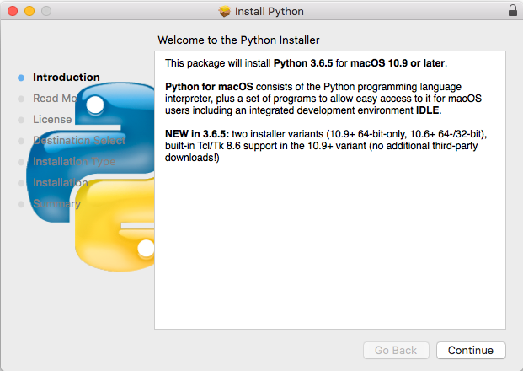
Figure 1
The message indicates that this installer applies to macOS version 10.9 or later. If you have an earlier version of MacOS (including a 32-bit version), please see the Professor for an older version of the Python installation program for the Macintosh.
If the installer complains that there is already a version of Python 3 installed on your computer, please seek help or contact the Professor. You must have Python 3.6.5 for this course. Earlier versions should be upgraded. Click Continue to bring up another dialog:–
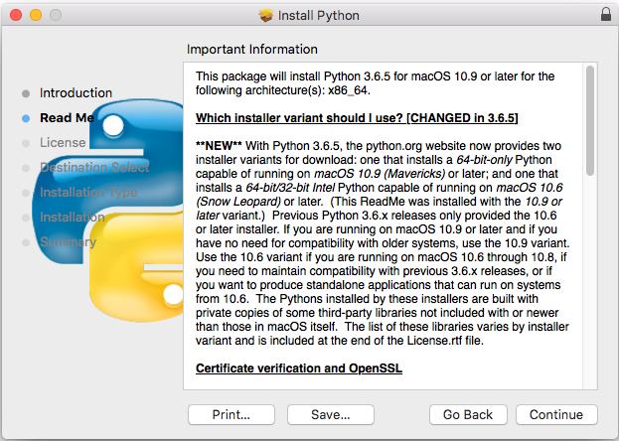
Figure 2
This dialog box is scrollable and contains information about what is new in this release. Click Continue to bring up one or more additional dialog boxes pertaining to the history of Python and its license. Continue clicking until the dialog in Figure 3 appears.
Figure 3
Click Agree to continue the installation. The installation itself will take several minutes and may show one or more dialog boxes. It will finish with a panel resembling Figure 4.
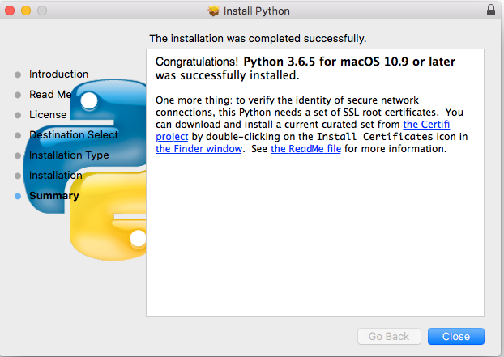
Figure 4
After it has completed, you should find a folder named Python 3.6 in your Applications folder, as shown circled in dotted black below.
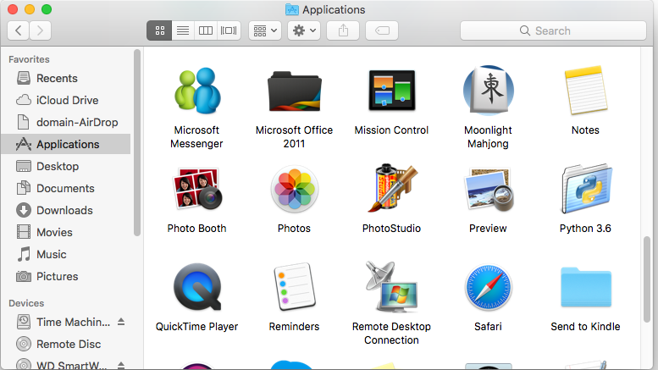
Figure 5
Open the Python 3.6 folder to show Figure 6 below.
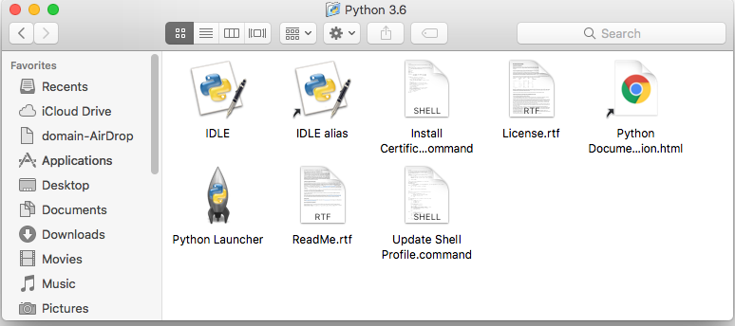
Figure 6
Drag the IDLE Alias in the first row to a convenient place so that you can access it easily — for example, on your desktop. Double-click this alias to bring up the following window:–
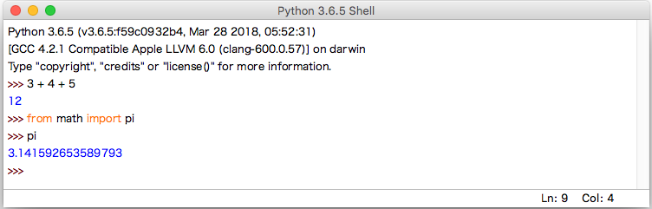
Figure 7
This is IDLE, the Python command prompt and graphical user interface. This is where we will start all programs and projects in this course.
For now, simply type any Python statement or expression after the “>>>” prompt. For example, Figure 7 shows the expression 3 + 4 + 5 as typed, followed by Python’s response with the value 12.
After the next two “>>>” prompts, type the command
from math import pi
and the expression
pi
Python responds by printing the value of pi to 15 decimal places, also shown in Figure 7
Continue testing by typing out the code on pages 10-11 of the textbook, just to make sure that your installation works as expected. Note that if you mistype something, you will probably get some unexpected behavior. Simply try again. If you get really lost, type CTRL-C to get back to the IDLE prompt.
Note: IDLE is essentially the same across Windows, Macintosh, and Linux platforms. It will be used the same way in all three for this course.

Installing graphics.py
Graphics.py is a simple drawing package that we will use a lot in this course. It was written in Python 3 and created by the textbook author for making simple drawings. To install it, click on this link — graphics.py — and download the file to the folder where you keep your Python programs. Follow the instructions in sections 4.3-4.8 of the textbook (3rd edition).

Installing matplotlib, numpy, and other packages
These steps require you to have a working internet connection.
One of the many benefits of Python is the vast number of third-party packages that can be downloaded and used by your Python programs. Many of these are open-source and free. For this course, we will use at least the following:–
- matplotlib (a package for creating 2D plots and graphs similar to Matlab),
- numpy (meaning “Numerical Python,” a package for efficient handling of large arrays of numerical data), and
Installing matplotlib, numpy, and other packages on a Macintosh requires you to type Linux-like commands in a Terminal window.
In the Applications folder of Figure 5, scroll down until to you see the Utilities folder, as shown in Figure 8. Open this Utilities folder, as shown in Figure 9 on the next page.
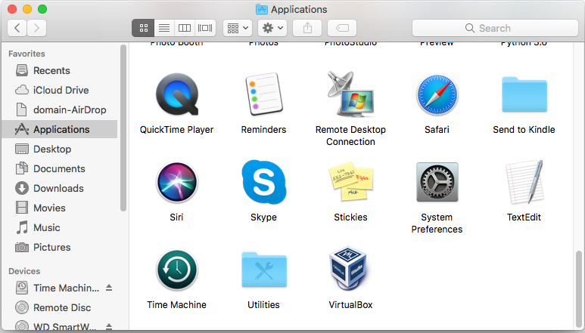
Figure 8

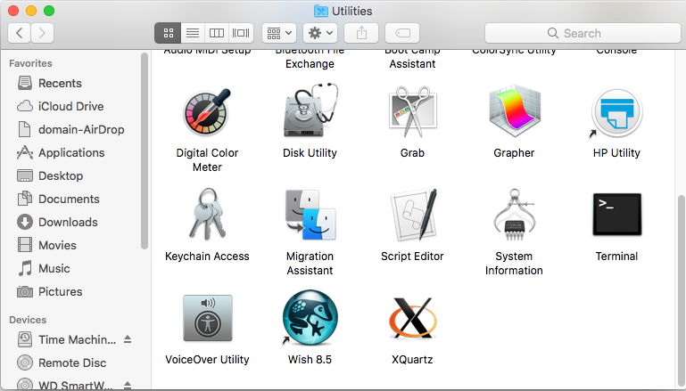
Figure 9
Scroll down the Utilities folder until you an icon labeled Terminal, as shown on the right side of Figure 9.
Double-click (or open) this icon to bring up a terminal window (also known as a command shell in Unix and Linux terminology). An example terminal window is shown in Figure 10. In this window, the system prints a prompt starting at the beginning of a line and ending in ‘$’. After the prompt, you type a command, consisting of a command name followed by zero or more operands, which control what the command does. When you terminate the command with the Enter key, the system performs the command.
A command may work silently and then type out its results in the same window, or it may engage in a textual conversation with you, requiring you to respond, or it may open its own window with its own graphical user interface. When the command has completed, the system prints a new prompt for the next command.

Installing matplotlib, and nose
In your terminal window, type the following command lines, one at a time, exactly as shown:--
pip install -U pip
pip install –U matplotlib
pip install –U nose
pip list
The first command will update pip (the Python Installation Program) if necessary. For many students in this course, it is likely that pip is already up-to-date; in this case, pip will indicate this fact.
The second command downloads and installs matplotlib, along with all its dependencies, including numpy. The third command downloads nose, the numpy test program. The final command lists the installed Python packages. It should produce a result resembling the following figure:--
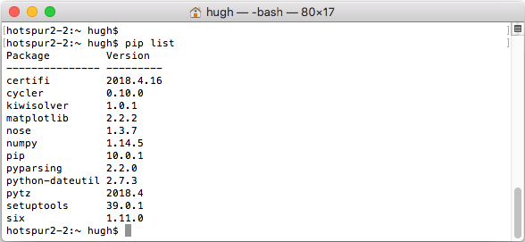
Figure 10
You can test your installation of numpy by opening an IDLE window, as in Figure 11. Type or paste the following commands into IDLE, one line at a time, exactly as written.
Note: In these lines, the word version is preceded by two underscore characters and followed by two more underscore characters.
The word arange is spelled with one “r” — it is a variation of the range function that we will learn about early in the course.
import numpy as np
np.__version__ 6F
a = np.arange(10)
a
b = np.arange(1, 9, 2)
b
c = np.eye(3)
c
d = np.diag(np.array([1, 2, 3, 4]))
d
After each line a, b, c, and d, Python will print the values of these variables. The result should resemble Figure 11 below:–
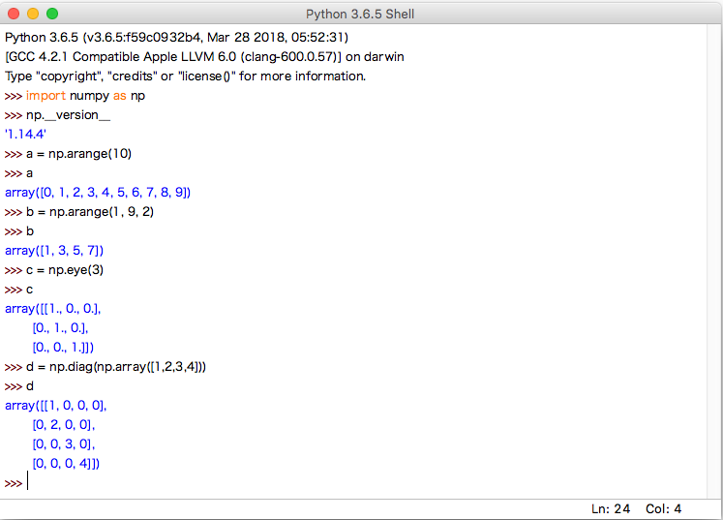
Figure 11
Congratulations! You have successfully installed and tested numpy 1.14.4. However, we will run another test below.

To test your matplotlib installation, type or paste the following commands into IDLE, one line at a time, exactly as written:–
from matplotlib import pyplot
pyplot.plot([1, 2, 3, 4], [1, 4, 9, 16])
pyplot.show()
The IDLE window should look something like the following:–
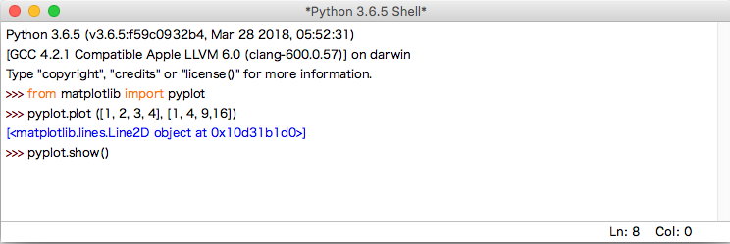
Figure 12
After you type the ENTER key following the last line, the following window should appear:–
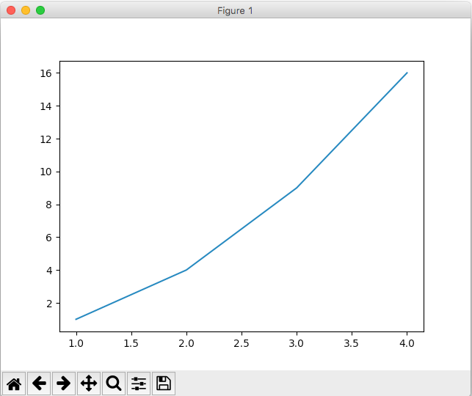
Figure 13
To close this window, click on the Macintosh “close” button in the upper left corner.
For a more interesting test, download the following file to a convenient folder and save it as a .py file:–
TestMatplotlib2.py
Then, use the File menu in the IDLE window to open this file in its own window, as shown in Figure 14:–
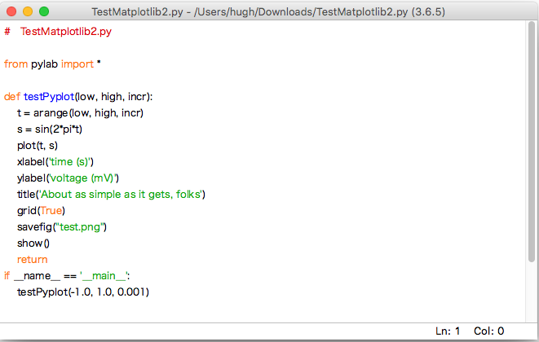
Figure 14
Click on this window to make it the active window, and then select the Run > Run Module command in the IDLE menu at the top of the Macintosh screen. This will cause the Python program to run and to produce the window of Figure 15.
This tests not only matplotlib but also numpy (in the background). The result should be a window like this:–
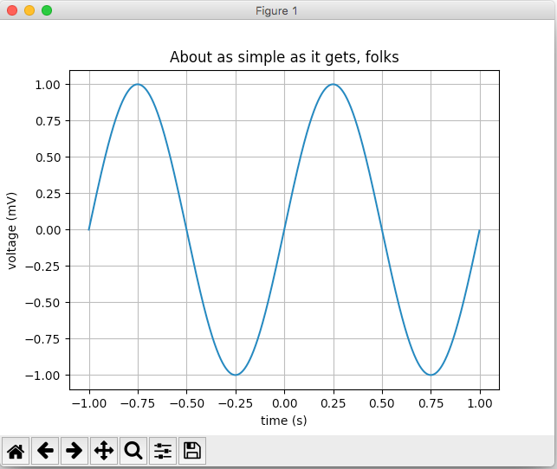
Figure 15
Congratulations! You now have a working version of matplotlib installed. As part of this test, a copy of the picture was saved under the name test.png in the current directory.
Note also that matplotlib used numpy in the background to build up the array of points making up the graph.
For a final test, type the following into an IDLE window:–
import numpy as np
np.test()
This will run a complete set of tests of the numpy package for several minutes, producing a lot of output. The output begins with the lines in Figure 16 and continues for some time. At times, it may seem like it has paused or stopped. Please be patient.
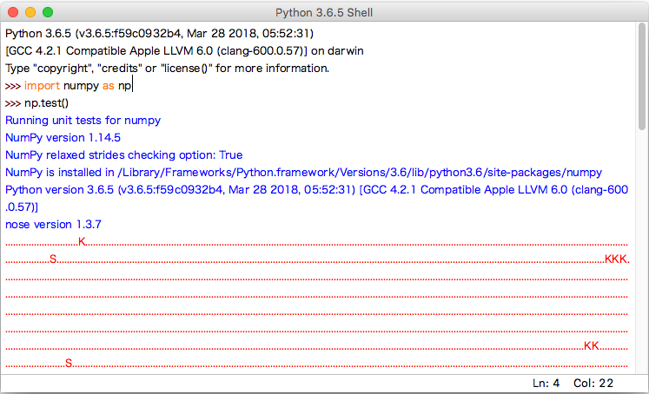
Figure 16
Eventually, it will finish with some “apparent” errors as shown in Figure 17 below. You may ignore these errors.
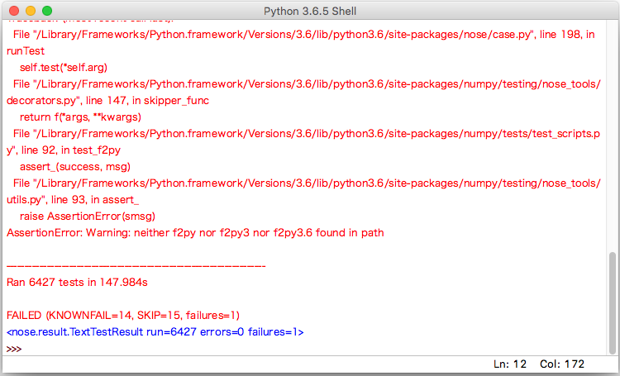
Figure 17
The last line shows that 6427 tests were run with one failure. This is considered success.
Congratulations! You now have both matplotlib 2.2.2 and numpy 1.14.4 working.

© Copyright 2018, Hugh C. Lauer. All rights reserved. Permission is given for use in courses at Worcester Polytechnic Institute, Worcester, Massachusetts.
If you have a Windows computer or laptop, please refer to this documents instead:– docx, pdf.
It is useful to print out the relevant section of this document. If you read it on-screen, the dialog boxes of the installation tend to obscure the instructions of the document, just when you need them the most!
These instructions have been tested on MacOS X 10.13.3 High Sierra. There may be slight differences with other versions of MacOS.
In particular, an additional package named Tcl/Tk is now built into the Python installation package and therefore does not have to be installed separately.

