Setting up Python 3.4 and numpy and matplotlib
on your own Windows PC or laptop
CS-1004, Introduction to Programming for Non-Majors, A-Term 2015

Hugh C. Lauer©
Adjunct Professor
Worcester Polytechnic Institute
Programming assignments in CS-1004 will be in the programming language Python — specifically, version 3.4 of Python. In addition, you will need several Python packages, including one called numpy (meaning “Numerical Python”) and one called matplotlib, a Python version of the popular Matlab system. The first part of this document provides instructions for installing Python 3.4 on Windows 7 and Windows 8 platforms. The second part of the document provides instructions on how to install additional Python packages, such as numpy and matplotlib.
Public laboratory computers at WPI will have Python 3.4, numpy, and matplotlib installed on them for the academic year 2015-2016.
In general, it is expected that assignments will be compatible among Windows, Macintosh, and Linux systems, provided that they all use compatible versions of Python and numpy.
Note: There are two different, incompatible versions of Python in general use around the world — Python 2.7 and Python 3.4. Significant changes to the Python language were made between Python 2.x and Python 3.y (for all values of x and y). The Python 3 language is cleaner, more self-consistent, and more user-friendly. Programs written for versions of Python 2 will not necessarily run on Python 3 installations; if they do run, they may get different answers to the same problem.
That being said, a lot of legacy Python 2 code is still in use, and new Python 2.7 code is still being written and distributed by organizations that have not yet upgraded to Python 3. Not all Python 2 packages have been ported to Python 3.

Installing Python 3.4 on Windows Systems,
There are two variants of Python 3.4 for Windows — a 32-bit version and a 64-bit version. Although almost all Windows PCs sold over the past few years are 64-bit systems, these instructions are for installing the 32-bit version, because we will be using a package called numpy that is only available in 32-bit releases for Windows.
To obtain the correct version of Python, click on this link — python-3.4.3.msi — and download the resulting file to a convenient folder or directory. Alternatively, you may browse to
http://www.cs.wpi.edu/~cs1004/a15/Resources
and download it from there.
Double-click on the file python-3.4.3.msi to start the installation. You should be greeted by a dialog box resembling the following:–
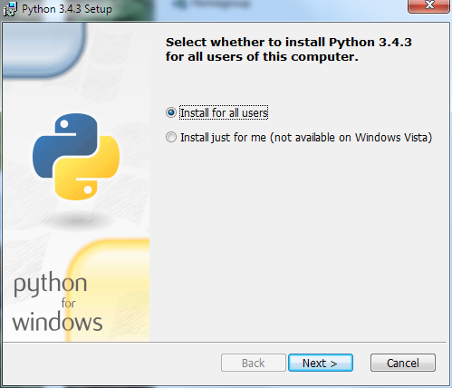
Figure 1
Whether you choose to install “for all users” or just for yourself is a personal preference.
If instead of Figure 1, you see a dialog box resembling Figure 2 below for any version of Python, select Remove Python for that version. This will remove an old, stale version, for example, an old 64-bit version of Python 3. Removing Python will take several minutes and may require you to confirm in one or more additional dialog boxes.
Note: Even if you don’t see the dialog box of Figure 2, if there is a previous version of Python installed on your computer, you should uninstall it before continuing.
You can also remove an old version of Python using the Start menu. Select the Python folder and the Remove Python x.y menu item in that folder, where x.y indicates the version.
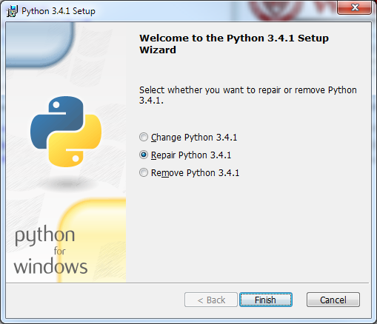
Figure 2
After removing the previous version of Python, click Finish and start over at Figure 1. Then click Next to bring up the following dialog box.
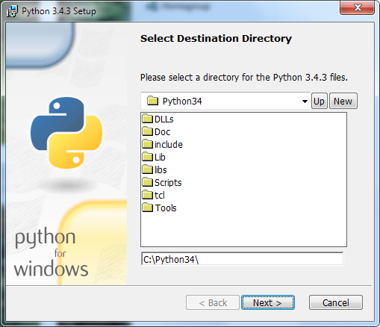
Figure 3
Click Next to select the default directory. If it tells you the directory already exists and asks if you are sure that you want to overwrite existing files, click Yes.
In the next dialog box (Figure 4 below), you will need to customize the installation. Scroll down to the bottom and click on the “X” next to Add python.exe to Path. It will expand this line to several options. Select Will be installed on local hard drive. This facility lets you run Python and related programs from command prompts, something that you will need to do later on when installing other packages and also during the term.
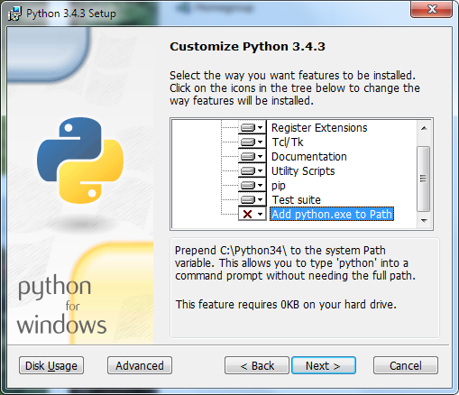
Figure 4
Click Next to begin the installation. The progress of the installation is shown in a dialog box resembling Figure 5 below.
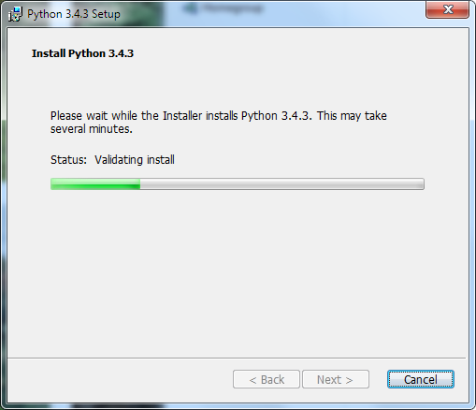
Figure 5
The installation should begin, will take several minutes, and may require confirmation in additional dialog boxes. Also, a text window may appear briefly showing the status of parts of the installation. When the installation completes, you should see the final dialog box, below.
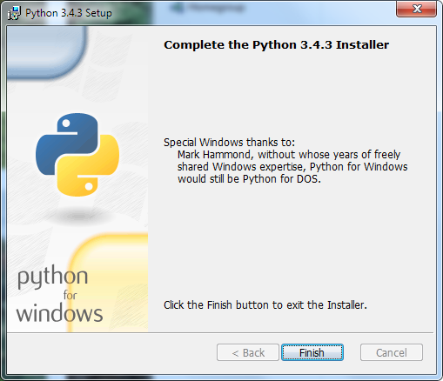
Figure 6
Click Finish to complete the installation of Python 3.4.3.

Testing your installation on Windows 7
If you are running Windows 7, you may confirm your installation by clicking the Start button to bring up the Windows Start menu. Select All Programs and scroll down to Python 3.4. Open this folder to expose shortcuts similar to the following:–
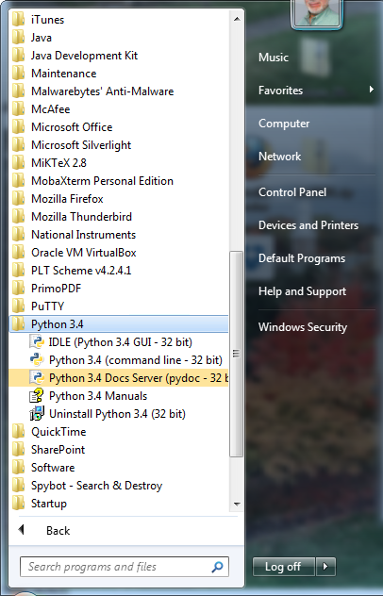
Figure 7
Click on IDLE (Python GUI) to bring up the following window (only a shortened version is shown here):–
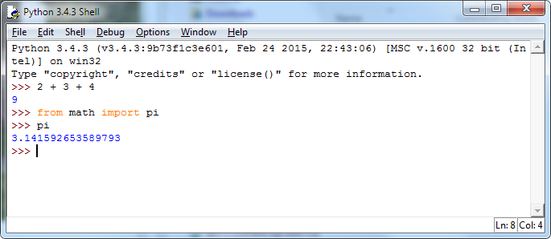
Figure 8
This is IDLE, the Python command prompt and graphical user interface. This is where we will start all programs and projects in this course. For now, simply type any Python statement or expression after the “>>>” prompt. For example, in Figure 8, the expression 2 + 3 + 4 was typed and Python responded with the value 9. Continue testing by typing out the code on pages 10-11 of the textbook, just to make sure that your installation works as expected.

Testing your installation in Windows 8
Windows 8 does not have a Start button but rather a Start screen that is intended to make the user experience more like the smartphone experience. Unfortunately, when Python is installed as instructed above, its icon does not automatically appear on the Start screen. It also does not appear in the list of apps.
To find it, move the cursor to the upper-right or lower-right corner of the screen to expose the Windows 8 pallet of “charms”. Select the Search charm to bring up a Search box. Type the word “Python.” This will bring up a list of matching items, such as shown in Figure 9 below.
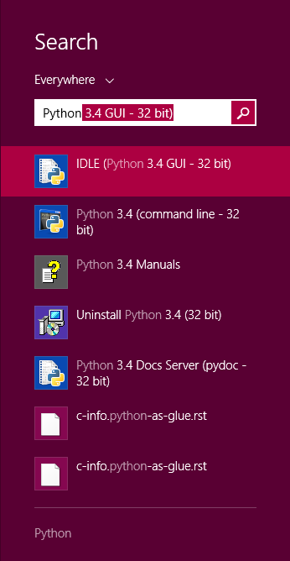
Figure 9
Note that this list is similar to the Python 3.4 folder in the Start Menu in Figure 7. Right-click on the item labeled IDLE (Python 3.4 GUI). From the menu, select “Pin to Start” to cause an icon to be added to the Start screen. You may also want to pin the item to the Task bar (i.e., the bar of tiny icons at the bottom of the screen). You may also select “Open file location,” which will bring up the following window:–
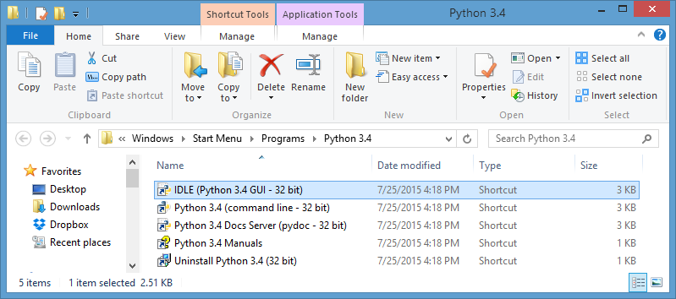
Figure 10
From this window, you can copy any or all of the Python links to the desktop.
To test your installation, double-click on the IDLE (Python GUI) icon and carry out the same tests as shown above under Figure 8.

Installing matplotlib, numpy, and other packages
One of the many benefits of Python is the vast number of third-party packages that can be downloaded and used by your Python programs. Many of these are open-source and free. For this course, we will use at least the following:–
- matplotlib (a package for creating 2D plots and graphs similar to Matlab),
- numpy (meaning “Numerical Python,” a package for efficient handling of large arrays of numerical data, also needed by matplotlib), and
- graphics.py, a simple tool written in Python 3 and created by the textbook author for making simple drawings.
Click on the following links to download the respective packages to a convenient folder:–
- numpy-1.9.2-win32-superpack-python3.4.exe
- matplotlib-1.4.3.win32-py3.4.exe

Installing Graphics.py
Graphics.py is a simple drawing package that we will use a lot in this course. To install it, click on this link — graphics.py — and download the file to the folder where you keep your Python programs. Follow the instructions on p.488 of the textbook.

Installing numpy 1.9.2
The numpy package needs to be installed immediately after you install Python 3.4.2 itself. In either Windows 7 or Windows 8, double-click (or open) the numpy installer that you downloaded above. After confirming that you do want to allow the system to install software, it will start the installation and show the following dialog box:–
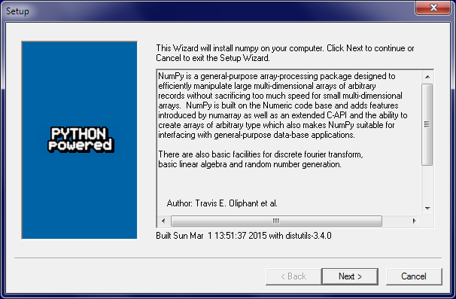
Figure 11
Click Next. If your installation of Python 3.4 is correct, you should get the following dialog:–
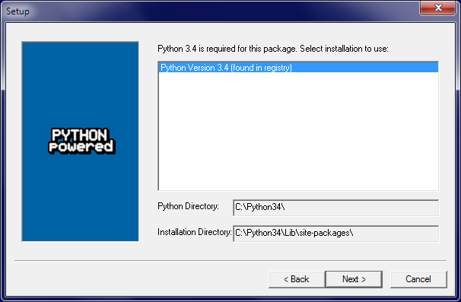
Figure 12
If instead, it complains that you do not have Python 3.4 installed, ask for help. Such a complaint could arise if Python was not correctly installed or if you have an incompatible version.
After the installation completes, click Finish. Note that you might have to click somewhere in some window to get the Close dialog box to pop up. Note also that this installer contains all of the dependencies of numpy — i.e., other packages needed by numpy to run. These are installed silently.
Make a quick test your installation of numpy by opening an IDLE window, as in Figure 8. Type or paste the following commands into IDLE, one line at a time, exactly as written:–
import numpy as np
np.__version__
a = np.arange(10)
a
b = np.arange(1, 9, 2)
b
c = np.eye(3)
c
d = np.diag(np.array([1, 2, 3, 4]))
d
The result should resemble Figure 13:–
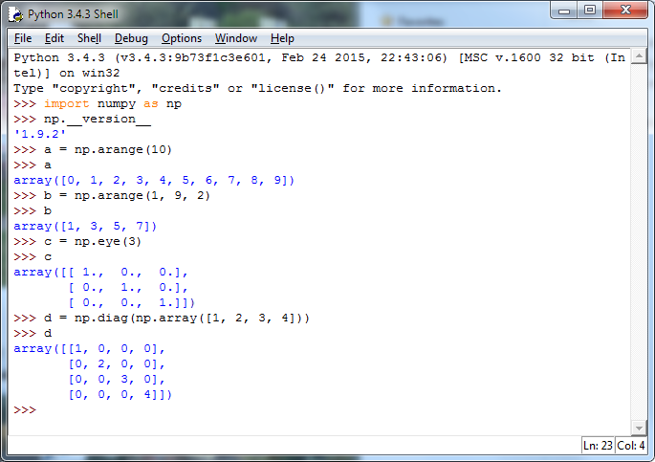
Figure 13
A more comprehensive test of numpy is described later in this document.

Installing Matplotlib on Windows
Installing matplotlib requires several steps. The official installer captures some, but not all, of the dependencies needed by matplotlib. To get started with Matplotlib, double-click or open the installer program
matplotlib-1.4.3.win32-py3.4.exe
that you downloaded above. After asking you to verify that you really do want to do this installation, it brings up the following window:–
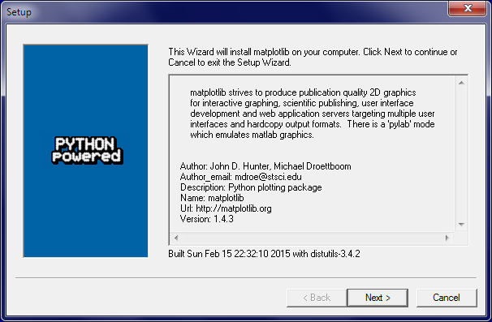
Figure 14
Click Next to bring up the following window:–
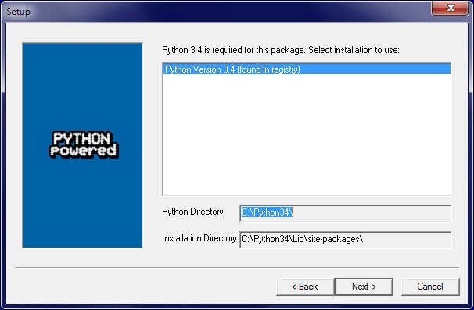
Figure 15
Click Next again to bring up a third window:–
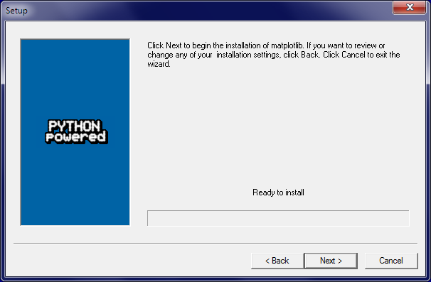
Figure 16
Clicking Next again starts the installation of matplotlib. It is probably necessary to click in the resulting screen to see the Finish window. Click the Finish button to complete this phase of installing matplotlib.
To install the remaining dependencies, bring up a Command Prompt window. This can be found in the Accessories folder of the Start menu in Windows 7. In Windows 8, you may have search for it, the same way you searched in Figure 9.
In the command prompt window, type or paste each of the following four commands. Let each command finish before typing the next one.
pip install --upgrade pip
pip install --upgrade matplotlib
pip install nose
pip list
The first of these command sometimes produces error messages, but it works anyway. The second command finds and installs the remaining dependency packages for matplotlib, including six, python-dateutil, pytz, and pyparsing. The third installs nose, a package used to test numpy. The last command lists the packages that are currently installed with your Python 3.4 installation. The list should include the following:–
matplotlib (1.4.3)
nose (1.3.7)
numpy (1.9.2)
pip (7.1.1)
pyparsing (2.0.3)
python-dateutil (2.4.2)
pytz (2015.4)
setuptools (12.0.5)
six (1.9.0)
Finally, type the exit command to close the Command Prompt.

Testing Your Installation
To carry out the comprehensive test of numpy, open a new IDLE window and type the following two commands:–
import numpy
numpy.test()
This uses nose to run the standard package of numpy tests for a minute or three. It prints a bunch of stuff in the IDLE window. Although some of the output may look like error messages, these are known issues with the tests. The test should end with something resembling the following:–
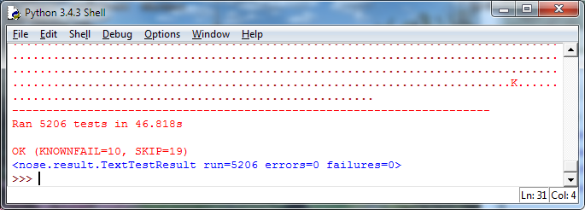
Figure 17
Congratulations! You have now installed a working versions numpy 1.9.2.
Finally, test your matplotlib installation by typing or pasting the following commands into an IDLE window, one line at a time, exactly as written:–
from matplotlib import pyplot
pyplot.plot([1, 2, 3, 4], [1, 4, 9, 16])
pyplot.show()
The IDLE window should look something like the following:–
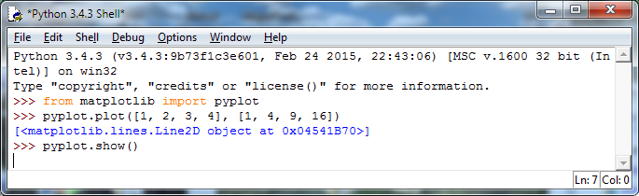
Figure 18
After you type the ENTER key following the last line, the following window should appear:–
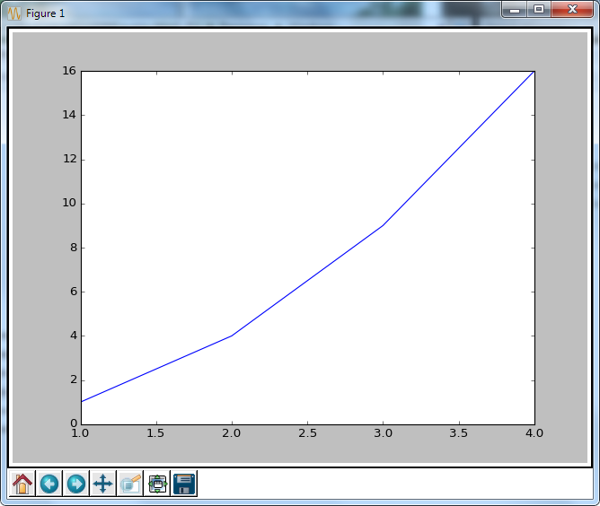
Figure 19
To close this window, click on the “close” button in the upper right.
For a more interesting test, download the following file:–
TestMatplotlib.py
Use the File menu in the IDLE window to open this file, which resembles the following:–
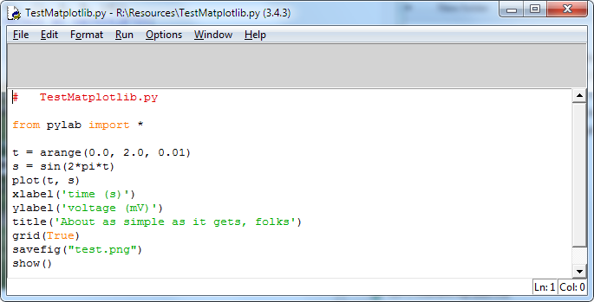
Figure 20
Click the Run > Run Module command in the menu at the top of the window to produce the following window:–
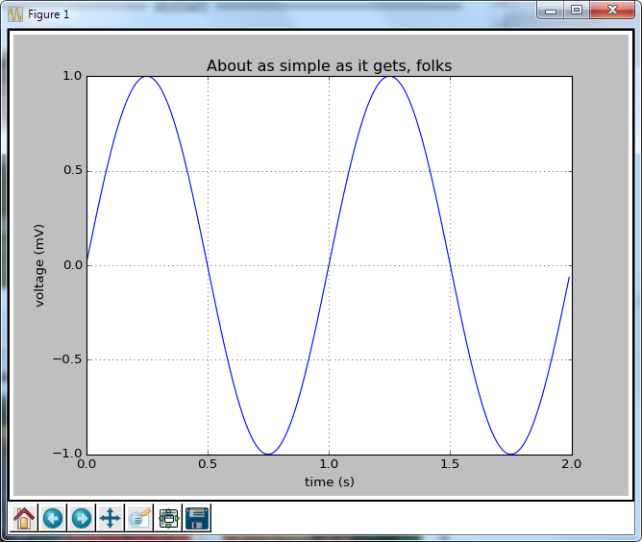
Figure 21
Congratulations! You now have a working version of matplotlib installed.
Note: Be sure to conduct these tests early in the term. There won’t be enough time to discover problems and fix them when a homework assignment is due the next day.

© Copyright 2015, Hugh C. Lauer. All rights reserved. Permission is given for use in courses at Worcester Polytechnic Institute, Worcester, Massachusetts.
If you have a Macintosh or Linux computer or laptop, please refer to this documents instead:– docx, pdf
It is useful to print out the relevant section of this document. If you read it on-screen, the dialog boxes of the installation tend to obscure the instructions of the document, just when you need them the most!
These instructions have been tested on both Windows 7 and Windows 8. Windows 10 was not yet available.
These additional dialog boxes are occasionally hidden behind other windows. If nothing seems to be happening, try clicking on or moving windows to look for such a dialog box.
In the Professor’s opinion, this was a mistake.
You can download the packages from http://www.cs.wpi.edu/~cs1004/a15/Resources/Windows, except for graphics.py, which is at http://web.cs.wpi.edu/~cs1004/a15/Resources/graphics.py.
Note that the word “version” is preceded by two underscore characters and followed by two more underscore characters.
Note the spelling of “arange” with only one ‘r’.
A dependency is another program or piece of software that needed to support a particular piece of software.

