SNMP MANAGER ON A PDA

A Major Qualifying Project Report:

submitted to the Faculty

of the

WORCESTER POLYTECHNIC INSTITUTE

in partial fulfillment of the requirements for the

Degree of Bachelor of Science

by

_________________________________
Stephen Goransen

_________________________________
Jeremy Lerch

_________________________________
Michael Milkin
and

_________________________________
Dimitri Stancioff

April , 2005
Approved:

1. SNMP
2. PDA
3. manager

_________________________________
Robert Kinicki, Advisor

_________________________________
Mark Claypool, Advisor

Table of Contents

Abstract iii
Acknowledgements iii
1.0 Introduction 1
2.0 Background 3
2.1 The Simple Network Management Protocol 3
2.1.1 The Structure of Management Information 3
2.1.2 The Management Information Base 5
2.1.3 Simple Network Management Protocol Version 1 7
2.1.4 SNMPv2 and SNMPv3 9
2.2 Pocket PC 11
2.2.1 Dell Axim X5 11
2.3 General Dynamics Encryption Products 11
2.3.1 The General Encryption Manager (GEM) 13
2.3.2 GEM vs. GEM Lite 13
3.0 Proof-of-Concept for an SNMP Manager Running on a PDA 15
3.1 Project Development 15
3.1.1 Manager Development Environment 15
3.1.2 Agent Development Environment 17
3.2 Manager Development 18
3.3 Agent Development 24
3.3.1 Agent Design 24
3.3.2 DLL Design 25
3.3.3 MIB Design 26
3.3.4 MIB Definition Design 26
3.3.5 MIB Database Design 28
3.3.6 Front-End GUI Design 29
3.3.7 DLL Implementation 29
3.3.8 Front-end GUI Implementation 31
3.3.9 MIB Implementation 34
3.4 Solution to General Dynamics Requirements 35
4.0 Recommendations and Future Work 36
4.1 GEM 36
5.0 Appendices 39
6.0 Works Cited 40
7.0 Bibliography 41

Table of Figures

Figure 1- Example Object Definition from the MIB-II 6
Figure 2- TACLANE/FASTLANE WAN Diagram 12
Figure 3- Microsoft embedded C++ IDE with emulator software 16
Figure 4 - Version 1 of the SNMP Manager 21
Figure 5- Working demonstration of the SNMP Manager 23
Figure 6- Agent Design 24
Figure 7- Interface of Encryptor Simulator 32
Figure 8- OID values implemented in the registry 34
Figure 9- OID tree structure in the registry 34
Figure 10 - Complete Solution Diagram 36
Figure 11 - Diagram of GEM port to the PDA 38

Abstract

This project, sponsored by General Dynamics C4 Systems, involved developing a proof-of-concept of an SNMP manager running on the Pocket PC platform. This proof-of-concept serves as the initial step in porting GDC4S’ General Encryptor Manager to a Pocket PC. A manager was developed that could assemble SNMP PDU’s on the Pocket PC and transmit them over TCP/IP to an agent. An agent was also developed for testing that served as a simulator of the encryptors that GDC4S manufactures.

Acknowledgements

The authors of this report would like to acknowledge the contributions of General Dynamics C4 Systems for their assistance throughout this project. In addition, we would like to recognize Brendon Chetwynd of C4 Systems for his help in coordinating this MQP between WPI and General Dynamics.

We would also like to acknowledge Professors Robert Kinicki and Mark Claypool for their assistance and advice on the compilation of this report.

1.0 Introduction

General Dynamics C4 Systems manufactures network encryptor devices to enable multiple LAN’s to communicate securely over insecure networks. Through the proper control of these devices, a network administrator can ensure that a network is secure and functioning properly. General Dynamics also develops a companion product that changes various options and settings on these encryptors via a PC. This project serves as the first phase of development of this management software for a personal digital assistant (PDA).
The encryptors that General Dynamics develop are currently managed by the General Encryption Manager (GEM), a Simple Network Management Protocol (SNMP) management suite that runs on a PC. This manager has all the necessary features to allow a network administrator to manage all of the encryptor devices on the network using a workstation located on one of the secure LAN’s. By developing this software for a portable platform, such as a Pocket PC-based PDA, network managers will have greater flexibility to control these encryptors due to the PDA’s mobility.
General Dynamics’ first step in porting the GEM software to the PDA was to determine the feasibility of this task. The purpose of this MQP is to develop a proof-of-concept showing the feasibility of this venture. This proof-of-concept would allow the company to invest a greater number of resources in the venture. In addition, the proof-of-concept can serve as a starting point for the development of this application. Due to security concerns, the agent used in the proof-of-concept stage is not an actual encryptor, but rather a PC simulating some of the functionality of an encryptor.
The proof-of-concept for an SNMP manager that runs on the Pocket PC platform had two main requirements. It needed to be a a fully functional SNMP manager that ran completely on a PDA. It needed to be able to build and send SNMP packets to any SNMP agent. It also needed to lay the groundwork for future porting of the General Encryption Manager to the Pocket PC.
This report will be organized as follows: First there will be a background chapter to bring the reader up to speed on SNMP, the PDA hardware, the laboratory hardware, and an overview of General Dynamics. Next will be a description of the solution to the problem proposed. This will include tools, development methods, laboratory setup, pitfalls that were faced, and a tutorial on how to use the software. Finally there will be suggestions for how to extend this project and an overview of GEM.

2.0 Background

Before the details of the implementation of the project can be examined, there are several necessary concepts to discuss. SNMP is the backbone of how the project is constructed. The hardware details of the PDA are also described in this section. The background will conclude with an overview of General Dynamics and its encryption products.

2.1 The Simple Network Management Protocol
The Internet Engineering Task Force’s (IETF’s) Network Working Group wrote the framework for the Simple Network Management Protocol (SNMP) in 1988. It was originally written as a series of three Request for Comments (RFC’s). The first of these documents, RFC 1065, defines the Structure of Management Information (SMI). The second, RFC 1066, defines the Management Information Base (MIB). The third, RFC 1067, defines the Simple Network Management Protocol that is used to manage the items inside of an MIB.

2.1.1 The Structure of Management Information
The Structure of Management Information is the standard set of rules for describing the managed objects. This scheme for describing the managed objects was originally written in a document entitled “Structure and Identification of Management Information for TCP/IP based Internets” which was published in 1988. It was revised and added upon in 1990 to become RFC 1155. The SMI definitions are written in the Abstract Syntax Notation One (ASN.1).
Each network device is managed using a series of network management objects. These objects each contain a name, syntax, access, and a status. The name of the management object is a unique identifier for that particular value. RFC 1155 defines the object identifier to be a hierarchal identification of a management object. The Structure of Management Information defines a basic tree structure that is used for all implementations of SNMP. For example, the SMI defines all Internet managed information underneath iso, org, dod, internet. The object identifier for this would be 1.3.6.1 where the 1 corresponds to iso, the 3 to org, the 6 to dod, and the 1 to internet.
The syntax of the management object is simply the type of data associated with that object. The syntax can be from three different types: simple, application-wide, or simply constructed. There are four simple data types: INTEGER, OCTET STRING, OBJECT IDENTIFIER, and NULL. These are the most basic data types that a management object can take on. The SMI defines six application-wide data types: IpAddress, NetworkAddress, Counter, Gauge, TimeTicks, and Opaque. IpAddress is a data type that represents the IP address of the managed device. NetworkAddress is a data type that can represent an address from several different protocol families but currently can only represent an IpAddress. Counter is a non-negative integer that counts up to a maximum value at set intervals and returns to zero when the maximum value is reached. Gauge is similar to a counter but it does not loop back to zero when the maximum is reached. It instead remains at the maximum value when it is reached. TimeTicks is a non-negative integer that counts hundredths of a second since an epoch. Opaque is a data type that represents an arbitrary encoding. It is used to bypass the limitations of the SMI by representing a data type. There are two simply constructed data types: list and table. A list is a list of any simple data type. A table is a sequence of lists.
The access of a network-managed object refers to the user’s permissions. There are four different levels of access: read-only, read-write, write-only, and not-accessible. Status refers to the implementation requirement of the management object. There are three different statuses that a management object may have: mandatory, optional, and obsolete. Mandatory means that any managed node must contain that object. Optional means that the user may decide whether or not to include that object in their implementation. Obsolete means that the data type is no longer necessary.

2.1.2 The Management Information Base
The Management Information Base is the set of objects that a device has that can be managed. The Internet-standard MIB is a set of objects that are expected to be in every managed device that is using Internet protocols. The first Internet-standard MIB was defined in RFC 1066, which was written in 1988. This was revised in 1990 and released as RFC 1156. This document defines the MIB-II, the current Internet-standard MIB. A managed device is not required to support all of the objects in the MIB-II, but if the device does implement part of a group, it must implement the entire group.
A management information base must be defined using an OBJECT-TYPE macro in ASN.1. In the MIB-I and MIB-II, each object also has an explanation of that specific object. Figure 1- Example Object Definition from the MIB-II shows an example of an object description inside an MIB. The example shows the definition for the system description, or sysDescr. This is the first object in the system group of the MIB-II and has a sub-identifier of 1. The entire identifier for this object would be 1.3.6.1.2.1.1.1. Each object in the MIB needs to have short mnemonic strings for the name and these strings need to be unique within the MIB.

sysDescr OBJECT-TYPE
SYNTAX OCTET STRING
ACCESS read-only
STATUS mandatory
::={ system 1 }
Figure 1- Example Object Definition from the MIB-II

The original Internet-standard MIB had eight groups with a total of 114 objects within these groups. These groups were system, interfaces, at, IP, ICMP, TCP, UDP, and EGP. During the revisions to this original MIB, two new groups were added. The MIB-II contains all of those groups in addition to the transmission group and the snmp group. The MIB-II now contains a total of 171 objects.
The system group contains seven objects. These objects contain information about the device being managed such as its description, object ID, and the system uptime. All managed devices must implement this group. The interfaces group contains generic information about the entities at the interface layer. Every managed device must also implement this group. This group contains a table that stores information on the interfaces such as the interface type, speed, state, and packets delivered. The IP group contains the information about the IP addresses associated with the managed device. It also defines whether the device should be IP forwarding and gives information on the number of datagrams received, forwarded, discarded and delivered. The ICMP (Internet Control Message Protocol) group contains 26 different counters. There are two counters for each different message type. These counters count the number of times a certain message type is created and received, respectively. There are also four other counters that count the number of times a message is sent, received, not sent due to an error, or received in error. The TCP group only needs to be implemented if the managed device is using TCP. This group contains data about the number of TCP connections and the amount of data sent over these connections. Similarly, the UDP group only needs to be implemented if the managed device is using UDP. This group has counters to count the amount of incoming and outgoing UDP packets in addition to having tables to keep track of UDP addresses and ports. The EGP group only needs to be implemented if the device is using the Exterior Gateway Protocol. The transmission group is a placeholder for media-specific MIB’s. These MIBs start out as experimental but may be added to the Internet-standard MIB if they are found to be useful. The SNMP group keeps track of all of the SNMP data going into and out of the managed device. It has counters for the different types of protocol data units (PDU) that are received by and sent by the device.

2.1.3 Simple Network Management Protocol Version 1
The Simple Network Management Protocol was first described in RFC 1067, which was written in 1988. This document was revised in 1990 and produced RFC 1157, which describes SNMP version 1 (SNMPv1).
There are only four operations in SNMPv1: GET, GET-NEXT, SET, and TRAP. The GET operation is used to retrieve specific in management information. This is used when the object ID of the specific data is known. The GET-NEXT operator is also used to retrieve management information. The difference is that GET-NEXT uses traversal to retrieve the information from the managed device’s MIB. This allows for the manager to retrieve all of the data from a table without knowing how many instances there are in that specific table. The SET operator is used to manipulate the management information. It can be used when a value has either write-only or read-write access. The TRAP operator is used to report asynchronous events. An agent would send a trap to a manager when something out of the ordinary happened to it. Examples of when a trap would be sent are a cold start, a warm start, a link going up or down, the loss of a neighbor device, or an authentication failure. There are also enterprise specific traps that are specific to different pieces of hardware.
An SNMP entity will build and send a message known as a protocol data unit (PDU). There are two types of PDU’s, a PDU and a Trap-PDU. A PDU has four data types: a request-id, an error-status, an error-index, and the variable-bindings. The request-id is an integer that allows for a manager to distinguish between outstanding requests. It allows for a manager to send several requests very rapidly and also allows for the identification of duplicate messages. The error-status denotes whether or not there is an error with the PDU. There are five different types of errors that can be reported by the error-status. The error-status tooBig means that the result of an operation was too large to be fit into one SNMP message. The error-status noSuchName means that the request identified an unknown variable. The error-status badValue means that the request had incorrect syntax when attempting to change a value. The error-status readOnly means that the request was attempting to modify a value that did not have write permissions. The genErr error-status means that there was some other kind of error with the request. The error-index indicates which variable caused the error in the request. This only has a value if the error-status is noSuchName, badValue, or readOnly. The variable-bindings is a list of variable with their names and values. This will be NULL for the GET and GET-NEXT operations.
SNMP is transport-protocol independent, allowing it to be used over any transport protocol. An SNMP message is transmitted over a network through serialization. The message is encoded into a sequence of octet strings before being sent. SNMP defines that it must accept messages that are serialized into a maximum of 484 octets. These messages are transmitted over the User Datagram Protocol (UDP). SNMP agents listen on UDP port 161 for incoming messages. Managers listen on port 162 for incoming trap messages from agents.

2.1.4 SNMPv2 and SNMPv3
The RFCs defining SNMPv1 were updated in 1993. The new documents, RFC 1442, RFC 1448, and RFC 1450, defined version 2 of SMI, version two of MIB and SNMPv2. These documents were later updated and released as RFC 1902, RFC 1905, and RFC 1907.
The Structure of Management Information was updated in RFC 1442, which was later revised as RFC 1902. There are not many differences between version one and version 2 of the SMI. There are new aggregate data types and new fields to make the documentation of objects better. The Management Information Base was updated in RFC 1448 and later revised in RFC 1905. There were also changes to the MIB. The main change was that it added support for Managers of Managers (MoM’s). This allows for there to be an independent manager that manages agents but also reports back to a higher manager.
The main differences in SNMPv2 are in the protocol operations added in RFC 1448, which was later revised to RFC1907. SNMPv2 added three new operations. These new operations are GET-BULK, INFORM, and REPORT. The GET-BULK operation allows for the transfer of larger amounts of data. The manager needs to just send a GET-BULK request with a variable name and a set number of repeats to retrieve more than one object. This made it a lot easier that initially sending a GET request and then sending many GET-Next requests. An INFORM request is a request that a manager would send to another manager. It is the equivalent of a GET request but it is only used in situations where one manager is managing another manager. The REPORT request is not currently defined. Anyone that wants to use REPORT request needs to define the usage and semantics on their own.
The specifications for SNMP version 3 were released in 1998 as five documents, RFC 2261 through 2265. These were revised twice and the current specifications are in RFC 2571 through 2575. SNMPv3 is a framework for modular capabilities into an implementation of SNMP that incorporates SNMPv1 and SNMPv2. SNMPv3 does not add any new PDU types. One main feature of SNMPv3 is the addition of the User-Based Security Model (USM) that is defined in RFC 2274. USM was added in SNMPv3 to address the concerns of security in the first 2 versions of SNMP. Any manager software would be able to manage an agent as long as it knew the correct community name. USM also protects against people modifying the data inside a message, stream modification such as copying a message and using it again later, and disclosure where a person monitors the traffic in order to learn the values of management objects.

2.2 Pocket PC
The project used a Dell Axim X5 Pocket PC. This was running Microsoft Windows CE 4.20, also known as Microsoft Pocket PC 2003. Windows CE is a smaller version of the Windows operating system specially designed to run on the PDA’s.

2.2.1 Dell Axim X5
The Dell Axim X5 features an Intel XScale processor that runs at a clock speed of 400MHz. It contains 64 MB of SDRAM and 48 MB of Intel StrataFlash read-only memory. The Axim has a 3.5-inch TFT display that displays a resolution of 240 x 320 with 65,536 colors. The Axim also features a CompactFlash Type II Card Slot and a Secure Digital/MMC Memory Card Slot that both allow for extra storage space. The Dell Axim uses the Pocket PC 2003 operating system.
The Dell Axim uses a USB cradle to connect to a computer. The Axim is synced with the computer using Microsoft ActiveSync 3.8. The Axim connects to the network using a TrendNet CompactFlash Fast Ethernet Adapter TE-CF100 capable of 10 and 100Mbps.

2.3 General Dynamics Encryption Products
General Dynamics develops two product lines of encryptors
- Sectéra branded products
- FASTLANE/TACLANE branded products
This project will focus on the FASTLANE and TACLANE projects as they are managed with the GEM Encryptor Manager software, which uses SNMP to monitor and modify the MIB of the FASTLANE or TACLANE product.
A TACLANE is an ATM or IP based encryptor. It can encrypt at up to 2GB/s (GigE model) over IP and can support up to 4000 simultaneous hosts. It is a bulk encryptor, meaning that it encrypts all data sent using the same key, and does not allow for individual secure paths to other devices on the network. It can communicate with multiple other TACLANE’s (up to 253) over the Internet, as well as being compatible with FASTLANE and Sectéra products.
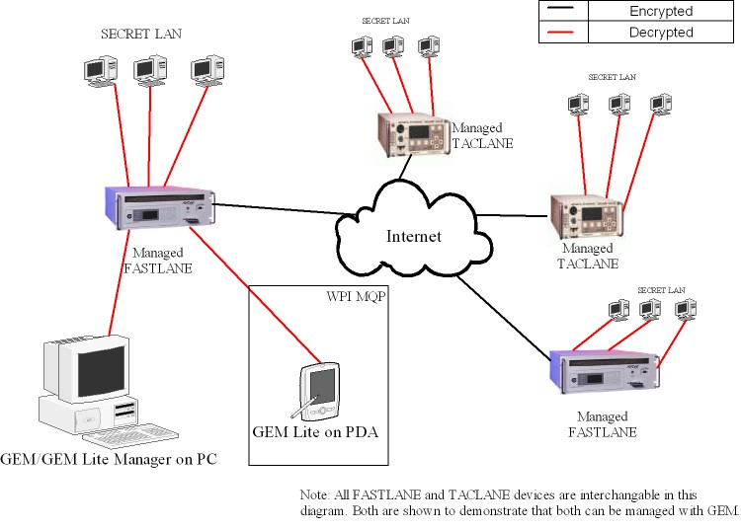
Figure 2- TACLANE/FASTLANE WAN Diagram

A FASTLANE is an ATM-only Encryptor. It allows users to transmit over shared public ATM lines for high-speed bandwidth. It can encrypt at up to 10Gb/s and support up to 1022 simultaneous connections. A FASTLANE also creates cryptographically dedicated virtual paths between hosts, which use generated keys for each connection. This ensures not only security between the FASTLANE devices, but ensures greater security for each connection. This feature also allows for more flexible bandwidth disbursement, allowing more bandwidth to be given to an individual connection. This helps to guarantee that bandwidth-sensitive applications such as VoIP calls will go through smoothly.
Both products make use of dynamic encryption keys, which are generated by the device and can be placed on a cryptographic ignition key (CIK). These keys can then be distributed to the various other FASTLANE or TACLANE products throughout the WAN.

2.3.1 The General Encryption Manager (GEM)
GEM is General Dynamics product, a custom written manager for the TACLANE and FASTLANE encryptors.

2.3.2 GEM vs. GEM Lite
GEM Lite is essentially a slightly modified version of GEM that General Dynamics gives away alongside each encryptor it sells. The limitations are described in the following section.
One difference between these two products is the database connectivity. GEM Lite OID value changes are recorded in flat files rather than into a database. Because of this the values received from the FASTLANE or TACLANE are not as easily accessible from other applications that have access to the oracle database. Depending on the type of installation and reasons for use, the customer might not need this additional functionality.
Another difference between these two products is the number of devices that each can manage. In order to assure that large-scale operations use the full version of GEM, the number of encryptors managed on GEM Lite is restricted to 25, while the full version is limited to 600.
The full version of GEM can create a graphical network map, which can show a large-scale view of the network and protected devices. This feature is not available in GEM Lite.
In order to assist in the management of the protected host and network elements, the full version of GEM contains HP’s OpenView capability, so that network managers can have more power from the single tool. This feature is not available in GEM Lite.
GEM Lite is a better choice for PDA porting rather than the full version of GEM due to the fact that a database or OpenView connection may not be available on the PDA.

3.0 Proof-of-Concept for an SNMP Manager Running on a PDA
The goal of this project was to create a proof-of-concept showing that an SNMP-based manager would be able to run on a PDA. This was done in two parts; a manager and an agent. The manager is a simple SNMP manager that runs on the Pocket PC operating system. The agent is designed to simulate a General Dynamics encryptor and runs on the Windows 2000 Professional operating system.

3.1 Project Development
The project development was split into two teams of two. One team worked on the development of the manager while the other group worked on the development of the agent simulator. The manager team was comprised of Dimitri Stancioff and Jeremy Lerch and the agent team was comprised of Stephen Goranson and Michael Milkin.

3.1.1 Manager Development Environment
The development environment for the manager consisted of two Dell Axim X5’s running Pocket PC 2003 (Windows CE 4.20) and two PC’s running Windows 2000. Microsoft Embedded C++ 4.0 was used for coding, using the Microsoft SDK for Pocket PC 2003. This IDE runs on the PC’s, which compile the application before uploading it to the PDA. Microsoft has made this environment very similar to their Visual Studio line of development products. Developing on a powerful PC rather than on the PDA directly has multiple advantages. First, the control offered by a mouse and keyboard is far superior to the stylus control on the PDA, and second, the compile times on the PC are greatly reduced due to the increased processor speed and memory.

In addition to being able to run the compiled application on the PDA directly, the Microsoft SDK for Pocket PC 2003 includes a simulator that can run the compiled code directly on the computer that it was compiled on. This is a valuable tool since the greater speed of control with the mouse and keyboard allowed us to test the builds of the application as it was developed.
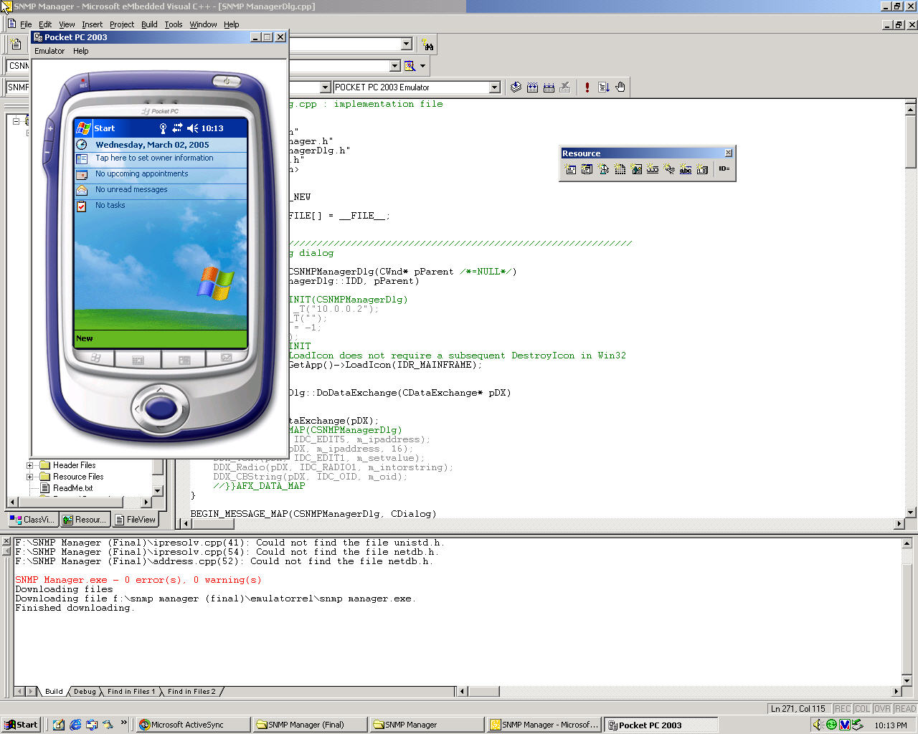
Figure 3- Microsoft embedded C++ IDE with emulator software

The compiled applications were then transferred to the PDA’s using Microsoft ActiveSync. This application is bundled with the Axim PDA. The PDA’s include a USB cradle that allows them to be constantly connected to the PC. Whenever a build of the application needed to be tested on the PDA, the process was simply to insert the PDA into the cradle and tell Embedded C++ to compile and upload to the PDA. This would then tell the Microsoft ActiveSync application to upload the executable to the PDA, and then the application could be opened on the PDA using the stylus.
To test and demonstrate that the PDA’s worked over a network, each was equipped with a TrendNet CompactFlash Fast Ethernet adapter. This device would slide into the Axim’s primary expansion bay, which took CompactFlash sized devices. The PDA could then immediately use the connected network. For simplicity, all the devices on the test network were assigned static IP addresses, but they all had the capability of being assigned an address using DHCP. When testing the code on the simulator, no special networking setup was needed, as the simulator was set up to take advantage of the computer’s network connection.

3.1.2 Agent Development Environment
The agent development was completed almost entirely under Windows 2000 running Visual C++ .NET. For the graphical user interface, this IDE allowed for the use of Microsoft Foundation Classes (MFC), and libraries like <windows.h> to make lower level win32 calls such as BitBlt(). The other main library the front-end relied on was the C++ Standard Template Library (STL) template for a <map>, <string>, and <vector>.
The back-end DLL was also constructed in Visual C++ .NET. It relied heavily on the <windows.h> win32 library to make use of its registry functions. For its SNMP functionality, it mainly used the win32 <snmp.h> library for functions to help with ASN object conversions, and variable bind list structures.
Finally, the database functionality of the MIB was constructed in the Windows Registry by using regedit.exe, which is included in every version of Windows. This program allows the user to edit the registry by way of a visual tree structure, or by importing and exporting entire branches of the registry. These branches are saved as flat text files with a .reg extension.

3.2 Manager Development
To develop an SNMP manager for the PDA, it was necessary to determine whether SNMP was supported by the Pocket PC 2003 operating system. In the case that the Pocket PC OS did not support SNMP, there were two backup plans for getting an SNMP manager to run on the PDA. The first plan involved creating the SNMP messages on the PDA but then encapsulating them and sending them to an intermediate PC. This PC would then strip the messages of the encapsulation and then send the SNMP message out to the managed device. The second backup plan was to have the actual manager running on the PC but have it controlled by a web interface on the PDA. The PDA would control the manager and the SNMP messages would be made accordingly on the intermediate PC.
An open source SNMP library named SNMP++ was found that was able to run on the Pocket PC 2003 operating system. This library provided functionality for generating the proper SNMP get and set PDU’s as well as sending them over the network. In addition, it has the ability to perform get-next and get-bulk commands as well as having basic trap functionality. The focus was on having the manager have the ability to both get and set data on an agent since a complete command set development would be unnecessary for a simple demonstration of SNMP.
SNMP++ is an SNMP library written by Peter E. Mellquist. It is an open source library that is based on the SNMP++ 2.6 library written by Hewlett Packard in 1996. SNMP++ version 2.8 was used which had support for SNMPv1 and SNMPv2. The library is now free for all development, including commercial uses, as long as the required code comments and documentation are included.
The SNMP++ libraries contain everything necessary to create SNMP packets. The library contains classes that will create SNMP protocol data units. The library also contains a class for object identifiers, octet strings, message queues and the abstract syntax notation. The library also contains every other class necessary to create either an SNMP agent or manager.
Through the use of this library, a series of builds was designed that would demonstrate the functionality of SNMP on the PDA. The focus was on developing a platform for SNMP that would be extensible. At any point in the development process, there would be flexibility to allow for any extra features deemed helpful for displaying the abilities of the PDA to perform as an SNMP manager. As features needed to be added into the proof-of-concept, the system would be flexible enough to reflect the new requirements.
The first version of the manager was a basic SNMP manager that allowed for the user to GET and SET the management data on an agent. It featured a simple interface that allowed the user to enter an IP address, an Object ID and an integer value to set. It also had a text field that would display the information sent back by the agent. On the top of this interface there were two buttons that would allow for the user to either send a get or set command to the client. This initial interface is shown in Error: Reference source not found.

This first manager ran using SNMPv1. The graphical user interface was created using the built-in dialog box creator in Microsoft Embedded Visual C++. The GET and SET buttons on the top of the GUI trigger code that creates an SNMP PDU. If the GET button is pressed the manager creates one PDU using the information in the IP address text field and the information in the in the object ID text field. This PDU is then set to be a GET PDU and is sent across the network to the agent at that IP address. The manager then receives the response from the agent and displays this information in the text field on the bottom of the GUI. If there is an error in the transmission of the SNMP packet, the error message is displayed in the same text field. When the SET button is hit the manager makes a PDU using the IP address and the object id. It then sends a GET PDU to the agent to verify that the object ID exists in the agent's MIB. If there is not an error message returned, the manager then uses the PDU that it created for the GET, adds the value from the value to set text field and sends this updated PDU to the agent with a set command instead of a get command. The agent then sends the same PDU to the agent as a get to refresh the values and make sure that the value was set properly. The limitations of the SET in this version of the manager is that it is only able to set integer values.
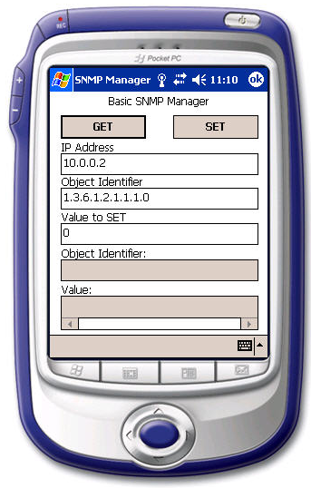
Figure 4 - Version 1 of the SNMP Manager
The second version of the manager only differed in the design of the graphical user interface. The core SNMP functionality is the same as that of the first version. In this manager, a hard coded example was needed to show what an MIB browser would look like. A labeled text field was made for every value in the agent's MIB. Each text field had a button that would execute a get on the object ID of that value. These object ID's were hard-coded into out manager. On the values that were able to be set there was a set button that executed a set with a hard-coded object IDs. This manager had a text field to enter the IP address of the agent which is the same functionality as in the first version of the manager.
A major problem was encountered with this implementation. The group was unable to get the browser window to properly scroll. The screen is limited to a 240 pixels by 320 pixels on the Dell Axim X5, which is far too small to properly display all of the management information for an agent. Scrolling was not implemented for dialog boxes in Windows CE 4.20. The screen of the PDA was only able to display five values from the MIB. The group modified the design to version three because of the inability of the dialog box to scroll to allow for the viewing of the other management information.
The third version of our manager is the final version that was created. This version looks similar to version one but it has some major differences. Instead of having a text field to specify the object ID of the value that the user would like to get or set, version three has a drop down menu that contains the names and object ID's of the management information hard-coded into it. This allows the user an easier interface to select the information that they would like to get or set. Version three also features the ability to set both integer and octet string values. The interface has two radio buttons that allow the user to select which type of data they would like to set into the agent's MIB.
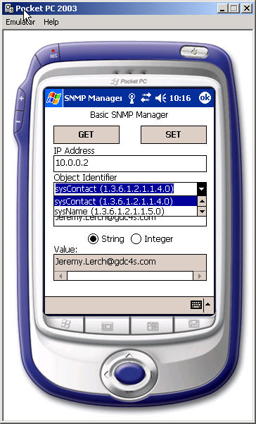
Figure 5- Working demonstration of the SNMP Manager

The third new feature of version three is the event log. An event class was written that would then write this event to a text file on disk. The event class records the time of an event, the IP address of the agent, the object ID of the management information, and the value either returned by the agent or set by the manager. This event is then written to disk in a text file.

3.3 Agent Development
The requirement for the agent was to simulate a manageable device that supported SNMP. The agent was designed to simulate an encryptor using the Win32 platform. The encryptor simulator is composed of three components: an extension agent DLL, a Windows registry MIB implementation, and the Microsoft Foundation Classes front-end. This is shown in Figure 6.

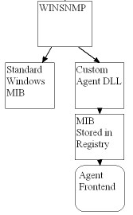
Figure 6- Agent Design

3.3.1 Agent Design
Writing software to make SNMP system calls would take up too much time, so the first step was to determine which SNMP framework to use. Development of the agent was to be done for the Win32 system. The PDA's ran Pocket PC 2003 so Windows 2000 Professional was the logical choice for the development of the agent.
The main problem with using the Windows environment was finding a library to use to develop the agent. There are numerous libraries available that offer high-level SNMP calls. It is usually as simple as one call to make a connection, one to send the PDU, and one to close the connection. One option was to use the same framework used to implement the manager, SNMP++. Unfortunately, none of these libraries simplify the task of creating an agent with a functional MIB that can store and retrieve custom MIB trees. Windows includes two built-in SNMP libraries, winsnmp.h and snmp.h. These libraries support agent calls to manipulate a MIB. The problem with these libraries was that they abstracted the task of using the Windows built-in MIB, but they added no support for creating a custom MIB. The best solution was to use an extension agent DLL.

3.3.2 DLL Design
An extension agent DLL is a Windows DLL that attaches to the Windows SNMP Service. It is commonly referred to as a subagent. The Windows SNMP Service is a program included with all variations of Windows NT that essentially gives the workstation the functionality of an SNMP agent. Windows has its own built-in MIB that contains objects such as FTP connections and software versions. If the SNMP Service is running, any SNMP manager can access these values. An extension agent DLL gives a programmer the ability to customize the Windows SNMP Service by adding a MIB branch. When the SNMP Service receives a request for an object contained in a custom MIB, the request is passed to the DLL, where it is handled and passed back to the service. The service sends the request to the manager.
The DLL needs to have greater functionality than simply responding to requests from the manager. There should be some functionality to communicate with a MIB database that is external to the DLL. One of the uses of SNMP is the ability to poll an agent over time on variable information, and display the variation in the form of graphs and charts. Typically, these would be MIB variables that are manipulated by the agent itself, such as throughput and current connection count. The fact that an agent needs to be able to change the MIB variables is the key reason why the agent was designed with a front-end and a back-end. A DLL by itself is not capable of asynchronously manipulating the MIB as necessary. Before this could be worked on, an MIB definition was needed.

3.3.3 MIB Design
Some of the functionality that all SNMP manageable devices have in common is the fact that they need a MIB definition and database. What this means in terms of design is that any agent needs a well thought out structure for the values it will use to describe itself, and how to store this structure. These two hurdles are the focus of the MIB design.

3.3.4 MIB Definition Design
Like any database, the MIB can be thought of as a tree of organized data. This data describes the current state of a device. The agent was designed to simulate an encryptor. The functionality of an actual encryptor inspired the encryptor MIB design. Like any MIB, a branch of the universal MIB needed to be chosen to place the simulated encryptor's local MIB inside. As described in the background, the universal MIB is first split into four branches: iso, org, dod, and internet. All MIBs must be placed in a subtree of one of these roots. In a production environment, it is not good practice to simply extend a random branch with a local MIB. Like a public IP address, there is actually registration with an organization that needs to happen so as not to override a previously defined MIB. For the agent’s purposes on an isolated four node LAN, this is not necessary. 1.3.6.1.4.1.2.70 was chosen for a root.
The root was then divided by functionality into three subtrees: general (for simple configuration variables such as router LAN address), advanced (for larger variable structures like tables representing a firewall configuration), and traps. Traps were not implemented, although they remain in the MIB. Some MIB variables were intended to only be read via GET, such as firmware version, model number, and Ethernet cable status. This read only status was defined via the ACCESS keyword, with a setting of read-only. All of these simple variables were found in the “general” tree. However, these read-only variables were not all constants. Specifically, the cable status and the Ethernet traffic variables were constantly changing based on the status of the simulated agent. This will be discussed further in the front-end design. The “advanced” tree was composed exclusively with MIB table structures. MIB tables are data types that allow a MIB variable to have both multiple sub-values (like a C struct or table columns) and multiple instances (like table rows). The tables were firewall configuration (that sets ports with enabled flags), port forwarding table (that forwards router ports to a specific IP address and local port), Demilitarized Zones table (standard router tool to let certain IP’s circumvent the firewall) a DHCP table, and a port connectivity table (which defined whether or not a cable was connected to a specific Ethernet port). To be able to properly use tables, the manager must be able to actually create rows in the MIB, but this was never implemented.

3.3.5 MIB Database Design
The confusing part about an MIB is that it is both a structure that defines metadata, and it is also a database that stores the actual data. The MIB definition design accomplished the metadata definition, and the agent now needed a suitable method of database design. The agent had a front-end and a back-end, but these two pieces of the agent needed to be able to share a MIB. There were several options. A MIB database could have been stored in a global C-struct in either the front-end or the back-end, and some form of interprocess communication (IPC) could have been used, such as Win32 message passing, or a memory mapped file. While possible, sharing this struct between a DLL and a MFC application would have been difficult, and there was a simpler approach. Additionally, the MIB was commonly referred to as a database, and a global C struct did not make sense for a method to implement a database.
The Windows registry was the ideal method to implement a MIB database. It already supported the tree structure that a MIB contained. It also already had an interface that would make creating, manipulating, and copying a MIB very easy. Once the structure was created in regedit.exe, the subtree could be exported as a flat text file and reloaded into any registry wanted. There were simple Win32 reading and writing calls that would support database sharing between multiple processes without creating a custom solution. Finally, it was the logical place to store device configuration values, since it is the place for Windows configurations in general.

3.3.6 Front-End GUI Design
The front-end Graphical User Interface (GUI) creates a human readable display of the communication going on behind the scenes between the manager and the agent. There were two main objectives for the front-end: to find an attractive method of displaying the current state of an encryptor, and to simulate events of an encryptor that would change this state.
The GUI window needed to display a set of tables to display the MIB OID data and dynamically update itself when the manager changed these values. It also needed to have a dynamic image that would change based on one OID value, such as the cable status. The tables display three columns: the OID name, the OID number, and the current value. Two tables display the ten variables from the “general” tree of the MIB, and three tables display the important tables of the “advanced” tree: firewall, port forwarding, and Ethernet traffic. The image itself should initially display a simple image of the router. Cable status is an integer between 0 and 4 inclusive. It represents which Ethernet cable is disconnected, if any. As a cable becomes disconnected, the image of the router will display a light, indicating a disconnect. Besides these details, the GUI window should be a typical Win32 default window.

3.3.7 DLL Implementation
The subagent DLL was divided into three files that each handled a different functionality of the DLL. The three files that make up the agent DLL are FillReg.cpp, RetrieveReg.cpp and SNMPREG.cpp.
The FillReg.cpp part of the subagent handles all write commands to the Registry. This file contains the function FillReg that requires four parameters: the OID of the node being altered, the name of the value being changed, the value that the node is being changed to, and the OID of the root node for the custom MIB. After this function executes, the node selected by the manager is altered to the value desired. If the function is unable to alter the node’s value for any reason the function returns false, otherwise it returns true.
The second file created to handle the subagent DLL functionality was the RetrieveReg.cpp. This file is responsible for querying of the Registry for values. When the manager issues a GET command, this function is called to retrieve the value from the desired node. The RetrieveReg function requires four parameters: the OID of the node to be queried, the name of the value to be queried, a value parameter that the value is to be stored in, and the string name of the root OID of our custom MIB. This function would return false if the value, key, or root was not found. If the value is found under the root and the node specified, the function returns true.
The final and most important file written was the SNMPREG.cpp. This file handles the set up of the custom MIB with the Windows SNMP Service and handles the sending and receiving of the SNMP packets. The first major function that was written for this file was the SnmpExtensionInit function. This function is responsible for the set up of the MIB with the Windows SNMP Service and inside the registry. This function utilizes two custom functions. StringtoOID converts a string to an OID. SearchOID takes a string as a parameter, finds and saves the root OID from the registry, and stores it in the string parameter.
By registering the MIB prefix with the service, the Windows SNMP Service will call the dynamically linked library when it receives a call to that MIB prefix. This function is also responsible for creating the log file for the DLL agent. This file will be stored in the WINNT/system32 directory.
The second most important functionality of the SNMPREG.cpp is the ability to parse the SNMP requests and to issue gets and sets according to the SNMP request. This functionality is written in the SnmpExtensionQuery. This function takes a VarBindlist of requests to the agent and, according to the PDU type of each request, calls a specific function. If the sub agent receives a GET or SET PDU, it then calls the function GetRequest or SetRequest, respectively.
The GetRequest function takes a VarBind and strips the OID suffix of the queried node from the custom MIB root prefix. It compares the access rights and the syntax versus the manager’s requested syntax. After completing those checks, the value is then stored inside a VarBind and sent back to the manager. The SetRequest function works the same way as the GetRequest function with one exception: the function sets the value in the MIB and does not change the value in the VarBind passed to the SetRequest function. Both the SetRequest and GetRequest function return an integer that is defined by the SNMPv1 errorStatus type, which indicates common transmission problems like access errors and malformed requests. When the subagent is terminated, the program de-registers the MIB root OID with the Windows SNMP service.

3.3.8 Front-end GUI Implementation
To display and maintain the current state of a router, the front-end must be capable of interacting with the MIB, which is implemented in the Windows registry. The GUI needs to periodically poll the registry for new values in the MIB. The MIB interaction functionality was collected into one C++ library regFunctions, and one class, MIB leaf. The class described an OID and its values, and was very useful for maintaining the tree of OID’s composing the MIB. Ultimately, a C++ Standard Library (STL) map was used to create an associative array of OID’s (strings) and OID structures (MIB leaf objects). The library regFunctions dealt primarily with traversing the MIB in the registry. Using standard Win32 calls like RegOpenKeyEx() and RegQueryValueEx(), the library’s primary function dumpReg() recursively traverses the MIB tree and creates a map of the OID’s given a MIB root string.
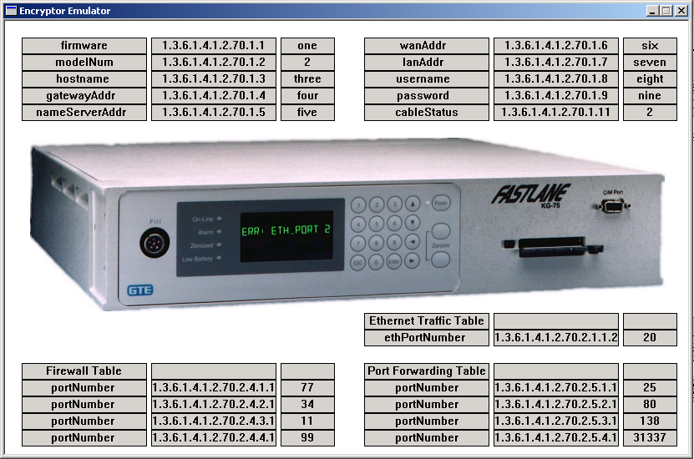
Figure 7- Interface of Encryptor Simulator
To deal with the problem of multiple process access to the registry, the new functions simply checked for error return codes on the Win32 registry functions, and waited one second before querying the registry a second time. Before the GUI was coded, these lower level registry functions were tested and debugged via a Windows console application. A global debug flag was added and a debug library written. The debug library overrides the debug() function several times to allow for virtually every data type one might want to observe and write to a file. If the debug flag is set, this debug file also doubles as a log file.
The GUI window itself was written using MFC. Originally, it was going to be written in lower level Win32 system calls, but the issue of classes and drawing tables made the task more difficult than originally expected. The overhead necessary for writing an MFC application will not be described here, but there are a few key functions necessary to discuss. The GUI tables representing the MIB OID tables were created using a new class called COidTable. Given a set of coordinates, a number of rows, and a window to create itself on, a COidTable will create an array of CRect (MFC rectangle class) objects that will visually appear to be a three-column table. It provides methods to set each column with a string representing an OID, an OID name, or a value.
To implement what appears to be lights changing based on cable status, four bitmaps were created and linked, and are bit block transferred (bitBlt) onto the screen based on the current cable status. To poll the registry, repaint the window, and also randomly generate spontaneous events like port traffic and cable disconnects, a Win32 timer was used. A typical sleep() function cannot be used because a GUI must be constantly repainting the window, and MFC handles this problem by supplying a timer object. Every 1000 milliseconds, the registry is dumped into a MIB leaf map. If the cable status has changed, a new bitmap will be bit block transferred onto the window. All the CRect text values are reset. Finally, if a rand() generator function produces a certain value, traffic will be generated and set in the registry, and/or a cable status will be reset in the registry.

3.3.9 MIB Implementation
The implementation of the MIB in the Windows registry was very straightforward. A common syntax was designed and created for the MIB data. The registry is composed of keys and values. Keys look like folders in the registry GUI, and values look like files. For the implementation, keys represented OID’s, and values represented OID attributes, specifically ACCESS, SYNTAX, DESCRIPTION, OIDNAME, and VALUE as shown in Figure 8 and Figure 9.

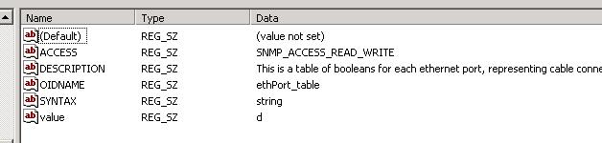
Figure 8- OID values implemented in the registry

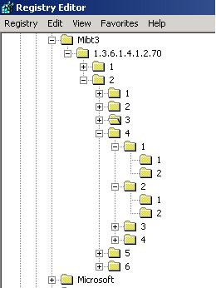
Figure 9- OID tree structure in the registry

In the registry, all the values were set to be REG_SZ, which is a null terminated string. The OID SYNTAX type is the data type that SNMP managers and agents use communicate with each other, whereas the registry data type is the type that the agent front-end and back-end use to share the MIB values.

3.4 Solution to General Dynamics Requirements
Our solution demonstrates the basic capabilities for a PDA to serve as an SNMP based network manager. Through the use of the SNMP++ libraries, and the functions that were used to make these libraries function properly on a PDA, General Dynamics should be able to more easily be able to update GEM to use the SNMP++ libraries. Our solution serves as a proof-of-concept however, and should help to secure the necessary funding for General Dynamics to pursue the use of PDA’s as network managers in the future. For more details on how GEM can be ported to the PDA, see section 4.1.
The complete solution is shown in Figure 10. The front-end forms a complete PDU, then calls the SNMP++ library calls with that PDU as an argument. SNMP++ then sends the PDU over TCP to the Agent, running on a Windows 2000 machine. This machine takes the request in through SNMP.exe, and processes it uses the custom agent DLL. This then modifies the registry (the MIB), or queries the registry and passes the value back to the manager using the SNMP.exe service.
Figure 10 - Complete Solution Diagram

4.0 Recommendations and Future Work
This project was a proof-of-concept to show that it is possible for a PDA to function as an SNMP manager. This was shown by the simple SNMP manager that was developed in this project. There are many things that can be done to extend this project past the proof-of-concept shown by the basic SNMP manager.

4.1 GEM
As the teams at General Dynamics or future WPI MQP’s take this project forward in the future, the next logical step in development is the porting of General Dynamics’ GEM software to the PDA. This will be aided by the network manager demonstration code that was produced through this MQP. The existing design of GEM is shown in the diagram below:

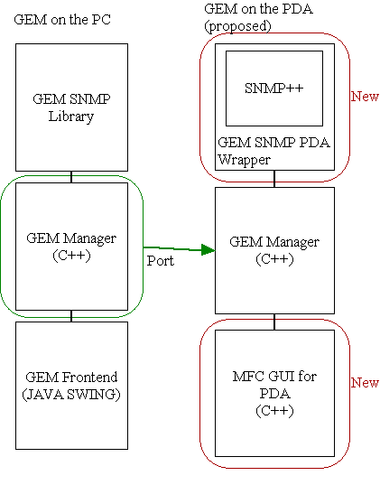
Figure 11 - Diagram of GEM port to the PDA

In order to properly port GEM to the PDA, two parts of the current application will have to be replaced.
The SNMP calls are made to a library that is designed to run on Win32. Rather than port this library, the open-source SNMP++ application could be substituted. This project has demonstrated the possibilities and functionality of SNMP++ on the PDA, and feels that it holds the necessary functionality to fill this role.
Because JAVA does not have a fully released version for the Pocket PC operating system, the JAVA GUI will have to be written. This will have to be developed using the Microsoft Foundation Class Library. In addition, the interface must be viewed on the much lower resolution screen of the PDA, which would require the GUI to be re-developed from the ground up to ensure proper usability at that size.
5.0 Appendices

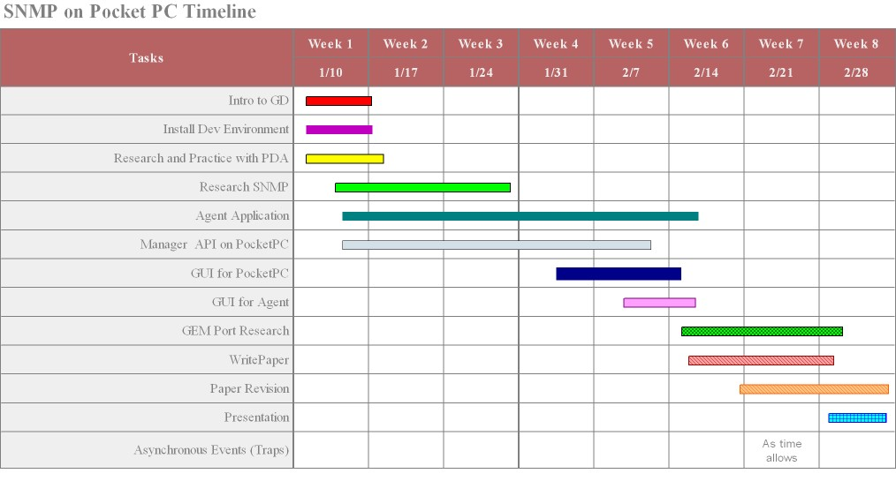
6.0 Works Cited

7.0 Bibliography
AdventNet, Inc. AdventNet C SNMP Agent. January, 2005. <http://www.adventnet.com/products/cagent/c_snmp_agent_datasheet.html>

Applied SNMP. Samples-C. January, 2005. <http://www.winsnmp.com/samples/c/index.htm>

Blumenthal, U. and Wijnen, B. “RFC2264: User-based Security Model(USM) for version 3 of the Simple Network Management Protocol (SNMPv3)”, January 1998.

Blumenthal, U. and Wijnen, B. “RFC2574: User-based Security Model(USM) for version 3 of the Simple Network Management Protocol (SNMPv3)”, April 1999.

Brain, Marshall. DevCentral. January, 2005. http://devcentral.iticentral.com/articles/MFC/vc6_mfc/2.php>

Case, J., Fedor, M., Schoffstall, M. and Davin, J. “RFC 1067: A Simple Network Management Protocol”, August 1988.

Case, J., Fedor, M., Schoffstall, M. and Davin, J. “RFC 1157: A Simple Network Management Protocol (SNMP)”, May 1990.

Case, J., McCloghrie, K., Rose, M. and Waldbusser, S. “RFC 1442: Structure of Management Information for version 2 of the Simple Network Management Protocol (SNMPv2)”, April 1993.

Case, J., McCloghrie, K., Rose, M. and Waldbusser, S. “RFC 1448: Protocol Operations or version 2 of the Simple Network Management Protocol (SNMPv2)”, April 1993.

Case, J., McCloghrie, K., Rose, M. and Waldbusser, S. “RFC 1450: Management Information Base or version 2 of the Simple Network Management Protocol (SNMPv2)”, April 1993.

Case, J., McCloghrie, K., Rose, M. and Waldbusser, S. “RFC 1902: Structure of Management Information for version 2 of the Simple Network Management Protocol (SNMPv2)”, January 1996.

Case, J., McCloghrie, K., Rose, M. and Waldbusser, S. “RFC 1905: Protocol Operations or version 2 of the Simple Network Management Protocol (SNMPv2)”, January 1996.

Case, J., McCloghrie, K., Rose, M. and Waldbusser, S. “RFC 1907: Management Information Base or version 2 of the Simple Network Management Protocol (SNMPv2)”, January 1996.

Case, J., Harrington, D., Presuhn, R. and Wijnen, B. “RFC 2572: Message Processing and Dispatching for the Simple Network Management Protocol (SNMP)”, April 1999.

Cisco Systems, Inc. Cisco MDS 9000. January, 2005. <http://www.cisco.com/univercd/cc/td/doc/product/sn5000/mds9000/1_3_1/ol533001.htm#37617>

Dart Communications, Inc. SNMP Agent OCX. January, 2005. <http://www.dart.com/snmpagent.asp>

Harrington, D., Presuhn, R. and Wijnen, B. “RFC 2261: An Architecture for Describing SNMP Management Frameworks”, January 1998.

Harrington, D., Presuhn, R. and Wijnen, B. “RFC 2262: Message Processing and Dispatching for the Simple Network Management Protocol (SNMP)”, January 1998.

Harrington, D., Presuhn, R. and Wijnen, B. “RFC 2571: An Architecture for Describing SNMP Management Frameworks”, April 1999.

Jupitermedia Corp. CodeGuru Forums. January, 2005. <http://www.codeguru.com/forum/index.php>

Levi, D., Meyer, P. and Stewart, B. “RFC 2263: SNMPv3 Applications”, January 1998.

Levi, D., Meyer, P. and Stewart, B. “RFC 2573: SNMP Applications”, April 1999.

McCloghrie K. and Rose, M. “RFC 1066: Management information Base for Network Management of TCP/IP-based Internets”, August 1988.

McCloghrie K. and Rose, M. “RFC 1156: Management information Base for Network Management of TCP/IP-based Internets”, May 1990.
Microsoft Corporation. MSDN Home Page. January, 2005. <http://www.msdn.com>

No author. ByteSphere's MIB Download Area. January, 2005.
<http://www.oidview.com/mibs/detail.html>

No author. NET-SNMP-TUTORIAL-MIB. January, 2005. <http://net-snmp.sourceforge.net/tutorial/tutorial-5/toolkit/mib_module/NET-SNMP-TUTORIAL-MIB.txt>

Petzold, Charles. Programming Windows: Fifth Edition. Redmond, WA: Microsoft Press, 1999.

Rose, M. and McCloghrie K. “RFC 1065: Structure and Identification of Management Information for TCP/IP-based Internets”, August 1988.

Rose, M. and McCloghrie K. “RFC 1155: Structure and Identification of Management Information for TCP/IP-based Internets”, May 1990.

Rose, Marshall T. The Simple Book: An Introduction to Management of TCP/IP-based Internets. Englewood Cliffs, New Jersey: Prentice-Hall, Inc., 1991.

Rose, Marshall T. The Simple Book: An Introduction To Internet Management Second Edition. Englewood Cliffs, New Jersey: Prentice-Hall, Inc., 1994.

Silicon Graphics, Inc. basic_string<charT, traits, Alloc>. January, 2005.
<http://www.sgi.com/tech/stl/basic_string.html>

Stroustrup, Bjarne. The C++ Programming Language, Special Third Edition. Indianapolis: AT&T, 2001.

The C++ Resources Network. C++ Tutorial: 6.1. January, 2005 <http://www.cplusplus.com/doc/tutorial/tut6-1.html>

Wijnen, B., Presuhn, R. and McCloghrie, K. “RFC 2265: View-based Access Control Model (VACM) for the Simple Network Management Protocol (SNMP)”, January 1998.

Wijnen, B., Presuhn, R. and McCloghrie, K. “RFC 2575: View-based Access Control Model (VACM) for the Simple Network Management Protocol (SNMP)”, April 1999.
Yoga Ramanan, T. The Code Project: How to Develop an SNMP extension Agent. January, 2005. <http://www.codeproject.com/internet/SNMP_Agent_DLL__Part1_.asp>

Rose, M. RFC 1065.
McCloghrie, K. RFC 1066
Case, J. RFC 1067
Rose, M. RFC 1155
McCloghrie, K. RFC 1156
Case, J. RFC 1157
Case, J. RFC 1442
Case, J. RFC 1448
Case, J. RFC 1450
Case, J. RFC 1902
Case, J. RFC 1905
Case, J. RFC 1907
Harrington, D. RFC 2261
Wijnen, B. RFC 2265
Harrington, D. RFC 2571
Wijnen, B. RFC 2575
Blumenthal, U. RFC 2574

