Project Number: MLC-CG06

THE EFFECTS OF DISPLAY SETTING IN
DIFFERENT VISUAL PERSPECTIVES ON
PERFORMANCE IN GAMES

A Major Qualifying Project Report:

submitted to the Faculty

of the

WORCESTER POLYTECHNIC INSTITUTE

in partial fulfillment of the requirements for the

Degree of Bachelor of Science

by

_________________________________
Geoffrey Verbeke

and

_________________________________
Michael Wood

Date: March 2, 2007

Approved:

_________________________________
Professor Mark Claypool, Major Advisor

Abstract

The goal of this study is to assess the effect of display settings in different visual perspectives on performance in computer games. We define perspective to be one of three possible views: 3rd person 3D where the camera is placed behind the avatar and objects increase or decrease in size with respect to the avatar, 3rd person 2D where the camera is placed above the avatar and objects do not appear to change size, and first person where the camera is placed as if you are looking through the eyes of the avatar. Three custom games, one for each perspective, were built with two basic tasks per game: the navigation task where the user had to find the correct object in a room and the shooting task where the user had to shoot a specific target. A test harness was developed for a study that presented users with games in these varying perspectives, tasks, frame rates, and resolutions and their performance was evaluated based on their score. Twenty-seven users participated in the user study. The analysis finds that participants perform better in the 3rd person view than in the 1st person view for the navigation task and perform better when frame rates are above 15 frames per second.
Acknowledgements

We would like to thank Professor Mark Claypool for taking the time every week to meet with us and point us in the right direction. In addition, we would like to thank the Worcester Polytechnic Institute for allowing us the use of their facilities.

Table of Contents

1: Introduction 1
2: Related Work 3
2.1 Perspective: 3
2.2 Display Settings: 6
2.3 Resolution: 7
2.4 Frame Rate: 9
3: Background 10
4: Approach 13
4.1 Experimental Parameters: 13
4.2 Development of Games: 14
4.2.1 Development of 3rd Person 2D Perspective: 15
4.2.2 Development of First Person Perspective: 17
4.2.3 Development of 3rd Person 3D Perspective: 19
4.2.4 Normalization: 21
4.2.5 Compilation of Executables: 22
4.3 Development of Test Harness: 22
4.3.1 Interface Design: 22
4.3.2 Data Collection: 26
4.3.3 Prevention of User Manipulation: 29
4.4 User Study: 29
4.4.1 Testing Location: 29
4.4.2 Local vs. Network Database: 30
4.4.3 Participant Solicitation: 30
5. Results: 31
5.1 Demographics: 31
5.2 Test Results: 37
6. Conclusion: 43
7. Further Studies: 45
References 46
Appendix A: Sample Flyer 48
Appendix B 49

1: Introduction

Throughout the history of the video game industry, games with several varying aspects such as genre, tasks, and display settings have been developed and introduced to the market. Games have been introduced in different genres such as role-playing games and first-person shooters, with varying graphics from 8-bit to 64-bit, with a range of roles and tasks from searching a cave to shooting a monster, and with several alternate display settings such as gamma correction, color versus black and white display, aliasing versus anti-aliasing, frame rate, and resolution. In general, players customize display settings to their preference.
Many researchers have studied the effects of some of these display settings such as frame rate and resolution on user performance in different games. For instance, the frame rate and resolution may have more or less of an impact on user performance depending on the genre of the game. In a role-playing game, frame rate and resolution are likely to be less important than in a game where precision and accuracy are needed for high user performance.
One of the factors that may effect how display settings impact user performance in games is the perspective of the game. In other words, perspective combined with different display settings may alter the user performance. For example, frame rates may have more of an effect on user performance than in a third-person perspective game than in a first person perspective game because when the user is placed in a first person view, they are limited in the amount of the room or world that they can see at a given time due to skipped frames. Perspective is defined is as the “depiction of three-dimensional objects and spatial relationships on a two-dimensional plane”¹. In video games, this has an even simpler definition, that being the position of the camera itself. Perspectives in video games control the amount of the virtual world in the viewport and effect the spatial relation to various targets. At first glance, there appears to be several different types of perspectives, including first-person, third-person, overhead view, omnipresent view, and isometric view. Often the perspective in games is chosen with respect to the task being performed. Notably, many games share the same tasks such as shooting, but have different perspectives. For example, both Winback and Doom 3 are shooting games, but Winback is set in a third-person view whereas Doom 3 is set in a first-person perspective. To shoot in Winback, a key is held down to stop the avatar from moving and begin the aiming process. The analog stick is moved to position a cursor and another key is pressed to fire the avatar’s weapon. In Doom 3, the user positions the weapon over the enemy and fires the weapon by pressing the left mouse button or the control key. Despite having such a large impact in a game, perspective has not been studied to the degree that visual and display settings have been. Perhaps varying frame rate and resolution may have a greater or lesser impact on user performance depending on the perspective the game is in.
This study is intended to define several general definitions of varying perspective and examine how display settings affect user performance in different perspectives in video games. The study will also consider how well different users perform tasks such as shooting a target and searching for an object within various perspectives. This will be determined by altering the frame rate and resolution in each perspective and measuring the loss or gain in player performance. To do this, three games were created with varying perspectives, 3rd person 2D, 3rd person 3D, and first person. Participants were then asked to play a series of fifteen second long games where the frame rate was altered between 7, 15, and 30 frames per second and the resolution was set at either 800 x 600 pixels or 1280 x 1024 pixels. Additionally, the games either focused on a navigation task or a shooting task. The score that each participant achieved in each game was used as a measure of performance.
Our hypothesis is that the user will perform the best in the first person perspective for the shooting task. However, we hypothesize the 3rd person 2D perspective will be better suited for the navigation task since the entire room is visible to the user. In addition as frame rate increases, we believe user performance will also increase. We do not expect changes in resolution to have a significant impact on score.
Overall our results proved that the 3rd person 2D perspective is indeed better suited for the navigation task. However, it was also found that this perspective was also the best for the shooting task. Notably, the first person perspective showed the worst user performance for the shooting task, though the results were not significant due to overlap in confidence intervals. As frame rates increased there was an increase in score as well. Resolution was found to have little impact on user performance across all perspectives, as hypothesized.
The rest of this paper is organized as follows: Chapter 2 provides various related works to our study; Chapter 3 outlines our basic definitions of perspective and tasks in video games; Chapter 4 defines our experiment and how it will be executed; Chapter 5 describes the results of the experiment; Chapter 6 provides a brief synapses of the entire study and concludes the final results; and Chapter 7 provides additional changes to the experiment for further study.

2: Related Work

Several articles have been written that relate to this study on perspective and display settings. Each article focuses on one of four different categories: perspective, display settings, resolution, and frame rate. The following section describes these articles in detail and how they relate to this study on the effects of visual perspective on user performance in video games.

2.1 Perspective
Richard Rouse² defined and compared the first-person perspective and the third-person perspective in video games. He explained that the difference between the two perspectives is the positioning of the camera in the virtual world. In the first-person perspective, the camera is positioned to give the effect of the world being seen through the eyes of the avatar. In the third-person perspective, the camera is positioned so that that the user can view the avatar. Generally in a 3D third-person perspective, the camera is positioned behind the character and over the shoulder. Rouse further discussed the advantages of one perspective over another, explaining how the first-person perspective allows for a player to become more immersed in the virtual world since the player may assume the role of the character. Rouse also gave various examples of games using the first-person perspective and the third-person perspective. Notably, he considered the 2D side-scrolling game Leisure Suit Larry to be a game using third-person perspective, despite the camera not being positioned in the general over the shoulder location. This example shows how perspective relates to both 2D and 3D games and allows for defining perspective with respect to them.
This article gave general definitions and examples of perspective in video games. This relates to our study since the definitions defined in this article are expanded upon and used in the creation of the games in our study.
Troy et al.³ performed various experiments to determine if different tasks involving relative positioning and orientation of objects are better suited for a display in 2D, 3D, or a display combining both of these views. The first experiment tested which view was superior for relative positioning and the second experiment tested which view was more effective for orientation. In the relative positioning experiment, participants had to determine the height of a ball over a block given one of the five different display settings presented. These display settings included 3D shadow where the ball cast a shadow on the block, 3D rotated where two 3D views at different angles of the objects were shown, 2D where flat images of the objects were shown, and two different combination displays of 2D and 3D images. The 3D shadow display took the fastest time and had the most errors, but the degree of error was small. The 2D and 3D rotated displays, on the other hand, were the least effective. In the orientation experiment, participants had to orient a plane to cut a torus in half. The displays in this experiment were similar to those used in the relative positioning experiment, with the only difference being that three combination displays were used and one strictly 2D and one strictly 3D display was used. Like in the previous experiment, the 3D display performed faster than the 2D display, but had significantly more error. From these experiments, it was concluded that strictly 3D displays are ineffective for both positioning and orienting objects unless there are additional features such as lighting, shadows, and a quality viewing angle. However, using these additional features made 3D displays highly effective for approximation in positioning and orientation.
This study relates to our experiment since it assists in providing a guideline for creating games with 3D perspectives. Whereas 3D perspective may be limited without several additional graphical features such as lighting and shadows, 2D perspectives may allow the user to perform well consistently. For this reason, the additional features of lighting and shadows must be taken into account when creating a game using the 3D perspective.
In a related study, Yang and Olson⁴ studied how differing views or perspectives affected two tasks: searching through a world and shooting an object. It was hypothesized that users would perform better in the shooting task and worse when searching for an object while in the first-person view. In the third-person view, the opposite was proposed. In the experiment, there were two users performing each task. One user was the driver and the other was the navigator. The navigator had to relay information to help the driver complete his specific tasks. Participants were asked to complete two tasks, navigate a virtual submarine through a 3D world to a desired location and destroy various enemy targets. Participants were asked to do this for three different views: first-person, tethered, and third-person. In the first-person view, the driver navigated the environment as if he or she was inside the ship. The navigator had the same view, except the target was represented as a flashing dot. In the tethered view, the camera was placed behind and slightly to the right of the submarine. As the submarine moved, the camera was “tethered” behind it, and moved in the same direction. In the third-person view, the driver and the navigator could see the entire board at any one time. The submarine moved around in the allocated playing field, but the camera remained stationary at all times. It was found that in the third-person view, searching was much faster than in the first-person view and that the first-person view was more effective in targeting an object.
This study examined how altering the perspective in two tasks: navigation and shooting affects user performance. This study uses the same tasks that will be used in the games created for our study. Contrary to this study, we examine user performance when displays settings are altered over three different perspectives using the aforementioned tasks.
Martijn Schuemie⁵ added a secondary external perspective to a Virtual Reality Exposure Therapy (VRET) system to determine how it impacted the performance of the therapist. Generally, a VRET system only provides a view of the virtual environment from the patient’s view, a first-person perspective. Participants took the role of the therapist and used a joystick to attempt to move a patient through a virtual environment as quickly as possible. Participants were either given solely the first-person view of the patient or they were given both the first-person view as well as an external view of the virtual environment. Variables including the total time to move the patient to the end of the environment and total length of the path taken to the end of the environment were recorded. The results indicated that the addition of the external perspective improved the precision with which the participants positioned the patients. However, the use of the external perspective indicated that the total path length and total time were both longer. The results of a questionnaire indicated that the reason for this was because the participants chose to look at the external view when it was available. These results show how first-person perspective may be ideal for the task of navigating an environment whereas a more precise task such as positioning a target may be more effective in an external or third-person perspective.
This article relates to our study since it observes user performance in different perspectives. Contrary to this study, our study will alter display settings and only use one perspective at a time in each created game to measure user performance. These results help to determine that the type of tasks to be implemented into the games that we will create should primarily consist of navigation and a precision task.
In the above two studies, it is noteworthy that the results seem contradictory. The main difference between the results is that in Schuemie’s study⁵ participants were asked to navigate an environment and place a target as opposed to actually shooting a target as in Yang and Olson’s⁴ study. This could explain the differences in conclusion.

2.2 Display Settings
Claypool et al.⁶ hypothesized that frame rate has a significant impact on user performance in first-person shooters whereas resolution does not. However, both resolution and frame rate have a significant impact on perceived picture quality in first-person shooters. To test this, a custom Quake III map was created and users were asked to shoot at and kill a bot as fast as they could. During this experiment, the resolution was varied from 320 x 240 to 640 x 480 and the frame rate was varied from 3 frames per second to 60 frames per second. User performance was measured from the number of times the player was shot by the bot and the number of times the bot shot the user. Users were also asked to rate the overall quality of the graphical settings. The study concluded that frame rate had a more significant effect on user performance than resolution. Frame rates were shown to affect performance so much that the game was deemed unplayable if the frame rate was lower than 7 frames per second. For user perception both frame rate and resolution were found to be important factors.
This study examined frame rate and resolution within one game genre and only the first-person perspective. In our study, we test the effect of frame rate and resolution in various perspectives.
Polys et al.⁷ hypothesized that having an increased display size will aid in 3D navigation. They believed that increasing the software field of view, how much of the screen the user is presented at one time, will improve search tasks, but cause spatial comparison to worsen. To test this, Polys et al. created a virtual biological cell with properly labeled components and presented the information in two views. The first view, the viewport workspace view, is best described as a Heads-Up-Display where the object labels are always visible at the top of the screen. The second view, the object view, places the labels next to the object. Therefore the labels are only visible when they are within the field of view of the user. The software field of view and screen size were also varied in both cases. The study concluded that in general, participants were able to search much faster with the object view. However, the viewport view allowed for better accuracy in identifying the needed object. On smaller screens it was found that changing the software field of view had no effect, but on larger screens there was an increase in participant accuracy.
This study examined two different views, the object view and the viewport workspace view, whereas our study examines the more broad varying perspectives of first-person and third-person. This study shows possible variations when the display settings are altered. Perhaps on a larger screen perspective has more of an impact on user performance.

2.3 Resolution
Ni et al.⁸ studied how larger display sizes and higher resolutions affected 3D navigation in an information rich virtual environment. It was hypothesized that a larger display size with a higher resolution would aid in 3D navigation. Ni et al. also believed that when users are given a map, participants will be able to navigate the environment more effectively. To do this, a virtual art museum was created and participants were asked to find various objects and information within it. Participants were then divided into four subcategories of settings: low resolution with a small screen size, low resolution with a large screen size, high resolution with a small screen size, and lastly high resolution with a large screen size. Half the participants in each subgroup were given a map while the other half were not. Subjects were then asked to find various objects and textual information in the museum. Overall, it was found that participants using the higher resolution on a larger screen found the desired object faster. Participants using the map also exhibited faster times in finding the object.
This study shows a higher resolution is beneficial in 3D environments. Our study examines if higher resolutions are beneficial in different perspectives. Changing the resolution may alter how well participants perform. Perhaps a lower resolution is better for first-person views, but a higher resolution is better for third-person views.
In another study, Smeet and Overbeeke⁹ examined the importance of resolution in immersive virtual reality as opposed to classic computer graphics applications. In immersive virtual reality, users explore the environment by moving their own physical body, as opposed to a computer graphics application where users explore the area by looking at a single viewport. Smeet and Overbeeke hypothesized that resolution is much less important for interactive tasks in virtual reality than it is in classic computer graphics applications. To test this, participants were given a pair of glasses which displayed three different camera views: active head-coupled camera motion where the camera is mounted on the glasses, passive camera motion where the camera can be pivoted with the participant’s body, and still camera motion where the camera is fixed. Participants were then asked to solve a basic jigsaw puzzle in the above camera views at varying resolutions. It was found that in most cases while in the active camera view, subjects still performed significantly well.
This study examined resolution on one task, solving a puzzle. Whereas this study examined the effects of resolution on one task, we examine the effect of resolution and other display settings on multiple tasks.

2.4 Frame Rate
McCarthy et al.¹⁰ conducted a series of experiments to assess the guideline that frame rate is a more important measure of quality to the user than resolution in video with high motion activity. To test their hypothesis, McCarthy et al. conducted an experiment where six different soccer clips were displayed on a desktop with the video window having a size of 352 x 288 pixels. The soccer clips were presented with variations in frame rate as well as resolution. Participants were asked to indicate when the quality of the video clips was acceptable or unacceptable. The results indicated that the acceptable level of quality only decreased slightly as frame rate was reduced. Participants found a decrease in frame rate more acceptable than a decrease in resolution. When the frame rate was at six frames per second, the quality was still considered acceptable at a rate of 80%. The experimenters conducted a similar study with the major difference being that the soccer clips were displayed on a palmtop with the video window having a size of 176 x 144 pixels. Similar results were concluded, though the participants found a lower frame rate to be less acceptable than on the desktop. When the frame rate was at twelve frames per second, the quality was still considered acceptable at a rate of 50%.
The study concluded that the existing guideline that frame rate is a more important measure than quantization is incorrect. This applies to our study since when using different perspectives in games, an alteration in the frame rate may not have as large of an effect as an alteration in the resolution.
Martin Reddy¹¹ examined the importance of frame rate on user performance in virtual games. Reddy hypothesized that the lower the frame rate, the larger the decrease in user performance. To test this, participants were shown a 3D world of one hundred and fifty objects. To prevent the eye from being drawn to one object in particular, all the objects were represented as a picture of a small tower. One object was selected as a fixation point and the user was asked to focus on that point. The camera would then move about the fixation point and the user was asked whether they had moved left or right of that point. Their response time and correctness were then recorded. The test was repeated several times at two frame rates, 11.5 Hz and 2.3 Hz. At the end of the study it was concluded that tests run at 2.3 Hz exhibited a much lower reaction time to achieve the correct result. To make sure the results were not skewed due to the large change in frame rate, another experiment was created with two frame rates that were closer together: 6.7 Hz and 14.2 Hz. The same results were achieved.
This study examines the effect of frame rate on user performance, whereas our study will investigate how frame rate along with other display settings in various perspectives affect user performance.
Thropp et al.¹² compiled various studies on frame rate to determine the effect of low frame rate on human performance. Thropp et al. hypothesized that there is a basic threshold of 15 Hz for most tasks dealing with perception and psychomotor skills. To prove this, Thropp drew several conclusions from existing papers on frame rate. It was found that psychomotor performance, the relationship between thinking about moving and actually moving, improves at higher frame rates with less variation. Participants in several of the studies were also found to be able to gather information from videos at frequencies as low as 5 Hz, however it is noted that the video quality was largely deemed unacceptable. However, when frames per second were decreased from 25 Hz to 15 Hz, the change was largely unnoticed by most participants. Thropp et al. concludes that there is indeed a threshold of about 15 Hz for most user performance at lower frame rates.
This study, while seemingly lacking the experiment portion of most studies provides conclusive evidence that most users seem to perform best at 15 Hz. Any lower than this and the quality of the picture is perceived as “unacceptable”. Realistically, it seems the case that most video or games can be understood and perceived at frame rates as low as 5 Hz. Our study examines how this changing of frame rates will affect user performance in various perspectives.

3: Background

Perspective tends to be generalized into the following views: first-person, third-person, overhead, isometric, and omnipresent. In a third-person view the camera is placed at some point around the avatar. Therefore, an overhead view, omnipresent view, and isometric view could also be classified as a third-person view. It is for this reason that it has been chosen to break down perspective into three basic definitions: first-person perspective, third-person 3D perspective, and third-person 2D perspective. In the first-person perspective the camera is placed where the avatar is, as if the player is looking through the eyes of the avatar. Figure 1 provides an example of Doom 3 in the first-person perspective. In the third-person 3D perspective, the camera is placed behind the avatar. As the avatar moves, objects appear to increase or decrease in size depending on their location relative to the movement of the avatar. Figure 2 provides an example of Space Harrier in the third-person 3D perspective. In the third-person 2D perspective, the camera is placed in a view where objects do not increase or decrease in size with respect to the direction the avatar is moving. Figure 3 provides an example of New Super Mario Bros. in the third-person 2D perspective.
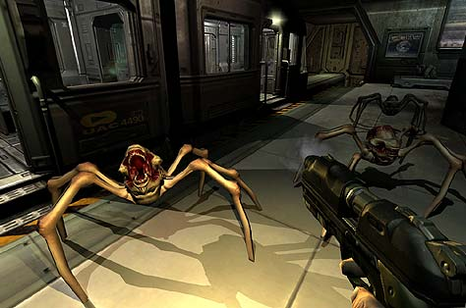

Figure 1: Doom 3 in First-Person Perspective¹³

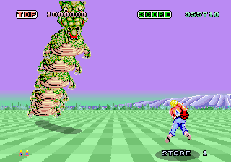

Figure 2: Space Harrier in Third-Person 3D Perspective¹⁴

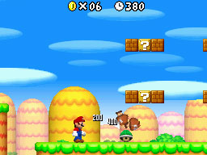

Figure 3: New Super Mario Bros. in Third-Person 2D Perspective¹⁵

In addition to the various perspectives in video games, there are also several fundamental tasks common to most video games. Since the two most basic tasks in a game are navigation and attacking another object, they will be tested in our study. Myst is an example of a game where the main task is navigation through a 3D environment. Ghost Recon: Advanced Warfighter, on the other hand, is a game where the main task is attacking another enemy by means of shooting to complete an objective. To allow for ease of measurement, only instantaneous projectiles will be tested when shooting an object. When an arced projectile is used, it takes more or less time to hit the target depending on the angle of the projectile and the distance from the avatar to the target. Since the target may vary in distance from the avatar, instantaneous projectiles provide a more accurate measurement of user performance.
Games have several different display settings. The two display settings that will be varied in this study are resolution and frame rate. Resolution is the number of pixels across and down the screen. Frame rate is the number of frames displayed per second on a screen. An example of resolution in games is 800 x 600 pixels and typical frame rates in games are 30 frames per second and 60 frames per second.

4: Approach

The following sections will describe the setup of our experiment and several issues that arose during development. In specific, Chapter 4.1 outlines some basic experimental parameters that were chosen for the study; Chapter 4.2 discusses the actual development of each of the views in detail; Chapter 4.3 discusses the development of the test harness; Chapter 4.4 addresses the various issues that occurred in the actual user study.

4.1 Experimental Parameters
It is apparent that perspective is an integral and often overlooked part of games. To accurately capture and measure changes in user performance due to perspectives, several design decisions were made. First and foremost where the number of perspectives to choose. The three perspectives, 3rd Person 2D, 3rd Person 3D, and first person where chosen for the simple reason that they are used most often in current games today. In addition, two tasks are to be tested as well: navigation and shooting. Typically the shooting task is mostly associated with the first person perspective, whereas the navigation perspective tends to be a 3rd person view. However, some games use a combination of varying perspectives and tasks. By testing the two tasks in all of the perspectives, it can be determined if one perspective is better suited for one task than another. For further evidence, frames per second and resolution were varied to determine whether this would have an effect on user performance in that perspective. For frames per second the following three settings were chosen 7, 15, and 30. Seven frames per second was chosen as the lowest frequency following the assumption that the lower the frame rate the lower the playability. As stated by Thropp et al.¹² frames per second at less than 5 Hz tend to provide uncharacteristic user performance. Thirty frames per second was chosen as the upper bound since many games run at that frequency. Choosing 15 frames per second allowed us to more easily interpret the results, since it is a good reference point between the upper and lower bounds. For resolution only two settings were chosen, 800 x 600 pixels and 1280 x 1024 pixels, largely because the amount of tests would have increased exponentially with more than two resolution sizes. 800 x 600 pixels was chosen as the lowest resolution since this is typically the lowest setting on most monitors. Most monitors are set at a resolution of 1280 x 1024 pixels, so this was picked as the higher resolution. These settings were applied to each perspective and presented to the user. The results were than gathered from their respective scores.

4.2 Development of Games
This section will discuss the ideas and implementation that went into the development of the three games with varying perspectives. While the underlying idea of each game is the same, each game was created separately and involved several design decisions. Only two platforms were used for the creation of the games: Game Maker 6 and Visual Basic 6.0. Upon completion of the three perspectives all games underwent a normalization process to ensure that the variables in each perspective were the same. Once normalization was completed, the executable files were built and saved. The above is discussed in greater detail in the sections to follow: Section 4.2.1 will discuss the development of the 3rd Person 2D view; Section 4.2.2 will discuss the development of the First Person Shooter; Section 4.2.3 will discuss the development of the 3rd Person 3D view; Section 4.2.4 will discuss the normalization process; Section 4.2.5 discusses the compilation of executable files.

4.2.1 Development of 3rd Person 2D Perspective
The 3rd Person 2D perspective was the first perspective to be created. In light of this, most of the overall design decisions about the layout of the game were decided on during the creation of this perspective. In this perspective the game is portrayed from an overhead view where the user is able to see the entire room. This perspective was written in Visual Basic 6.0 largely because this perspective does not require a 3D graphics engine. There was also existing experience in developing games in this environment. Since each perspective has two tasks, navigation and shooting, two separate games are created for each task within this perspective. This allows for faster building of the executable files.
The first step in creating the game was to create a simple room for the avatar to move in. A square room is used with simple grass textures and a small brick wall to serve as the indication of the bounds of the room. No walls or obstacles are placed in the room, because the participant’s performance could be adversely affected. Next, the avatar was added, in our case a simple Mario Kart sprite. As following most games, the user can turn in eight directions: forwards, backwards, left, right, and their respective diagonals. The avatar only moves when pressing forwards or backwards on the arrow keys. To turn, the user presses the left or right arrow keys. In addition, to give the user the illusion of movement the sprite moves up and down by a small degree to simulate the car bouncing. Upon hitting a wall, the avatar stops moving. After the completion of the avatar’s movement, two copies of the game were made for both the shooting and navigation tasks respectively.
In the navigation task the user has to find the correct object out of a set of six objects. A sword sprite is used as the correct object. The average size for all sprites is 32 x 32 pixels. For the dummy or incorrect objects, a heart, bow and arrow, crystal, mailbox, and bottle are used. The sword and bow objects were taken from Secret of Mana. The rupee, heart, and honey jar were taken from The Legend of Zelda: A Link to the Past. Lastly, the mailbox was taken from Earthbound. The objects are shown in Figure 4.2.1-1.


Correct Object
Dummy Objects

Figure 4.2.1-1: Sprites used in 3rd Person 2D Navigation Task

To ensure the user has the same chance of finding the correct object, the sword is always placed the same distance in pixels from the avatar. The dummy objects are assigned randomly throughout the room. When a participant successfully collects the correct object, every dummy object in the room is sent to a new random position. As a measure of performance, the number of correct objects successfully collected is counted. Initially the current score was displayed in the title bar, however it was later removed to prevent the score from influencing the user. The completed game is shown in Figure 4.2.1-2
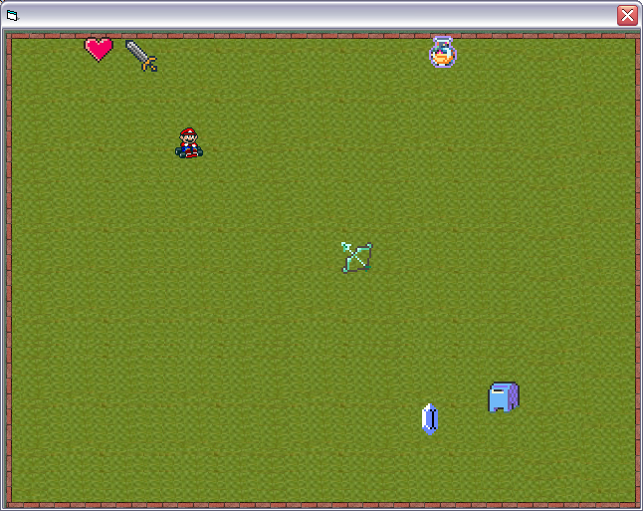
Figure 4.2.1-2: 3rd Person 2D Perspective Navigation Task

In the shooting task the user has to find and successfully shoot an enemy sprite. For the enemy sprite, another Mario Kart sprite was chosen. Rather than shoot a stationary object, the enemy sprite is set to change direction when colliding with the walls of the room to keep the user interested. Also to give the user a visual indication that they have successfully hit the enemy sprite, the sprite is altered. The enemy sprite is shown in Figure 4.2.1-3.


Enemy Sprite
Hit Enemy Sprite

Figure 4.2.1-3: 3rd Person 2D Enemy Sprites

To shoot, the user presses the spacebar. However to prevent the user from firing too rapidly, a time delay is placed between the firing of each bullet. The user can shoot two bullets every second. The user’s performance is measured by the number of hits times their accuracy. The completed game is shown in Figure 4.2.1-4
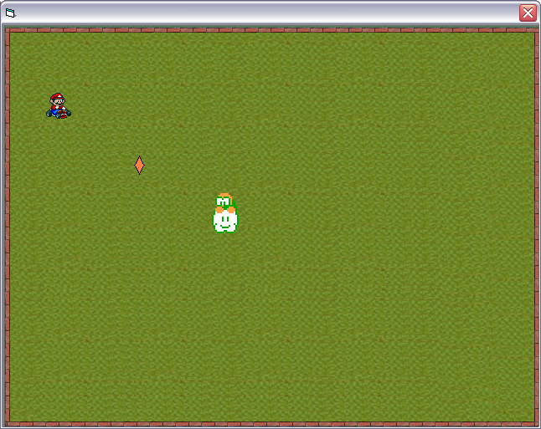
Figure 4.2.1-4: 3rd Person 2D Shooting Task

4.2.2 Development of First Person Perspective
In the first person perspective the entire game is played as if through the avatar’s eyes. The first person perspective was created using Game Maker 6. This is largely because using Game Maker allows for use of their incorporated 3D engine while allowing for faster completion of the game itself.
The initial creation followed the same steps as the 3rd Person 2D perspective. First a square room was created, but contrary to the 3rd Person 2D perspective, wall placeholders are added as the bounds for the room instead of adding wall sprites. Each of these placeholders is given a wall texture. Upon completion of these steps, the 3D engine draws the wall correctly. In addition, a floor and ceiling sprite are chosen. For the floor sprite a basic tile texture is used. However this was later changed to a grass sprite so that it would appear similar to the 3rd Person 2D perspective. Since this perspective is shown through the avatar’s eyes, a steering wheel sprite is used instead of the Mario Kart sprite as in the case of the 3rd Person 2D perspective. When the user turns, the steering wheel also turns. In this case it is not necessary to simulate the motion of the car since the user is looking through the avatar’s eyes. However, the user is only shown a small portion of the room, or the equivalent of the avatar’s line of sight. After this was completed, two copies were saved and development so that the navigation and shooting tasks could be completed separately and using this template.
For the navigation task, the same 2D sprites as in Figure 4.2.1-1 are used. Game Maker simulates these sprites as 3D models using a 3D graphics engine. As in the 3rd person 2D task, the correct object is placed equidistant from the avatar. All other objects are placed in a random location. All other aspects of development remained the same as in the 3rd Person 2D. The completed game is shown in Figure 4.2.2-1
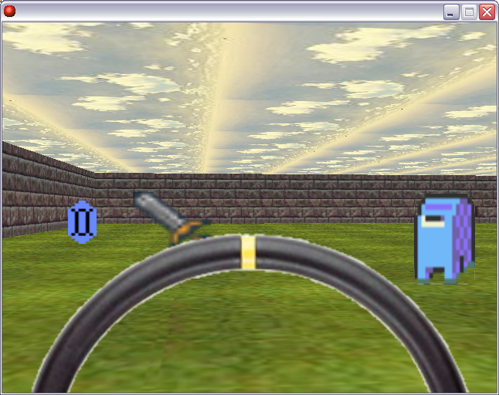
Figure 4.2.2-1: First Person Perspective Navigation Task

In the shooting task the enemy sprite is displayed in the same fashion as the Mario Kart sprite. The enemy moves in the same fashion as in the 3rd Person 2D perspective, where it moves until a collision with a wall and then proceeds in a new random direction. When shot the enemy sprite is changed to the hit enemy sprite, as shown in Figure 4.2.1-3. The same delay as in the 3rd Person 3D game was once again added so the user could not fire too rapidly at the enemy. All other aspects of development remained the same as in the 3rd Person 2D view. The completed game is shown in figure 4.2.2-2.
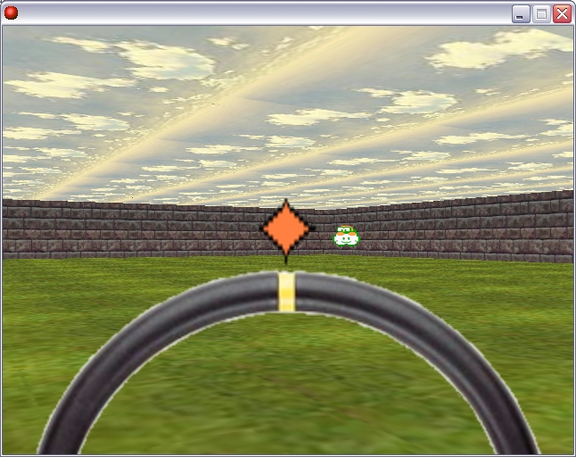
Figure 4.2.2-2: First Person Perspective Shooting Task

4.2.3 Development of 3rd Person 3D Perspective
The 3rd person 3D perspective is defined as when the avatar is placed in front of the camera and objects appear to change in size as the avatar gets closer or further away. To do this, the 3rd Person 3D perspective was initially written using Game Maker 6.0. However, it was done without using a 3D graphics engine. The original design was similar to the game Fall Down. The user guides the avatar through a room by using the arrow keys as in the 3rd person 2D and first person perspectives. As opposed to the avatar actually moving, objects in the room move toward or away from the avatar. Turning overlays the sprite at a forty-five degree angle in that direction. These algorithms for rotation and turning presented an additional difficulty. If the avatar continues to turn more than 360 degrees, the turning radius of the avatar grows larger and objects do not appear in the same spot as they started. This version of the 3rd person 3D perspective is shown in Figure 4.2.3-1.
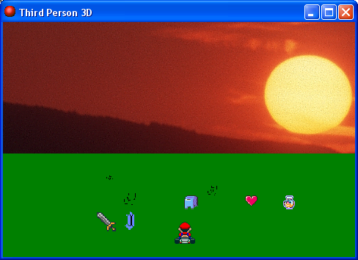
Figure 4.2.3-1: Initial Development of 3rd Person 3D Perspective

No solution to this flaw was found until the development of the first person perspective. Upon completion of the first person perspective, it was found that this perspective could be altered to accurately depict the 3rd person 3D perspective. To do this, instead of the steering wheel present in Figures 4.2.2-1 and 4.2.2-2, a Mario Kart sprite is placed a certain distance in front of the camera at all times. Once this was completed the only remaining problem with development was collision detection. In the first person perspective, motion stops when the camera hits the wall. For the 3rd Person 3D perspective motion stops when the avatar hits the wall. To correct this, four different wall types were created for each side of the room. When the avatar collides with the wall, he is pushed into the direction opposite it is facing. In this way the avatar appears to stop moving when it hits a wall, but in reality the avatar is pushed back faster than he moves forward, giving the illusion of a collision. In addition, collision with the objects was altered so that impact would occur when the avatar, and not the camera, hits the object. Creating the perspective in this way allowed for easy adaptation since all the other aspects of the game remained constant. The finished games are shown in Figures 4.2.3-2 and 4.2.3-3.
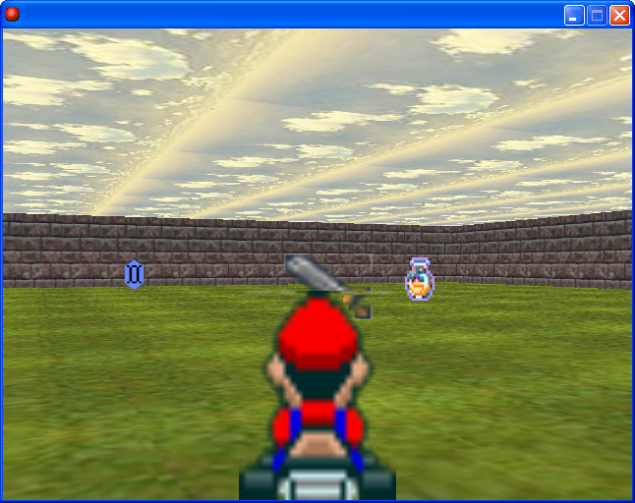
Figure 4.2.3-2: 3rd Person 3D Navigation Task
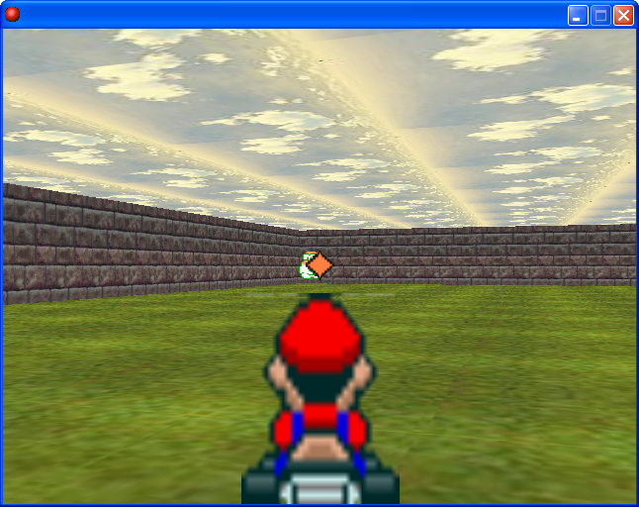
Figure 4.2.3-3: 3rd Person 3D Shooting Task

4.2.4 Normalization
Once all the games were completed, the three perspectives needed to be normalized so that all aspects of the games appear the same to the user. To do this we chose a specific perspective to normalize to, the first person perspective. The remaining games were adjusted to reflect this perspective. To do this, the amount of time to travel from one end of the room to other was recorded to be four seconds and the room sizes of the 3rd Person perspectives were adjusted accordingly. In addition the time taken to approach the correct object was measured as one second and changed in the remaining perspectives. The timing in-between when a bullet is fired and then fired again was set to be half a second. Another factor of time to turn in a full circle was normalized to be two seconds.

4.2.5 Compilation of Executables
After normalization was completed on all games, the actual executable files for each setting were created. It was decided that instead of pausing the game and changing the resolution or frame rate while the game was running, that a new executable would be built for each setting. Since each game has two tasks and could be played at three frame rates with one of two resolutions, this gives 36 executables with twelve for each individual perspective. Each executable was set to terminate after fifteen seconds. Creating the executables in this fashion also allowed for easy integration with the test harness. Load times for each of the games are so small that it is negligible for the entire study. The test harness would then only have to launch a new executable instead of gaining control of the program and altering the settings.

4.3 Development of Test Harness

4.3.1 Interface Design
A test harness was implemented to present participants with the developed games and to gather user performance statistics for varying perspectives and display settings. It was developed in Visual Basic 6.0 primarily for ease of graphical user interface development. Figure 4.3.1-1 shows the first interface presented to each participant, the Demographics Interface. This interface asked users to enter their gender, age, number of hours they play games per week, and how they would describe themselves as gamers. These questions were asked in the form of radio buttons so that users could select only one answer per question. The gender and age of users were questions incorporated so that performance statistics could be grouped by various age groups and gender when performing data analysis. The number of hours played per week as well as how the users would describe themselves as gamers were questions incorporated to check for correlations with user performance statistics. Additionally, the interface asked for users to optionally enter their email addresses. Once these fields were filled in and users clicked “OK”, the actual study could begin.

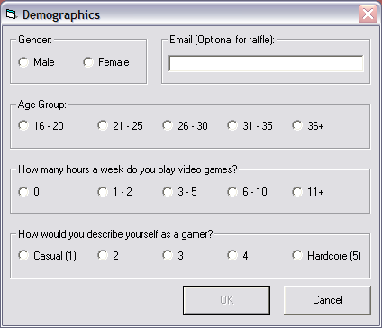
Figure 4.3.1-1: Demographics Interface

The test harness next launched a screen explaining that the participants would play a series of fifteen-second long games and that all scores and demographic information would be kept anonymous. After the demographic information was entered, the test harness began launching the actual games in varying perspectives, display settings, and tasks. The test harness contains three separate string arrays. Each string array contains the names of all of the executable files for a particular perspective. So that participants could become acquainted with the control scheme, two dummy tests are launched before data is actually accumulated. The first dummy test launched contains explicit instructions and controls for the navigation task. These instructions are shown in Figure 4.3.1-2.
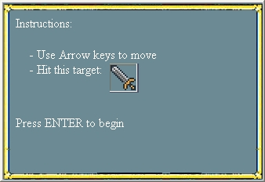
Figure 4.3.1-2: Navigation Instructions

After the user hits the Enter key, the test harness then randomly selects and launches any game with the highest frames per second and highest resolution. The games are started by entering the folder containing the executables and launching the game with the chosen string name. This was done by randomly choosing one of the three string arrays and selecting the index with the hard-coded string for the executable with 30 frames per second and a resolution of 1280 x 1024 pixels. The highest resolution and frame rates were used so that the user could become comfortable with the task and controls at optimal settings in preparation for later tests when settings are less favorable. The second dummy test launched contains instructions and controls for the shooting task. The instructions for this are shown in Figure 4.3.1-3.
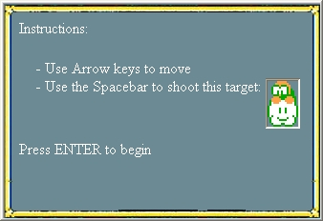
Figure 4.3.1-3: Shooting Instructions
Once again, the test harness randomly selects and launches any executable with the highest frames per second and highest resolution. These dummy tests were implemented since the navigation task and shooting task both involve two different goals and control schemes. On the first run of either of these tasks, it may not be immediately clear to the user of what to do. By providing two initial dummy tests, possible inaccurate data due to participant unfamiliarity could be avoided.
After the two initial dummy tests, the test harness launches the thirty-six games that will be used to collect data. To decide which game to launch, the test harness randomly chooses one of the three string arrays and then randomly chooses a member of the selected string array until all members have been chosen exactly once. This type of randomized testing is used so that the twelve games in each perspective can be launched one after another. By randomly selecting which member in the string array to launch, the participant will not adapt to a consistent pattern in variations in task, frames per second, and resolution.
After launching each game, the test harness waits fifteen seconds for each game to complete. Once each game terminates, the Questionnaire Interface is launched. Figure 4.3.1-4 shows the Questionnaire Interface, which asks the user to rate the playability and the picture quality of the game just played by selecting one radio button per question. These statistics were gathered to determine if the score that the user achieved was a good reflection of their skill level based on how playable they believed the game was. Upon clicking “Next Game”, the test harness launches the next game and the process continues until all games have been played. The total approximate time for the test harness to execute all games is fifteen minutes.

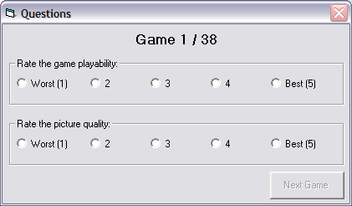
Figure 4.3.1-4: Questionnaire Interface

4.3.2 Data Collection
An important aspect of the test harness was how it collected the demographic information as well as the user performance statistics and game playability information. All of this data was collected by means of a Microsoft Access database. The database contains seven different tables. The main table “master” contains the following fields:

id: The unique user ID created for each new participant.
Gender: The gender of the participant.
Age: The age of the participant.
Hours: The number of hours the participant plays games per week
Gamer: A number that gauges how the participant views himself as a gamer.
Email: The email of the participant.

The six other tables are separated by perspective and task. There are two database tables per perspective since the shooting task gathers additional data including shots taken and successful hits whereas navigation only gathers the score. The table “3rd 3D nav” corresponds to the games with a third person 3D perspective and navigation task, the table “3rd 3D shooting” corresponds to games with a third person 3D perspective and shooting task, the table “3rd 2D nav” corresponds to games with a third person 2D perspective and navigation task, the table “3rd 2D shooting” corresponds to games with a third person 2D perspective and shooting task, the table “FPS nav” corresponds to games with a first person perspective and navigation task, and the table “FPS Shooting” corresponds to games with a first person perspective and shooting task. In all of the tables with a navigation task, the following fields are used:

id: A number that references the participant number from the table “master”.
score: The number of swords collected in each game.
fps: The frames per second display setting for that game.
width: The screen resolution width for that game.
height: The screen resolution height for that game.
autoid: An auto incremental number that makes the entry unique.
playability: The number that the user designated as how playable the game was.
picture: The number that the user designated as how high the picture quality of the game was.

The tables with a shooting task contain all of the same fields as well as shots taken which is the number of times the participant hit the space bar and successful hits which is the number of times the participant successfully hit the target. In the tables with a shooting task, the field score was calculated as the number of successful hits times the accuracy. Figure 4.3.2-1 shows the relational model of the database.
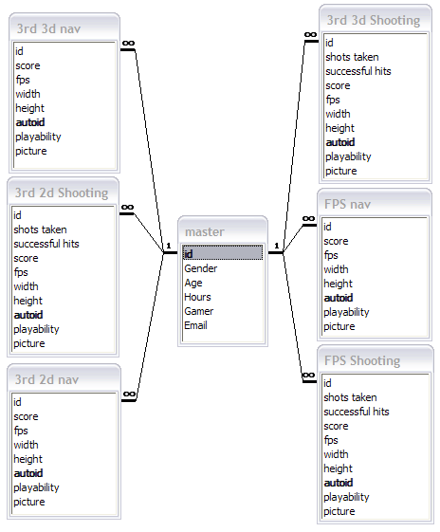
Figure 4.3.2-1: Relational Model of Database

At various stages, the test harness updates the database. After the demographics interface is filled out, a new unique user ID is created and placed in the field id of the table “master”. The gender, age, email, number of hours of games played per week, and type of gamer are also added along with the new user id to their corresponding fields in the table. The unique user ID that was created is stored and used several times throughout the course of each test harness run. Before each game terminates, it creates a text file “Results.txt” with details on user performance. The score is outputted for games with a navigation task whereas games with a shooting task output the number of successful hits as well as shots taken. In addition, all games output the frames per second as well as the resolution to the text file. After each game terminates, the test harness parses the string containing this data in the text file “Results.txt.” Due to the interface design of the test harness, it is known at this point of parsing which perspective the game was in and also the task of the game. After the user fills out the questionnaire interface to get data for the playability and picture quality fields, the test harness uploads the data to the appropriate table depending on the perspective and task of the game just played. A new row is created in the appropriate table with the unique user ID of the user, as well as the score the user achieved and the settings of the game that was parsed from the text file. Upon database update, the test harness deletes this text file and the process is repeated for the remaining games.

4.3.3 Prevention of User Manipulation
The test harness also has several features built in that prevent the user from breaking the flow of the games and updates to the database. One of these features is a recovery system from the user attempting to close one of the games at any point during the study. Since the test harness deletes the text file it reads after each game, no new text file will be created if the game is closed prematurely. So if a text file is not created within five seconds of a game being terminated, the test harness will restart the same game to recollect the data. Other measures were implemented such as graying out the close buttons in the title bar of all interfaces and making it clear that the study would take fifteen minutes in the initial instructions.

4.4 User Study

4.4.1 Testing Location
The actual study was conducted at a computer lab in Atwater Kent at Worcester Polytechnic Institute over the course of two weeks. The test harness executable was installed on several machines in the lab, and participants could come to the lab and undergo the study at the allotted times. To ensure that users did not prematurely end the study and understood the goal and controls scheme of the games, a proctor was in the room at all times. In addition, all machines installed with the test harness were kept at least one machine apart from one another to keep participants from being distracted by the performance of other users. The test was performed on a Dell Precision 380 Pentium D 3.0 GHz Dual Core computer with a Dell 1907 Flat Panel display. Each computer has 2 gigabytes of RAM and a default resolution of 1280 x 1024 pixels.

4.4.2 Local vs. Network Database
An important design decision in the user study was the location of the database. One option was to have a database stored locally on each of the machines installed with the test harness and then later merge all of the databases into one. The second option was to have a single database stored on a network that could handle multiple reads and writes at a single time. The local database would ensure that all data would be properly accumulated in the database and avoid any networking errors, but it would have the disadvantage of limiting the number of computers the test harness could be on and also the problem of merging the databases into one. The network database, on the other hand, would allow for as many computers at once to have the test harness running and updating to the database, but it was not as safe since the network could go down and it was unclear if the network database could handle multiple updates at once. To decide which approach to implement in the user study, the database was placed on the network of one of the students conducting the study. The test harness connected to the network database was then run simultaneously on several machines to observe if the updates would work appropriately. It was concluded that the network database could support several read and writes at the same time, so the network database approach was used for the study.

4.4.3 Participant Solicitation
To get as many people as possible to participate in the study, an incentive that two random participants would receive a $25 dollar gift certificate to Best Buy was promoted. Several flyers, as seen in Appendix A, were posted around Worcester Polytechnic Institute (WPI) campus encouraging users to participate at the designated times and promoting the incentives. The event was also promoted through email to various student groups and in the events calendar. In addition, extra credit was offered to students in an IMGD course at WPI if they participated in the study.

5. Results
The following chapter will discuss in detail the results of our study and provide statistics and visual aids. The chapter is outlined as follows: Chapter 5.1 describes the demographics behind the study; Chapter 5.2 outlines the overall test results; Chapter 5.3 discusses the various findings and their relevance.

5.1 Demographics
During the course of the study statistical information was gathered on the actual demographics of the participants. In total, 27 participants underwent the study, 24 of which were males and 3 of which were females. In Figure 5.1-1, the x-axis shows male and female categories and the y-axis shows the number of people who participated from each gender. It is notable that the majority of participants were male, which is likely due to WPI being a male dominant school with a percentage of 77% male students. In addition the majority of students in the computers science and interactive media and game development majors are male.

Figure 5.1-1: Gender Demographics

Age demographics were also collected. Eight people participated with ages ranging from 16 to 20 years old, ten people participated with ages ranging from 21 to 25 years old, two people participated with ages ranging from 26 to 30 years old, three people participated with ages ranging from 31 to 35 years old, and four people participated from ages ranging from 36 years old and up. In Figure 5.1-2, the x-axis represents the current age in years divided into five subcategories. The y-axis shows the number of people in each age group. Most people that participated were between the ages of 16 and 25, which is representative of a college campus. The remaining categories primarily consisted of graduate students and professors at WPI.

Age Demographics
0
2
4
6
8
10
12
16-20
21-25
26-30
31-35
36+
Age (Years)
# of People
Figure 5.1-2: Age Demographics

The number of hours that each participant played video games was also collected to determine the validity of the user performance. Figure 5.1-3 shows on the x-axis the amount of time in hours that each participant played video games per week. The y-axis shows the number of people who played video games divided into five subcategories. As shown in Figure 5.1-3 most participants played video games for approximately six to ten hours per week. However, there is a large distribution among all five categories. This is useful to make an accurate assessment on the various skill levels of users.

Figure 5.1-3: Time Demographics

To accurately test that the number of hours that each participant played video games per week was a good measure of user performance, the average score was computed for each task over the five time categories. In Figure 5.1-5a, the x-axis shows the amount of time in hours that each participant played video games per week. The y-axis shows the average score of participants for each time subcategory in the shooting task. There are three different data sets shown: the dotted hash bar represents the 3rd person 2D view, the diagonal hash bar represents the 3rd person 3D view, and horizontal hash bar represents the first person view. An interesting finding on this graph is that there is a consistent increase in score for the shooting task as the number of hours played per week increases up until the 11+ hours per week. In Figure 5.1-5b, the same axes and data sets are used, with the only variation being that the y-axis shows the average score of participants for each time subcategory in the navigation task as opposed to the shooting task. In this graph, the scores for the 3-5 years old age group, 6-10 years old age group, and 11 years and up age group are clearly higher than the first two age groups but there is no visible linear trend. This data indicates that the number of hours that each participant plays video games per week may not be a reflective measure of user performance.

Figure 5.1-5a: Hours vs. Shooting Score (Left) and
Figure 5.1-5b: Hours vs. Navigation Score (Right)

Each participant made a self-assessment of their gaming skill by choosing a number on a scale between 1 and 5 where 1 represented a casual gamer and 5 represented a hardcore gamer. The following data is shown in Figure 5.1-6. The x-axis represents a scale where 1 is a casual gamer and 5 is a hardcore gamer. The y-axis represents the number of participants who selected that level of gaming. The graph reveals an interesting trend. There is a bi-modal distribution with most participants being either one, a casual gamer, or four a hardcore gamer.
Figure 5.1-6: Gamer Demographics

To test the validity of the gamer demographics the same structure was followed as in the hour demographic chart. The average score was computed for each gamer level over the five categories. In Figure 5.1-7a, the x-axis shows the gamer level that each participant selected. The y-axis shows the average score of participants in each selected gamer level for the shooting task. There are three data sets which remain the same as in Figure 5.1-5a and 5.1-5b. Both graphs show a fairly consistent increase in average score with respect to gamer level, especially in the shooting task. This suggests that Gamer Level is an accurate measure of user performance.
Figure 5.1-7a: Gamer Level vs. Shooting Score (Left) and
Figure 5.1-7b: Gamer Level vs. Navigation Score (Right)

5.2 Test Results
To test if perspective in video games impacts user performance several results from games with various tasks and display settings were gathered and analyzed. Figure 5.2-1 shows one of the more interesting results. The x-axis in the graph shows the three different frames per second settings and the y-axis shows the average score of every user for that specific setting in the navigation task. There are three data sets: the points shown as a triangle represent the score in the 3rd person 2D perspective, the points shown as a square represent the score in the 3rd person 3D perspective, and the points shown as a diamond represent the score in the first person perspective. The confidence intervals for each are shown by the bar lines at each frames per second setting. There are several interesting findings within this graph. The score in the 3rd person 3D perspective is significantly higher than the score in the first person perspective at 15 frames per second and 30 frames per second. This may be due to the fact that in the 3rd person 3D perspective, the avatar being placed in front of the camera makes for a clearer view of all collisions with walls and objects placed throughout the room. Also in this view, it is clearer when the correct object has been picked up since the user can see the avatar colliding with it and watch the objects change their positions. In the 3rd person 3D view, it can also be seen that there is a large increase in score between 7 and 15 frames per second. However, this increase is not as apparent between 15 and 30 frames per second. This may indicate that frames per second settings above 15 have less of an impact on user performance while in the 3rd person 3D view. Overall the best performance is shown in the 3rd person 2D view. Yet interestingly enough there is negligible difference in user performance at 7 and 15 frames per second.

Figure 5.2-1: Navigation Score vs. Frames per Second

To see if resolution has a significant impact on user performance for the navigation task, the average score is computed for all users and graphed for both resolutions of 800 x 600 pixels and 1280 x 1024 pixels. Figure 5.2-2 shows these results. The x-axis represents the two resolutions and the y-axis represents the average score for all users at that resolution setting for the navigation task. The three data sets and confidence intervals remain the same as in Figure 5.2-1. Despite there being minimal difference in score between the two resolution settings for all perspectives, a notable finding is that the score is significantly different among all perspectives, with no confidence overlap. The flat trend lines show that changes in resolution have no impact on user score. Once again, performance is best in the 3rd person 2D perspective.

Figure 5.2-2: Navigation Score vs. Resolution

Similar to the navigation task, the shooting task also shows interesting results with respect to changes in frames per second. Figure 5.2-3 shows the results of average score in the shooting task versus frames per second. The x-axis in the graph shows the three different frames per second settings and the y-axis shows the average score of every user for that specific setting in the shooting task. The three data sets and confidence intervals remain the same as in Figure 5.2-1. Despite not having results as significant as the navigation task, there are still several interesting trends in the data. As frames per second increase in the 3rd person 3D view, the score increases linearly. As frames per second increase in the first person view the score has negligible difference between 15 and 30 frames per second. This trend may be indicative that the 3rd person 3D view may be better suited for shooting tasks at higher frame rates than a first person view, contrary to our hypothesis. Due to the overlap between confidence intervals, further tests are needed to ascertain the true relationships in this data.

Figure 5.2-3: Shooting Score vs. Frames per Second

Like in the navigation task, the average score is computed for all users and graphed for both resolutions of 800 x 600 pixels and 1280 x 1024 pixels to see if resolution has a significant impact on user performance for the shooting task. In Figure 5.2-4 the x-axis represents the two resolutions: 800 x 600 pixels and 1280 x 1024 pixels. The y-axis shows the average score of every user for that particular resolution in the shooting task. The data sets remain the same as in the previous graphs. As shown in the figure, there is no major difference between the first person and 3rd person 3D views. As shown by the flat trend lines, the resolution seems to have little or no impact on score. In addition, due to the confidence intervals overlapping these results can be deemed insignificant. Interestingly enough, there is a large gap between the 3rd person 2D view and the remaining views. The score in most cases is one point more than in the 3rd person 3D and first person view. This may be a statistical anomaly or due to poor normalization techniques.
Figure 5.2-4: Shooting Score vs. Resolution

To accurately judge whether participants in the study preferred one resolution or frames per second to another, users were asked to evaluate the playability and picture quality of each game, using a scale from 1 to 5 where 1 indicates the worst playability or picture quality and 5 indicates the best playability and picture quality. Figure 5.2-5a and 5.2-5b show the playability for each graph versus the actual frames per second setting. Both graphs x-axis represents the three frames per second settings chosen. The y-axis shows the average playability rating of all users for each setting. The three data sets remain the same as the previous graphs. Confidence intervals are also shown. Figure 5.2-5c and 5.2-5d show the picture quality versus the resolution for both the navigation and shooting tasks respectively. The x-axis represents the two resolution settings, whereas the y-axis represents the average picture quality rating of all users for that particular resolution. The data sets and confidence intervals remain the same as the previous graphs.

Figure 5.2-5a: Shooting Playability vs. Frames per Second (Upper Left),
Figure 5.2-5b: Navigation Playability vs. Frames per Second (Upper Right),
Figure 5.2-5c: Shooting Picture Quality vs. Resolution (Lower Left), and
Figure 5.2-5d: Navigation Picture Quality vs. Resolution (Lower Right)

Figure 5.2-5a shows a large increase between 7 frames per second and 15 frames per second for the 3rd person 3D view whereas the 3rd person 2D and first person views show a linear increase in playability. Once the 15 frames per second setting is exceeded, the 3rd person 3D view overtakes the remaining views as having the highest playability rating. This may be due to the fact that at 7 frames per second, the 3rd person 3D view displays the avatar in front of the camera, possibly blocking the view. The small number of frames displayed per second combined with the avatar blocking the center of the view may limit the player’s ability to accurately identify the enemy sprite. Figure 5.2-5b also shows an interesting result in that the first person view shows the largest increase in playability rating, overtaking the other views. After 15 frames per second there seems to be a less significant impact on the playability rating in all games. This may indicate that for the navigation task a setting of over 15 frames per second has a limited impact on the user’s playability rating of the game. Figure 5.2-5c and 5.2-5d show very little difference in the actual picture quality rating for both the 800 x 600 pixel and 1280 x 1024 pixel resolution indicating that users do not find changes in resolution to deter picture quality. It is also notable that none of these results are statistically significant with an overlapping confidence interval.

6. Conclusion
In many video games perspective controls the amount of the virtual world seen in the viewport. There are three distinct perspective types that the games were developed in: the 3rd person 3D, 3rd person 2D, and first person view. Despite having such a large impact in a game, perspective has not been heavily studied as a contributing factor in user performance. Perspective, as shown, can impact the user performance just as much as frame rate or resolution alone.
This study focused on defining several definitions of perspectives and how display settings affect user performance in different perspectives in video games. Several games were created in these perspectives and a test harness was built to execute these games in a random fashion while varying the frame rates and resolutions. Users were than asked to rate the playability and picture quality of each game. The test harness collected user performance statistics and uploaded them into a database for later analysis.
Overall, users seem to perform the best in the 3rd person 2D view for both the shooting and navigation tasks, in all frame rates and all resolution settings. This is likely due to the fact that the user can see the entire room from an overhead perspective in the 3rd person 2D view. Because of this, when the correct object appears behind the avatar in the navigation task or the enemy sprite goes behind the avatar in the shooting task, the user can immediately identify its position. This is different from the first person view and third person 3D view, where the user can only see what is in front of the avatar. Since the user knows the position of all objects in the room at any given time, it is likely that the user can react faster than in the other views. This may also account for the significant difference in score between the 3rd person 2D view and the other views. Additionally, the 3rd person 2D game is built off of a different engine than the other two views, perhaps skewing the results. Therefore, the first person view and 3rd person 3D view have more statistically significant results.
For both frames per second and resolution settings, the navigation task had fewer points of overlapping confidence intervals and gave more significant results than the shooting task. This is likely due to a more consistent scoring system in the navigation task where the score is incremented by one for each correct item gathered by the avatar. In the shooting task, the scores had a broader range since it was calculated as the number of hits multiplied by the accuracy. In addition, users performed significantly better in the 3rd person 3D view than in the first person view for the navigation task for all frames per second and resolution settings. This is an interesting result since both games were built off of the same engine and realistically have little difference. It would be expected that users would perform better in the first person view than in the 3rd person 3D view since the avatar is not blocking the user’s view of the objects in the room. Yet users performed better in the 3rd person 3D view in the navigation task. This may be due to the fact that in the 3rd person 3D perspective, the avatar being placed in front of the camera makes for a clearer view of all collisions with walls and objects placed throughout the room. Also in this view, it is clearer when the correct object has been picked up since the user can see the avatar colliding with it and watch the objects change their positions.
Another notable finding from these results is that between the three perspectives, there is significant difference in score for the navigation task. As mentioned previously, this is likely due to the 3rd person 2D game giving the user an advantage since the whole room is visible and due to it being more clear that the user has successfully gathered the correct object in the 3rd person 3D view. This result is further supported by the fact that there is no significant difference in score of the shooting task between the 3rd person 3D view and first person view. In both navigation and shooting tasks, however, there was no significant difference in score between the two resolutions. This indicates that changes in screen resolution have little to no impact on user performance in video games in any perspective. From these results, it is apparent that the 3rd person 3D perspective may be better suited for navigation tasks in video games than the first person perspective. Overall resolution seems to affect the performance of 3rd person 2D games the most. Changes in frames per second seem to have the largest impact in the 3rd person 3D view. There is negligible difference between the effects of the shooting and navigation tasks on user performance in any perspective.

7. Further Studies
There are several options open to further study. An additional resolution could be tested to see if there is an increase in performance when a lower or higher resolution is used. Perhaps frame rate affects the user performance as a logarithmic curve and a more significant frame rate could be chosen that would have more of an impact on user performance. In addition, a better scoring system that is more reflective of the user’s performance could be developed for the shooting tasks to provide more accurate and comparable results to the navigation task. Other frame rate settings could be added as well to indicate where frames per second matters most. At frames rates higher than 30 frames per second the user performance may peak or have a less significant impact, revealing an optimal frame rate for a certain perspective. Another possible study could focus on how perspective influences different genres of games, such as a role playing game or a sports game. To determine the validity of the 3rd person 2D view, the entire study could be replicated with a minor change to the 3rd person 2D view. As opposed to showing the entire room from an overhead view, the game could be modified to show a smaller portion of the room in the same fashion. This would eliminate the user’s ability to immediately identify the location of the correct object or enemy sprite. Additionally the 3rd person 2D view could be changed to an isometric view or side scroller to see if there is any difference in the user’s performance.

References

1. “Perspective.” Encyclopædia Britannica. 2006. Encyclopædia Britannica Online. 27 Sept. 2006 <http://www.britannica.com/eb/article-9374978>.

2. Rouse, R. 1999. “What's Your Perspective?” SIGGRAPH Comput. Graph. 33, 3 (Aug. 1999), pg. 9-12. <http://doi.acm.org/10.1145/330572.330575>.

3. Tory, M.; Kirkpatrick, A.E.; Atkins, M.S.; Moller, T. 2006, ”Visualization Task Performance with 2D, 3D, and Combination Displays.” Visualization and Computer Graphics, IEEE Transactions on , vol.12, no.1 pg. 2- 13, Jan.-Feb. 2006
<http://ieeexplore.ieee.org/iel5/2945/32930/01541995.pdf?isnumber=32930&prod=JNL&arnumber=1541995&arnumber=1541995&arSt=+2&ared=+13&arAuthor=Tory%2C+M.%3B+Kirkpatrick%2C+A.E.%3B+Atkins%2C+M.S.%3B+Moller%2C+T>.

4. Yang, H. and Olson, G. M. 2002. “Exploring Collaborative Navigation: The Effect of Perspectives on Group Performance.” In Proceedings of the 4th international Conference on Collaborative Virtual Environments (Bonn, Germany, September 30 - October 02, 2002). CVE '02. ACM Press, New York, NY, pg. 135-142. <http://doi.acm.org/10.1145/571878.571899>.

5. Schuemie, M. 2002. “Effect of an External Viewpoint on Therapist Performance in Virtual Reality Exposure Therapy.” In CHI '02 Extended Abstracts on Human Factors in Computing Systems (Minneapolis, Minnesota, USA, April 20 - 25, 2002). CHI '02. ACM Press, New York, NY, pg. 834-835. <http://doi.acm.org/10.1145/506443.506622>.

6. Claypool, K.; Claypool, M.; Damaa, F. “The Effects of Frame Rate and Resolution on Users Playing First Person Shooter Games.” In Proceedings ACM/SPIE Multimedia Computing and Networking (MMCN) Conference, San Jose, California, USA, January 2006.

7. Polys, N. F.; Kim, S.; Bowman, D. A. 2005. “Effects of Information Layout, Screen Size, and Field of View on User Performance in Information-Rich Virtual Environments.” In Proceedings of the ACM Symposium on Virtual Reality Software and Technology (Monterey, CA, USA, November 07 - 09, 2005). VRST '05. ACM Press, New York, NY, pg. 46-55. <http://doi.acm.org/10.1145/1101616.1101626>.

8. Ni, T.; Bowman, D. A.; Chen, J. 2006. “Increased Display Size and Resolution Improve Task Performance in Information-Rich Virtual Environments.” In Proceedings of the 2006 Conference on Graphics Interfaces (Quebec, Canada, June 07 - 09, 2006). ACM International Conference Proceeding Series, vol. 137. Canadian Information Processing Society, Toronto, Ont., Canada, pg. 139-146.

9. Gerda J.F. Smets, Kees J., Overbeeke 1995, “Trade-Off Between Resolution and Interactivity in Spatial Task Performance”, IEEE Computer Graphics and Applications ,vol. 15, no. 5, pg. 46-51, September, 1995.

10. McCarthy, J. D., Sasse, M. A., Miras, D. 2004. “Sharp or Smooth?: Comparing The Effects of Quantization vs. Frame Rate for Streamed Video.” In Proceedings of the SIGCHI Conference on Human Factors in Computing Systems (Vienna, Austria, April 24 - 29, 2004). CHI '04. ACM Press, New York, NY, pg. 535-542. <http://doi.acm.org/10.1145/985692.985760>.

11. Reddy, M. 1997. “The Effects of Low Frame Rate on a Measure for User Performance in Virtual Environments.” In Technical Report ECS-CSG-36-97, Department of Computer Science (University of Edinburgh. January.) <"citeseer.ist.psu.edu/reddy97effects.html">.

12. Thropp, J. E. and Chen, J. Y. C. 2007. “Review of Low Frame Rate Effects on Human Performance.” To appear in IEEE Systems, Man and Cybernetics.

13 “Doom 3.” id Software. 2004. Online Image. Doom 3 Screenshot. September 27, 2006. <http://doom3.com/images/screenshots/01.jpg>.

14 “Space Harrier.” Sega. 1985. Online Image. Space Harrier Screenshot. September 27, 2006. <http://www.klov.com/S/Space_Harrier.html>.

15 “New Super Mario Bros.” Nintendo. 2006. Online Image. Super Mario Screenshot. September 27, 2006. <http://media.nintendo.com/mediaFiles/KIdA2o1QZQIbWyR45LFUzWvuwvZVRtGf.jpg>.

Appendix A: Sample Flyer

- Play a series of games.
- Takes no longer than 15 minutes.
- Help fellow students in a MQP Study.
- A chance to win one of two $25 dollar gift certificates to Best Buy.
WHERE?
AK120D
WHEN?
January 22nd – February 1st
Monday 11am – 1pm
Tuesday 4pm – 6pm
Wednesday 4pm – 6pm
Thursday 11am – 1pm

Participants will play a series of video games and performance statistics will be gathered to assist in a MQP study. All information gathered will remain anonymous. Two participants will be randomly selected to receive a $25 dollar gift certificate to Best Buy.

Still Interested? Can’t make the above times?
Contact:
Michael Wood, mcw@wpi.edu
Geoffrey Verbeke, gverbeke@wpi.edu
Professor Mark Claypool, claypool@wpi.edu

Appendix B

The following items are included in electronic form on CD:
- Source Code
- Executables
- Database
- Results File

